# Kubernetes

Run containers for production

## Welcome to the Kubernetes Session

Hello and welcome to the Kubernetes session! Today, we'll delve into Kubernetes, the most popular container orchestration tool, understanding what it is and why it has gained such fame.

### The Problem with Single Docker Engines

In our previous sessions, we've run multiple containers on a single Docker engine. However, this approach has a critical flaw: if the Docker engine fails, all running containers will go down, causing service disruption.

### High Availability and Docker Clustering

To address this issue, we can implement high availability by clustering multiple Docker engines. This setup not only involves multiple Docker nodes but also requires a master node to control and manage them. The master node distributes container workloads across these Docker nodes, ensuring continuous operation even if one node fails. This capability, known as **container orchestration**, allows containers to migrate automatically to healthy nodes if their current node fails.

### Container Orchestration Tools

Several orchestration tools are available, including:

* Docker Swarm (from Docker)
* **Kubernetes** (the most popular)
* Mesosphere Marathon (Apache)
* Cloud-based solutions like AWS ECS, AWS EKS, Azure Container Service, and Google Container Engine
* CoreOS Fleet
* OpenShift

### Why Kubernetes?

Kubernetes stands out for several reasons:

* **Origin and Adoption**: Developed by Google, Kubernetes was inspired by Borg, an internal container management system. In 2014, Google open-sourced Kubernetes, and by 2015, its stable version was released. Managed by the Cloud Native Computing Foundation (CNCF), Kubernetes saw rapid adoption, with tools like Kops and Minikube aiding its deployment.
* **Features**: Kubernetes offers robust features like service discovery and load balancing, storage orchestration, automated rollouts and rollbacks, automatic bin packing, self-healing, and more. These features make Kubernetes a powerful and reliable platform for managing containerized applications.

### Kubernetes Architecture

Kubernetes architecture comprises two main components: the master node (control plane) and worker nodes.

#### Master Node (Control Plane)

1. **Kube API Server**: The central management entity that handles all incoming and outgoing communication. It exposes the Kubernetes API, enabling integration with various tools and clients.
2. **etcd**: A key-value store that holds all cluster data. Regular backups are essential to prevent data loss.
3. **Scheduler**: Assigns workloads to worker nodes based on resource requirements and policies.
4. **Controller Manager**: Manages different controllers, including node controller (monitors nodes), replication controller (monitors pods), endpoint controller, and service account & token controller.

#### Worker Nodes

1. **Kubelet**: An agent running on each node that executes container operations as directed by the master node.
2. **Kube-proxy**: Manages network rules and facilitates communication within the cluster.
3. **Container Runtime**: The environment where containers run (e.g., Docker, containerd, CRI-O).

### Pods: The Basic Unit

In Kubernetes, the basic unit of deployment is a Pod, which can contain one or more containers. Pods provide an abstraction layer, allowing Kubernetes to manage containers using different runtime environments seamlessly.

* **Single Container Pod**: A Pod with one container.
* **Multi-Container Pod**: A Pod with helper containers (e.g., sidecar or init containers) that support the main container.

### Networking

Kubernetes uses an overlay network, creating a virtual network that spans all nodes. Each node has a private network, connected by virtual switches and routers, ensuring seamless communication across the cluster.

### Setting Up a Kubernetes Cluster

There are several tools to set up a Kubernetes cluster:

* **Minikube**: Ideal for testing and learning, it sets up a single-node Kubernetes cluster on your local machine.
* **kubeadm**: A popular tool for setting up production-grade Kubernetes clusters with multiple nodes.
* **Kops**: A stable tool for creating and managing Kubernetes clusters, initially designed for AWS but now supporting other platforms like Google Cloud and DigitalOcean.

In our session, we will explore setting up Kubernetes using both Minikube and Kops.

Feel free to ask any questions or request more detailed explanations on any of these topics as we proceed!

### Minikube, kubeadm, and Kops: Use Cases, Specifics, and Relevant Commands

#### Minikube

**Overview:** Minikube allows you to run a single-node Kubernetes cluster on your local machine. It is designed for testing, development, and learning purposes. Minikube supports various virtualization technologies like VirtualBox, VMware, Hyper-V, and KVM.

**When to Use Minikube:**

* **Learning and Development:** Ideal for exploring Kubernetes features.
* **Testing:** Suitable for developers to test applications locally before deploying to a production cluster.
* **CI/CD Pipelines:** Can be used in continuous integration pipelines to test Kubernetes manifests and deployments.

**Relevant Commands:**

1. **Install Minikube:**

bash

Copy code

curl -LO https://storage.googleapis.com/minikube/releases/latest/minikube-linux-amd64

sudo install minikube-linux-amd64 /usr/local/bin/minikube

1. **Start a Cluster:**

bash

Copy code

minikube start

1. **Check Cluster Status:**

bash

Copy code

minikube status

1. **Deploy Applications:**

bash

Copy code

kubectl create deployment hello-minikube --image=k8s.gcr.io/echoserver:1.4

1. **Expose the Deployment:**

bash

Copy code

kubectl expose deployment hello-minikube --type=NodePort --port=8080

1. **Access the Application:**

bash

Copy code

minikube service hello-minikube

1. **Stop the Cluster:**

bash

Copy code

minikube stop

1. **Delete the Cluster:**

bash

Copy code

minikube delete

#### kubeadm

**Overview:** kubeadm is a toolkit that helps you bootstrap a Kubernetes cluster. It performs the necessary actions to get a minimum viable, secure cluster up and running. kubeadm is designed for production use.

**When to Use kubeadm:**

* **Production Clusters:** For setting up production-grade multi-node Kubernetes clusters.
* **Custom Clusters:** When you need a highly customizable Kubernetes setup.
* **Bare-Metal Deployments:** Suitable for setting up Kubernetes on bare-metal servers.

**Relevant Commands:**

1. **Install kubeadm, kubelet, and kubectl:**

bash

Copy code

sudo apt-get update && sudo apt-get install -y apt-transport-https curl

curl -s https://packages.cloud.google.com/apt/doc/apt-key.gpg | sudo apt-key add -

sudo apt-add-repository "deb http://apt.kubernetes.io/ kubernetes-xenial main"

sudo apt-get update

sudo apt-get install -y kubelet kubeadm kubectl

sudo apt-mark hold kubelet kubeadm kubectl

1. **Initialize the Master Node:**

bash

Copy code

sudo kubeadm init --pod-network-cidr=10.244.0.0/16

1. **Set Up kubectl for the Non-Root User:**

bash

Copy code

mkdir -p $HOME/.kube

sudo cp -i /etc/kubernetes/admin.conf $HOME/.kube/config

sudo chown $(id -u):$(id -g) $HOME/.kube/config

1. **Install a Pod Network Add-on (e.g., Flannel):**

bash

Copy code

kubectl apply -f https://raw.githubusercontent.com/coreos/flannel/master/Documentation/kube-flannel.yml

1. **Join Worker Nodes:**

bash

Copy code

sudo kubeadm join <master-node-ip>:<master-node-port> --token <token> --discovery-token-ca-cert-hash sha256:<hash>

1. **Verify the Cluster:**

bash

Copy code

kubectl get nodes

#### Kops (Kubernetes Operations)

**Overview:** Kops is a tool for creating, destroying, upgrading, and maintaining Kubernetes clusters. It is particularly well-suited for AWS but also supports other cloud platforms like Google Cloud, DigitalOcean, and OpenStack. Kops automates the provisioning and management of clusters.

**When to Use Kops:**

* **Cloud-Based Clusters:** Ideal for creating and managing Kubernetes clusters on AWS, Google Cloud, DigitalOcean, and OpenStack.
* **Production Environments:** For deploying production-grade clusters with built-in best practices for security and reliability.
* **Automated Cluster Management:** When you need automation for creating, upgrading, and managing Kubernetes clusters.

**Relevant Commands:**

1. **Install Kops:**

bash

Copy code

curl -LO https://github.com/kubernetes/kops/releases/download/$(curl -s https://storage.googleapis.com/kubernetes-release/release/stable.txt)/kops-linux-amd64

chmod +x kops-linux-amd64

sudo mv kops-linux-amd64 /usr/local/bin/kops

1. **Create an S3 Bucket for State Store:**

bash

Copy code

aws s3 mb s3://<your-kops-state-store>

1. **Set Environment Variables:**

bash

Copy code

export KOPS_STATE_STORE=s3://<your-kops-state-store>

export KOPS_CLUSTER_NAME=<your-cluster-name>.k8s.local

1. **Create a Cluster Configuration:**

bash

Copy code

kops create cluster --zones=<your-aws-zones> ${KOPS_CLUSTER_NAME}

1. **Edit the Cluster Configuration (Optional):**

bash

Copy code

kops edit cluster --name=${KOPS_CLUSTER_NAME}

1. **Create the Cluster:**

bash

Copy code

kops update cluster --name ${KOPS_CLUSTER_NAME} --yes

1. **Validate the Cluster:**

bash

Copy code

kops validate cluster

1. **Rolling Update (for Upgrading Clusters):**

bash

Copy code

kops rolling-update cluster --name ${KOPS_CLUSTER_NAME} --yes

1. **Delete the Cluster:**

bash

Copy code

kops delete cluster --name ${KOPS_CLUSTER_NAME} --yes

### Summary

* **Minikube** is great for local development, testing, and learning with a simple single-node setup.
* **kubeadm** is suitable for production clusters on physical or virtual machines, offering high customization and control.
* **Kops** excels in managing cloud-based Kubernetes clusters with automated provisioning and maintenance, ideal for production environments.

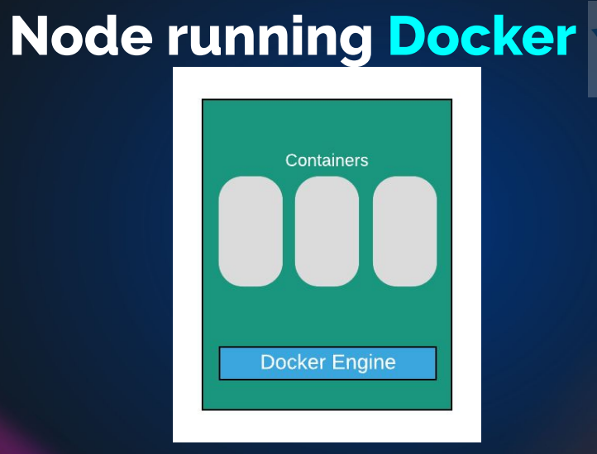

But if this docker-engine fail’s , all the containers inside the docker engine comes down and uses will not able to access then

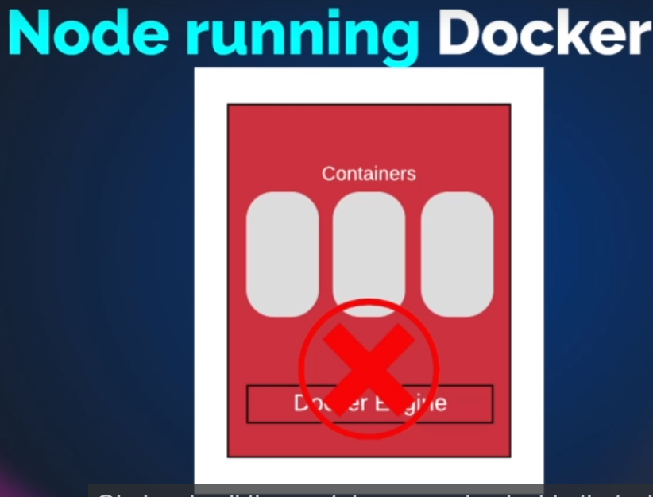

To overcome this, we should to clustering of docker engine if you are running it for production,

* + Multiple docker node that are control by master node

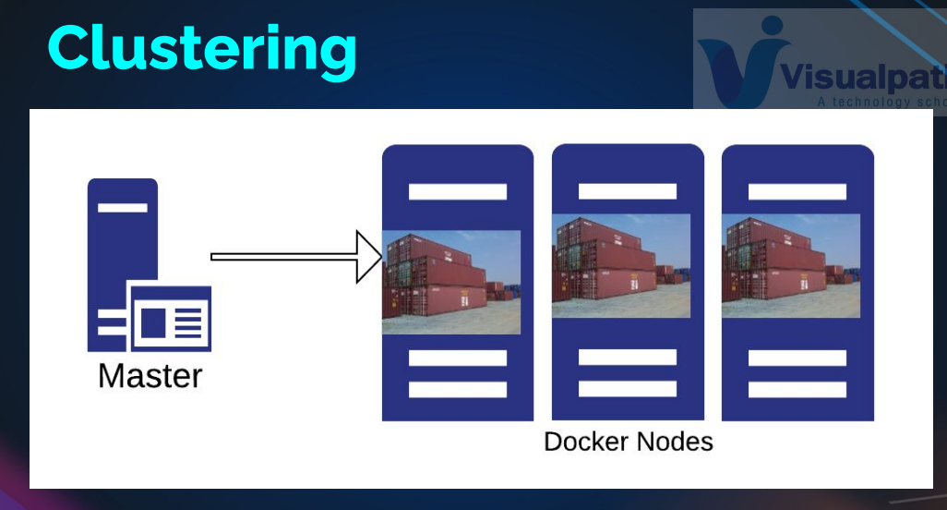

Master node (will give instruction about container to run, it going to distribute containers across your docker nodes)

* + If in case any of the docker node fails you can run on the live docker engines

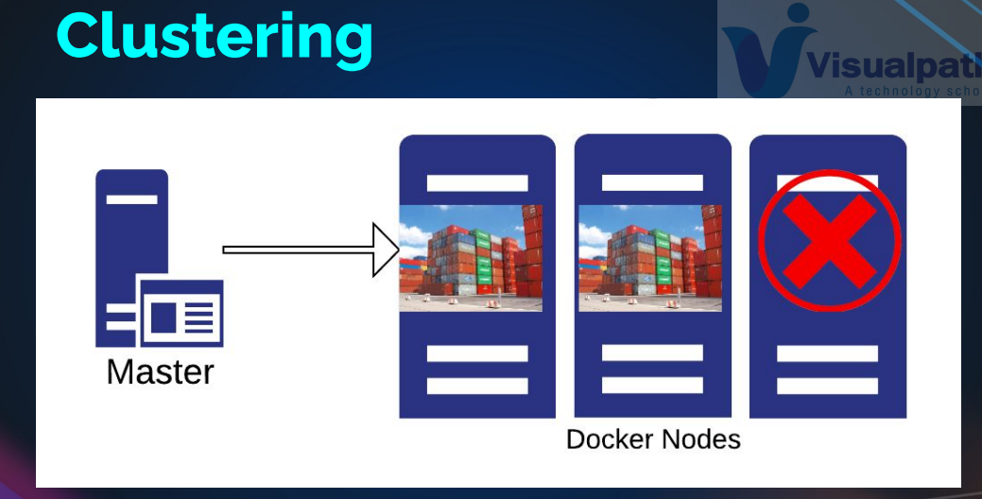

Or it start’s automatically on docker engine , containers on node three failed, then containers migrated to the healthy node.

This itself is called container orchestration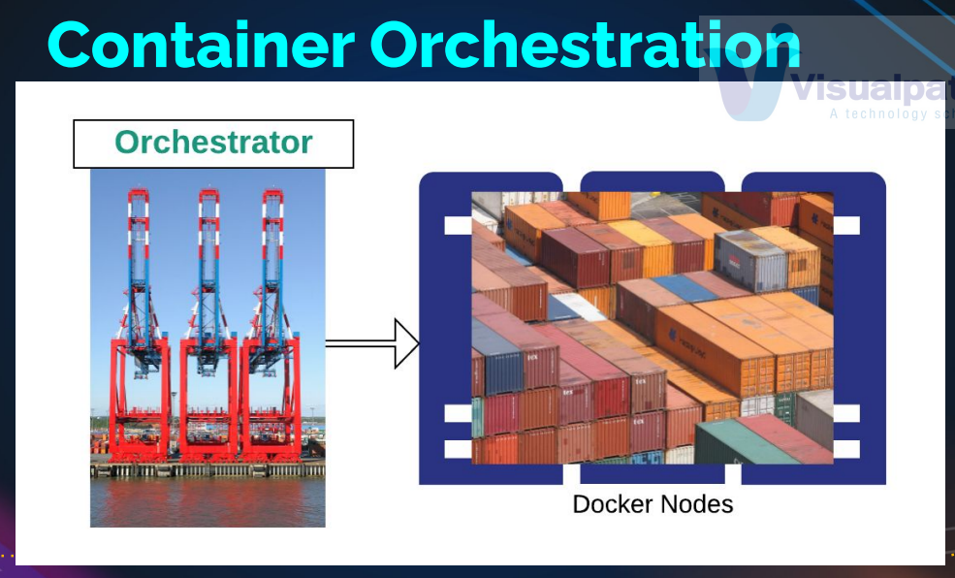

You have master node, which we called as Orchestrator , you have the cluster of docker nodes or worker nodes , where Orchestrator will distribute the container, so all the docker nodes will be the one single pool of resource , which is fault tolerant .

Container orchestration is done mostly for production environment

But we can run also normal container also on them.

# Orchestration Tools

● Docker Swarm 🡪 it is from docker directly

● Kubernetes 🡪 google

● Mesosphere Marathon 🡪 Appache

● AWS ECS & EKS 7 🡪 AWS

● Azure Container Service, AKS 🡪 Azure

● Google Kubernets Engine 🡪 google

● OpenShift

coreOS fleet 🡪

# why Kubernetes is famous

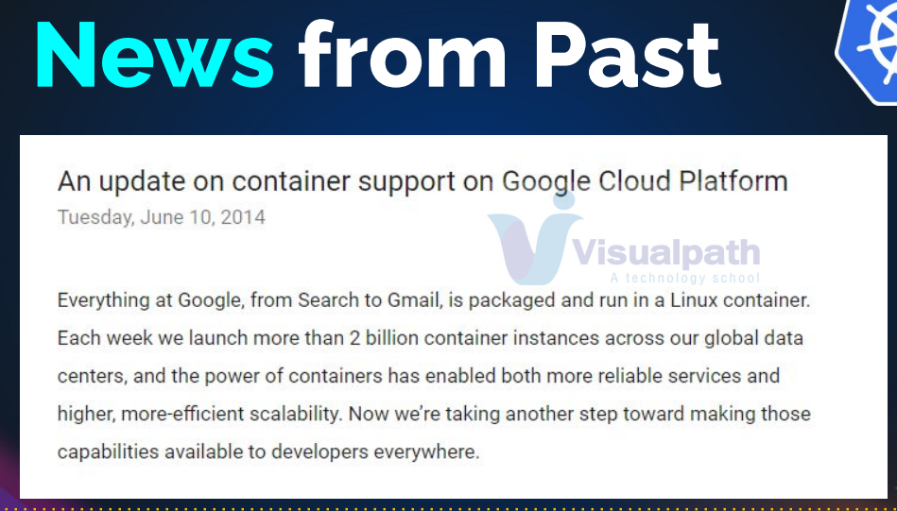

* + Containers are disposable🡪 any changes we want to make we replace the containers

# Kubernetes History

● Created by Google to manage their containers AKA Borg 🡪 to mange Linux container LXC

● Mid-2014: Google introduced Kubernetes as an open-source version of Borg

● July 21-2015: Kubernetes v1.0 gets released. Along with the release, Google partnered with the Linux Foundation to form the Cloud Native Computing Foundation (CNCF).

● 2016: Kubernetes Goes Mainstream!

○ Kops, Minikube, kubeadm etc

○ September 29: Pokemon GO! Kubernetes Case Study Released!

● 2017: Enterprise Adoption

○ Google and IBM announce Istio

○ Github runs on Kubernetes

○ Oracle joined the Cloud Native Computing Foundation

## Note

Kubernetes is not a replacement of docker engine, Kubernetes manages the cluster of docker engine.

Not only docker engine it can manage the other container runtime environment like rocket.

# Kubernetes Provides

● Service discovery and load balancing

🡪 you create a container, which we called as pod here which will get automatically discovered by load balancer and its gets updated in the load balancer

● Storage orchestration

🡪 Kubernetes provide integration with lots of storage , SAN, NAV, EBS , CEPH storage etc .

● Automated rollouts and rollbacks

🡪 it is very easy to roll out the new image versions also roll back easily if it is not working. Just like we do in beanstalk but faster then that.

● Automatic bin packing

🡪 it going to please your container on right node, where it get the right resource based on the requirement

● Self-healing

🡪 container orchestration and also container are monitored like autoscaling group(when instance goes down it will launch an new instances)

● Secret and configuration management

🡪 you can manage configuration and volume and also secret which are encoded values

https://kubernetes.io/docs/concepts/overview/what-is-kubernetes/

# Kubernetes Architecture

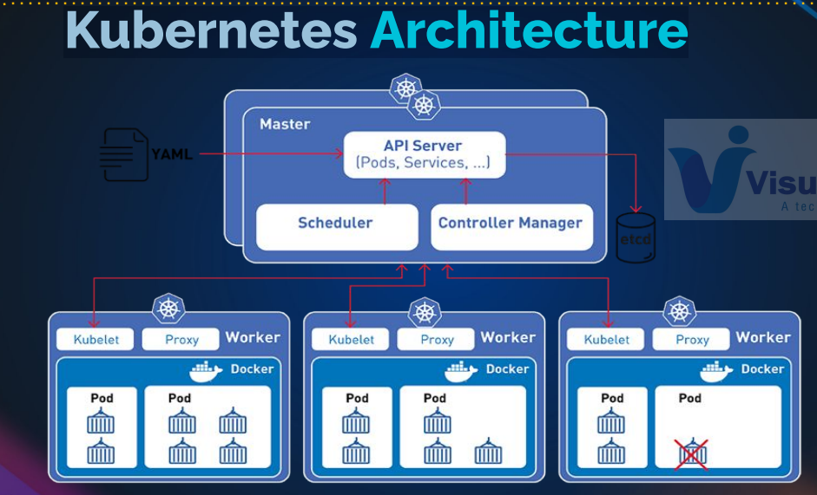

Two main components

* 1. Master node (it is also called as control plane) 🡪 master node manages the worker node
  2. Worker node 🡪 docker engine are running here

Actually, we don’t want to login in to the master/ worker node. we can use some client to give information to the master node (I want to run these commands to run the container, based on that it will take required action)

### Master node services

* API server
* Scheduler
* Controller Manager
* Etch

### Worker node services

* Kubelet
* Proxy
* Docker engine

# Master: Kube API Server

● Main Hero! Handles all the requests and enables communication across stack services.

🡪it handles all incoming and outgoing communication

● Component on the master that exposes the Kubernetes API.

● It is the front-end for the Kubernetes control plane.

● Admins connects to it using Kubectl CLI 🡪 we need to master if you are using Kubernetes

● Web Dashboard can be integrated with this API

● and many more integrations….

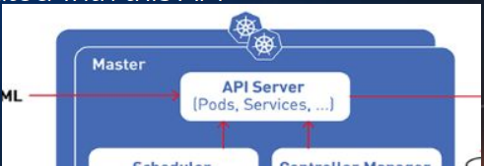

# Master: ETCD Server

Key-value store

● Stores all the information

● Consistent and highly-available key value store used as Kubernetes’ backing store for all cluster data.

● Kube API stores retrieves info from it.

● Should be backed up regularly.

● Stores current state of everything in the cluster.

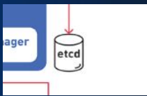

# Master: Kube Scheduler

● watches newly created pods that have no node assigned, and selects a node for them to run on

● Factors taken into account for scheduling decisions include

○ individual and collective resource requirements,

○ hardware/software/policy constraints,

○ affinity and anti-affinity specifications,

○ data locality,

○ inter-workload interference and deadlines

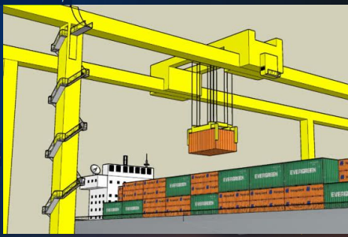

# Master: Controller Manager

❖ Logically, each controller is a separate process,

❖ To reduce complexity, they are all compiled into a single binary and run in a single process.

❖ These controllers include:

➢ Node Controller: Responsible for noticing and responding when nodes go down.

➢ Replication Controller: Responsible for maintaining the correct number of pods for every replication controller object in the system.

➢ Endpoints Controller: Populates the Endpoints object (that is, joins Services & Pods). . ➢ Service Account & Token Controllers: Create default accounts and API access tokens for new namespace

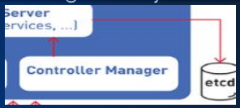

# Node Components

● Kubelet 🡪 agent to scheduler

○ An agent that runs on each node in the cluster. It makes sure that containers are running in a pod. 🡪 it is listens the Kubernetes master requests or commands

● Kube Proxy

○ network proxy that runs on each node in your cluster

○ Network Rule

■ rules allow network communication to your Pods inside or outside of your cluster

● Container Runtime: Kubernetes supports several container runtimes:

○ Docker,

○ containerd,

○ cri-o, rktlet

○ Kubernetes CRI (Container Runtime Interface)

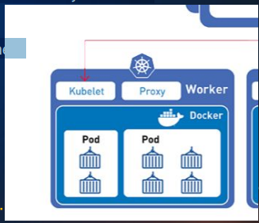

# Addons

● DNS

● Web UI

● Container Resource Monitoring

● Cluster Level Logging

Most of the times these components are taken by third party vendors who have some specialization in that area like better logging tool, better monitoring tool web user interface , DNS server etc

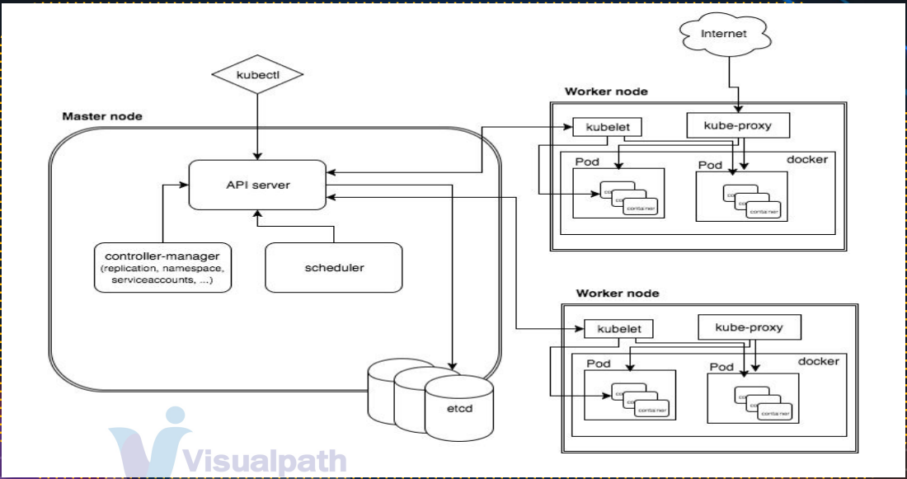

Kubectl 🡪 it is tool to connect

Kubelet 🡪 worker note agent

# PODS

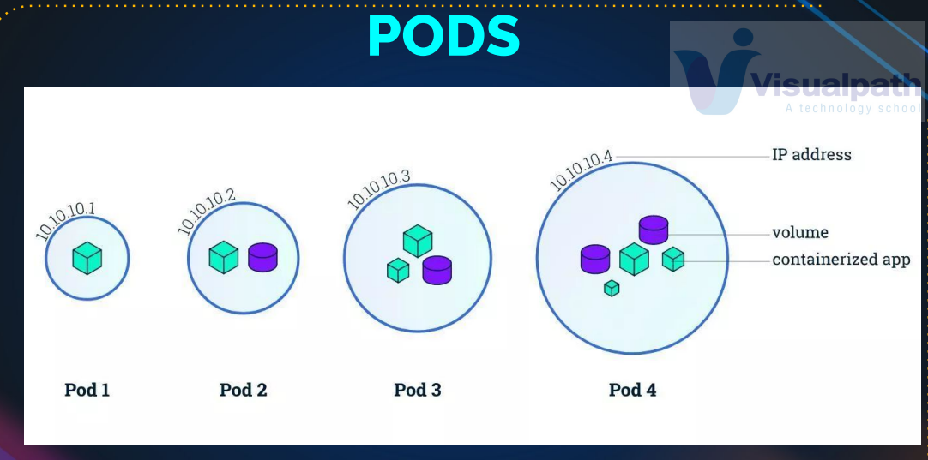

* + Pods and VM’s as same relation
    - Vm’s as process running inside it like tomcat ,so VM provide all the resources, which is running like network , RAM , CPU, Storage , everything, and the process just uses it

Similarly PODS provide the all the resources to container, the container running inside the PODS

But they are no Virtualization, just an isolation

## Why does Kubernetes use PODS? why not run directly containers?

Because Kubernetes can use different container runtime environment like docker , roket, CRI etc, if don’t have the POD then they is no abstraction. Now we have pod , it is standard set of commands, standard set of configuration that we use, it don’t matter what technology we are using behind the scene

### Should we run multiple container inside the pod?

It depends:

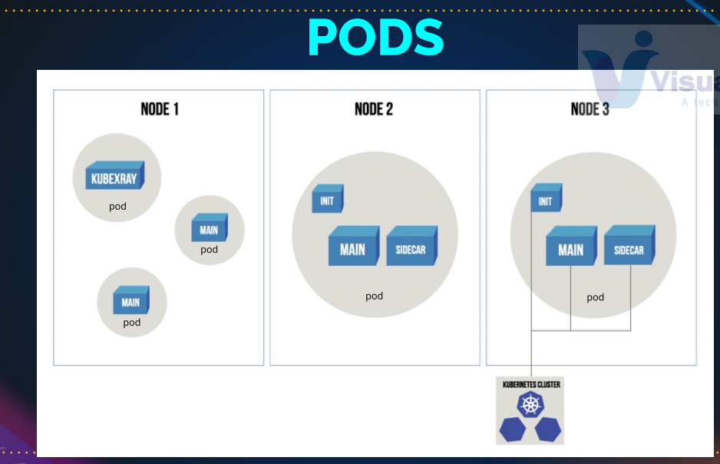

Node1 : have different pod

Node2: init container 🡪 it is short life container (do some work and it will be deid) , when it is deid the main container will start with sidecar container(if sidecar container is helper container🡪 logging agent or monitoring agent to help the main container)

* + But any point of the time , you should have only one main container only running in the pod other container will be helper containers

Ex: if you have tomcat and mysql , you are not going to running in the same pod.

Pod will distribute across the multiple worker nodes

# Over-lay networks

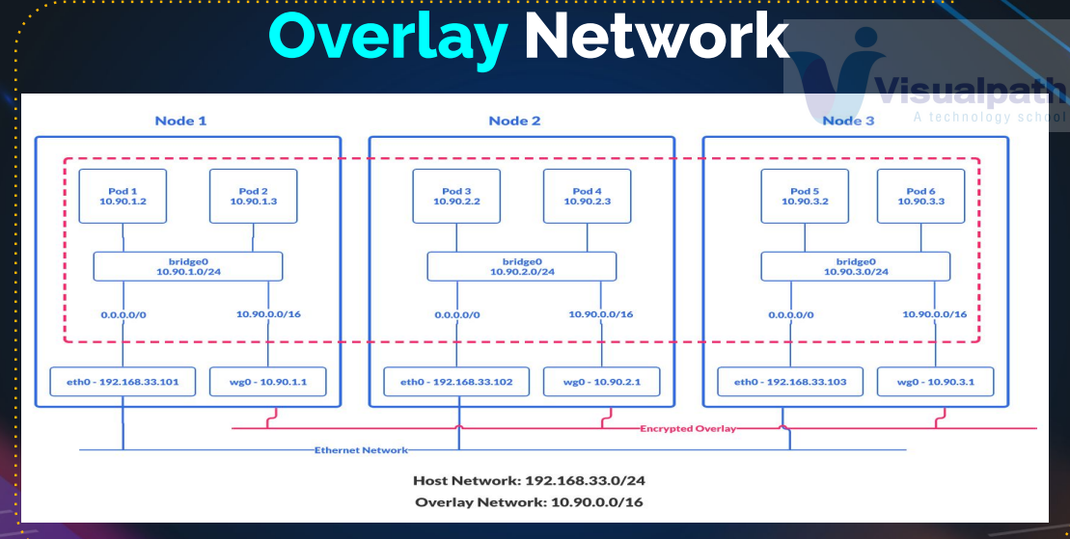

Ex: pod1 and pod6 want to interact, (think about the VPC network in AWS) 🡪 we have a giant network that connects all the node and every node have a subnet like local area network(private network running inside the node)

All the pod can connect to each other in NODE 1 with bridge0

If you want to communicate pod1 and pod6 then ( pod1 request to🡪 bridge0🡪 wg0 🡪wg0🡪bridge0🡪 pod6)

# Kubernetes Setup Tools

● Hard Way: Manual Setup

● Minikube: 🡪 it is for testing and learning propose

It is going launch the virtual machine using virtualbox and on that one VM , master node and worker node components will be running .

○ One Node Kubernetes cluster on your computer

● Kubeadm: 🡪 production

○ Multi node Kubernetes Cluster

○ Can be created on any Platforms vm’s, ec2, physical machines etc

● Kops: 🡪 it is most stable way to run Kubernetes for production now it also have support of google cloud , digital ocean, open stack

○ Multi node Kubernetes Cluster on AWS

# Setup with Minikube

● Open Powershell as Admin

● Setup Chocolaty

● Install Minikube with Chocolaty choco install minikube kubernetes-cli

● Open PowerShell and run **minikube start 🡪 it will launch one VM in oracle virtualbox**

## Install minikube

<https://minikube.sigs.k8s.io/docs/start/>

New-Item -Path 'c:\' -Name 'minikube' -ItemType Directory -Force

Invoke-WebRequest -OutFile 'c:\minikube\minikube.exe' -Uri 'https://github.com/kubernetes/minikube/releases/latest/download/minikube-windows-amd64.exe' -UseBasicParsing

$oldPath = [Environment]::GetEnvironmentVariable('Path', [EnvironmentVariableTarget]::Machine)

if ($oldPath.Split(';') -inotcontains 'C:\minikube'){

[Environment]::SetEnvironmentVariable('Path', $('{0};C:\minikube' -f $oldPath), [EnvironmentVariableTarget]::Machine)

}

## kubernetes-cli

<https://kubernetes.io/docs/tasks/tools/install-kubectl-windows/> 🡪 follow this link

curl.exe -LO <https://dl.k8s.io/release/v1.28.3/bin/windows/amd64/kubectl.exe>

curl.exe -LO <https://dl.k8s.io/v1.28.3/bin/windows/amd64/kubectl.exe.sha256>

CertUtil -hashfile kubectl.exe SHA256

**type** kubectl.exe.sha256

or

$(Get-FileHash -Algorithm SHA256 .\kubectl.exe).Hash -eq $(Get-Content .\kubectl.exe.sha256)

### Commands

mkdir kubernetes

cd kubernetes/

git clone <https://github.com/devopshydclub/vprofile-project.git>

git checkout kubernetes-setup

git branch

cd vprofile-project/

git checkout kubernetes-setup

minikube start

kubectl get nodes or kubectl.exe get nodes

cat .kube/config

I have waste a day to find this 🡪 first run the minikube(without running vm kubectl won’t detect)

minikube start

507 kubectl get nodes -v=10

508 kubectl get node

509 history

$ cat .kube/config

apiVersion: v1

clusters:

- cluster:

certificate-authority: C:\Users\puran\.minikube\ca.crt

extensions:

- extension:

last-update: Sun, 29 Oct 2023 11:20:19 IST

provider: minikube.sigs.k8s.io

version: v1.31.2

name: cluster_info

server: https://192.168.59.100:8443

name: minikube

contexts:

- context:

cluster: minikube

extensions:

- extension:

last-update: Sun, 29 Oct 2023 11:20:19 IST

provider: minikube.sigs.k8s.io

version: v1.31.2

name: context_info

namespace: default

user: minikube

name: minikube

current-context: minikube

kind: Config

preferences: {}

users:

- name: minikube

user:

client-certificate: C:\Users\puran\.minikube\profiles\minikube\client.crt

client-key: C:\Users\puran\.minikube\profiles\minikube\client.key

kubectl create deployment hello-minikube --image=kicbase/echo-server:1.0

$ kubectl.exe get deploy

NAME READY UP-TO-DATE AVAILABLE AGE

hello-minikube 1/1 1 1 69s

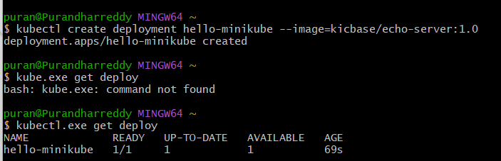

$ kubectl expose deployment hello-minikube --type=NodePort --port=8080

service/hello-minikube exposed

$ minikube service hello-minikube --url

<http://192.168.59.100:31997>

we can use the url to see the deployment

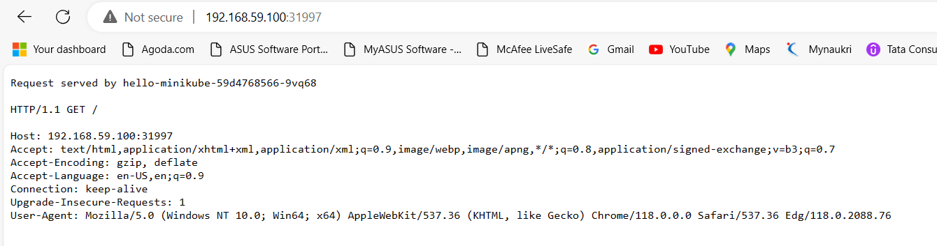

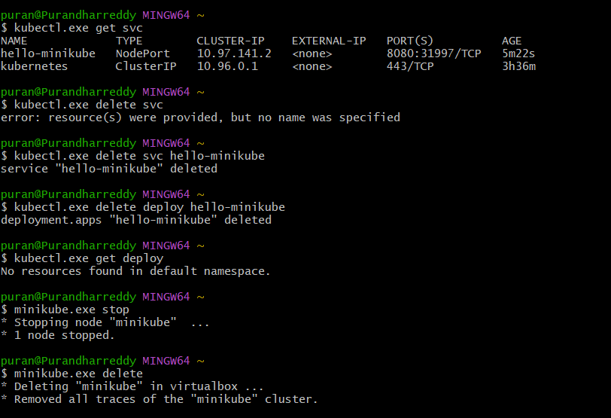

506 minikube start

507 kubectl get nodes -v=10

508 kubectl get node

509 history

510 cat .kube/config

511 kubectl create deployment hello-minikube --image=kicbase/echo-server:1.0

512 kube.exe get deploy 🡪 wrong command

513 kubectl.exe get deploy

514 kubectl expose deployment hello-minikube --type=NodePort --port=8080

518 minikube service hello-minikube –url

519 kubectl.exe get svc

520 kubectl.exe delete svc

521 kubectl.exe delete svc hello-minikube

522 kubectl.exe delete deploy hello-minikube

523 kubectl.exe get deploy

524 minikube.exe stop

525 minikube.exe delete

526 history

499 minikube start --no-vtx-check

500 cat ~/.kube/config

501 kubectl get node

502 kubectl create deployment hello-minikube --image=kicbase/echo-server:1.0

503 kubectl get pod

504 kubectl get deploy

505 kubectl expose deployment hello-minikube --type=NodePort --port=8080

507 minikube service hello-minikube --url

508 history

509 kubectl delete svc hell0-minikube

510 kubectl delete svc hello-minikube

511 kubectl get pod

512 kubectl get deploy

513 kubectl delete deploy hello-minikube

514 kubectl get deploy

515 kubectl get pod

516 minikube delete

518 history

# Setup with Kops (Prerequisites) 🡪 kops for K8s Setup

● Domain for Kubernetes DNS records

○ e:g groophy.in from GoDaddy

● Create a linux VM and setup.

○ kops, kubectl, ssh keys, awscli

● Login to AWS account and setup

○ s3 bucket, IAM User for AWSCli, Route53 Hosted Zone.

* 1. Create a EC2 instance 🡪 kops 🡪( it is not a part of Kubernetes cluster but it is used to execute the Kubernetes cluster)
  2. Create a IAM user🡪 kopsadmin🡪 download the csv file access keys
  3. Route53🡪 host zone🡪create host zone🡪kubevpro.groovy.in(name.domain) 🡪 create

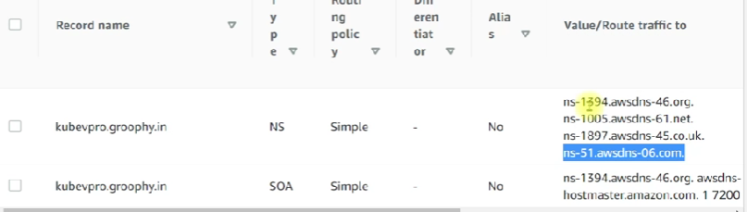

Add this in GO DADDY Account

Records

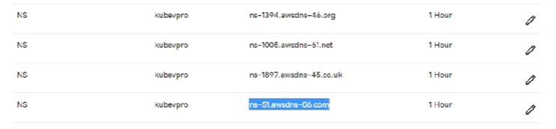

* 1. ssh-keygen
  2. sudo apt update && apt install awsctl -y
  3. sudo apt install awsctl -y
  4. sudo apt install awscli -y
  5. aws configure 🡪 add the access key , region, type=json
  6. curl -LO [https://dl.k8s.io/release/$(curl -L -s https://dl.k8s.io/release/stable.txt)/bin/linux/amd64/kubectl](https://dl.k8s.io/release/$(curl%20-L%20-s%20https://dl.k8s.io/release/stable.txt)/bin/linux/amd64/kubectl)
  7. chmod +x ./kubectl
  8. mkdir -p /usr/local/bin

13 mv kubectl /usr/local/bin/kubectl

14 sudo mv kubectl /usr/local/bin/kubectl

17 kubectl –help

18 kubectl version –client

19 histroy

## Install Kops

Kops 🡪 kubernates operation

[Installing Kubernetes with kOps | Kubernetes](https://kubernetes.io/docs/setup/production-environment/tools/kops/) 🡪 but new version have venerability so going to pervious version

[Releases · kubernetes/kops (github.com)](https://github.com/kubernetes/kops/releases) 🡪 github link to download it

[**v1.26.5**](https://github.com/kubernetes/kops/releases/tag/v1.26.5)

v1.26.4

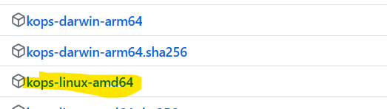

21 wget <https://github.com/kubernetes/kops/releases/download/v1.26.5/kops-linux-amd64>

22 ls

23 chmod +x kops-linux-amd64

24 mv kops-linux-amd64 /usr/local/bin/kops

25 sudo mv kops-linux-amd64 /usr/local/bin/kops

26 kops

27 kops version

28 nslookup -type=ns kubervpro.groophy.in

29 kops create cluster --name=kubevpro --state=s3://vprofile-kop-states --zone=us-east-2a,us-east-1a --node-count=2 --node-size=t3.small --master-size=t3.medium --node-volume-size=8 --master-volume-size=8

30 kops create cluster --name=kubevpro --state=s3://vprofile-kop-states --zone=us-east-1a,us-east-1b --node-count=2 --node-size=t3.small --master-size=t3.medium --node-volume-size=8 --master-volume-size=8

31 history

kops create cluster --help

one of the example:

kops create cluster --name=k8s-cluster.example.com \

--state=s3://my-state-store \

--zones=us-east-1a \

--node-count=2

It is used to create a configuration for the cluster and storage it in the S3 bucket

kops create cluster --name=kubevpro.groophy.in \

--state=s3://vprofile-kop-states --zones=us-east-2a,us-east-2b \

--node-count=2 --node-size=t3.small --master-size=t3.medium \

--dns-zone=kubevpro..groophy.in --node-volume-size=8 --master-volume-size=8

(--node-volume-size=8 --master-volume-size=8 🡪 you need to keep this , if you not mention this you will get lot of bills)

kops create cluster --name="kubevpro.purandhar.shop" --state=s3://puran678 --node-count=2 --zones=us-east-1a,us-east-1b --node-size=t3.small --control-plane-size=t3.medium --dns-zone="kubevpro.purandhar.shop" --node-volume-size=8 --control-plane-volume-size=8

### Update command

When ever you can change a kops configuration then you say kops update 🡪 it will update the changes

kops update cluster --name kubevpro.groophy.in --state=s3://vprofile-kop-states --yes –admin

### validate command

kops validate cluster --name kubevpro.groophy.in --state=s3://vprofile-kop-states

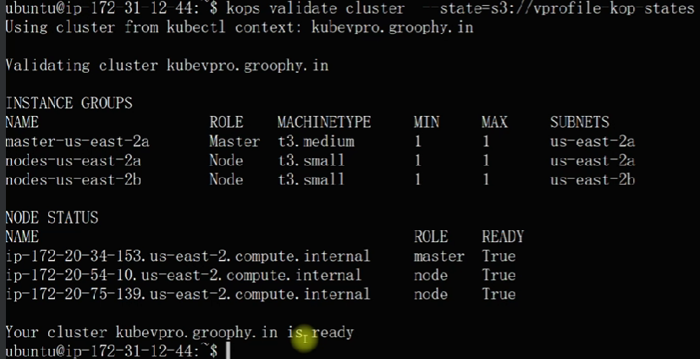

When you create a cluster with kops, kops will create a file for the kubectl command.

That file path will be in the home directory 🡪 cat ~/.kube/config 🡪 this is the file for kubectl

But this file is used by kubectl to connect to the cluster

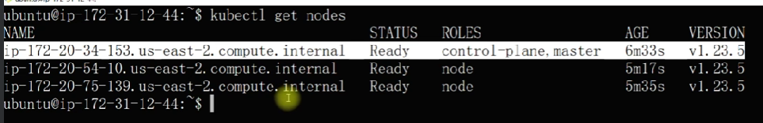

### In AWS side

It will the instances for master and worker nodes, VPC and Route53🡪 dns create for both public and private ip’s

### Delete the cluster command

kops delete cluster --name kubevpro.groophy.in --state=s3://vprofile-kop-states --yes

ubuntu user

1 sudo apt update

2 sudo apt install awscli

3 sudo apt install awscli -y

4 sudo apt search aws

5 sudo apt search awscli

6 sudo -i

7 wget https://github.com/kubernetes/kops/releases/download/v1.28.2/kops-linux-amd64

8 ls

9 chmod +x kops-linux-amd64

10 mv kops-linux-amd64 /usr/local/bin/kops

11 sudo mv kops-linux-amd64 /usr/local/bin/kops

12 nslookup -type=ns kubevpro.purandhar.shop

13 sudo -i

14 kops validate cluster s3://puran678

15 kops delete cluster --name=kubevpro.purandhar.shop --state=s3://puran678

16 kops delete cluster --name=kubevpro.purandhar.shop --state=s3://puran678 --yeas

17 kops delete cluster --name=kubevpro.purandhar.shop --state=s3://puran678 --yes

Root user

2 ls

3 chmod +x ./kubectl

4 mv kubectl /usr/local/bin/

5 kubctl --help

6 kubectl --version

7 kubectl --help

8 apt install awscli -y

9 apt upgrade

10 apt install awscli -y

11 apt install epel-release -y

12 apt search cli

13 apt install aws-cli

14 apt install awscli -y

15 sudo apt install curl unzip -y

16 curl "https://awscli.amazonaws.com/awscli-exe-linux-x86_64.zip" -o "awscliv2.zip"

17 unzip awscliv2.zip

18 sudo ./aws/install

19 aws --version

20 aws s3 ls

21 history

### sudo poweroff

it will stop the EC2 instances

### same commands

kops create cluster --name=kubevpro.groophy.in \

--state=s3://vprofile-kop-states --zones=us-east-2a,us-east-2b \

--node-count=2 --node-size=t3.small --master-size=t3.medium --dns-zone=kubevpro.groophy.in \

--node-volume-size=8 --master-volume-size=8

kops update cluster --name kubevpro.groophy.in --state=s3://vprofile-kop-states --yes --admin

kops delete cluster --name kubevpro.groophy.in --state=s3://vprofile-kop-states --yes –admin

Here is a step-by-step guide to set up a Kubernetes cluster with kOps, summarizing the instructor's instructions:

### Prerequisites

1. **Domain:** You need a domain (e.g., from GoDaddy) to be used for Kubernetes DNS records.
2. **Linux VM:** Use an EC2 instance or a Vagrant VM for setting up kOps, kubectl, SSH keys, and AWS CLI. This VM will not be part of the Kubernetes cluster.
3. **AWS Account:** Ensure you have access to an AWS account to create S3 buckets, IAM users, and Route 53 hosted zones.

### Step-by-Step Guide

#### 1. Launch an EC2 Instance

1. Go to the AWS Management Console.
2. Navigate to the EC2 service and launch a new instance with Ubuntu AMI (Ubuntu 22).
3. Use a t2.micro instance type.
4. Create a new key pair named kops-key.
5. Configure a security group to allow port 22 from your IP.
6. Launch the instance and name it kops.

#### 2. Create S3 Bucket

1. Navigate to S3 in the AWS console.
2. Create a bucket in the same region as your EC2 instance.
3. Name it uniquely (e.g., vprofile-kops-state).

#### 3. Create IAM User and Policy

1. Navigate to IAM in the AWS console.
2. Create a new user named kops-admin with programmatic access.
3. Attach the AdministratorAccess policy to the user.
4. Create and download the access key and secret key for the user.

#### 4. Set Up Route 53 Hosted Zone

1. Navigate to Route 53 in the AWS console.
2. Create a new hosted zone with a subdomain (e.g., kubevpro.groophy.in).
3. Note the NS (Name Server) records provided by Route 53.
4. Log in to your domain registrar (e.g., GoDaddy) and update the NS records to point to the Route 53 NS servers.

#### 5. Configure the EC2 Instance

1. SSH into the EC2 instance.
2. Generate an SSH key: ssh-keygen -f ~/.ssh/id_rsa -N ''.
3. Install AWS CLI:

bash

Copy code

sudo apt update

sudo apt install awscli

1. Configure AWS CLI:

bash

Copy code

aws configure

Enter the access key, secret key, region (us-east-2), and output format (json).

#### 6. Install kubectl and kOps

1. Install kubectl:

bash

Copy code

curl -LO "https://dl.k8s.io/release/$(curl -L -s https://dl.k8s.io/release/stable.txt)/bin/linux/amd64/kubectl"

chmod +x kubectl

sudo mv kubectl /usr/local/bin/

1. Install kOps (version 1.26.4):

bash

Copy code

wget https://github.com/kubernetes/kops/releases/download/v1.26.4/kops-linux-amd64

chmod +x kops-linux-amd64

sudo mv kops-linux-amd64 /usr/local/bin/kops

#### 7. Create the Kubernetes Cluster

1. Run the following command to create the cluster configuration:

bash

Copy code

kops create cluster --name=kubevpro.groophy.in --state=s3://vprofile-kops-state --zones=us-east-2a,us-east-2b --node-count=2 --node-size=t3.small --master-size=t3.medium --dns-zone=kubevpro.groophy.in --node-volume-size=8 --master-volume-size=8

1. Apply the cluster configuration:

bash

Copy code

kops update cluster --name=kubevpro.groophy.in --state=s3://vprofile-kops-state --yes

Wait for about 15 minutes for the cluster to be created.

#### 8. Validate the Cluster

1. Validate the cluster:

bash

Copy code

kops validate cluster --state=s3://vprofile-kops-state

You should see a message indicating the cluster is ready.

1. Check nodes with kubectl:

bash

Copy code

kubectl get nodes

#### 9. Clean Up

1. Delete the cluster:

bash

Copy code

kops delete cluster --name=kubevpro.groophy.in --state=s3://vprofile-kops-state --yes

1. Shut down the EC2 instance:

bash

Copy code

sudo poweroff

### Summary

By following these steps, you will set up a Kubernetes cluster using kOps on AWS. This setup involves preparing your environment, configuring AWS resources, and using kOps to create and manage your Kubernetes cluster. Remember to delete your cluster and shut down resources when not in use to avoid unnecessary charges.

# Kubernetes Objects and documents

### Kubernetes Objects:

For example, container is the objects of docker

Pod:

This is the smallest object that we create in Kubernetes, and container lives inside the pod. We do not touch container; we manage pod and pod in turn manage the containers for us.

### Service:

To have a static endpoint to your pod, like load balancer, we have a EC2 instance.

### Replica set:

To create a cluster of pod or Replica of same pod

Deployment:

which works similar to Replica set, plus you can deploy new image tags by using deployments

it is the most used object as per the devOps (because we are involved in lot of deployments. And deployment object helps to do that)

### config map:

To store our variable and configuration

### Secret:

To store the variable and some information to store , which are not in clear text

### Volume:

Just like EBS volume for EC2 instance, we have the different volumes to attach to our pod.

# Document

One of the best ways is document, always try to read the documents

[Kubernetes Documentation | Kubernetes](https://kubernetes.io/docs/home/)

### introduction

Hello and welcome.

In this video, we will discuss Kubernetes objects and how to use the Kubernetes documentation effectively.

### Understanding Kubernetes Objects

If you're wondering what objects are, think of them in terms of Docker. For example, a container in Docker can be considered an object.

In Kubernetes, we have several key objects:

#### Pod

* **Definition**: The smallest and simplest Kubernetes object.
* **Function**: Containers run inside pods. We don't manage containers directly; instead, we manage pods which, in turn, manage containers.
* **Details**: We'll explore pods in detail in a dedicated lecture.

#### Service

* **Definition**: Provides a stable endpoint to your pod, similar to a load balancer on an EC2 instance.
* **Function**: Facilitates network access to your pods.

#### ReplicaSet

* **Definition**: Ensures a specified number of pod replicas are running at all times.
* **Function**: Helps in maintaining pod clusters.

#### Deployment

* **Definition**: Manages ReplicaSets and provides declarative updates to pods and ReplicaSets.
* **Function**: Allows rolling updates and rollbacks, commonly used in deployment processes.
* **Experience**: From my experience, the deployment object is the most frequently used in DevOps for managing application deployments.

#### ConfigMap

* **Definition**: Stores configuration data in key-value pairs.
* **Function**: Used to inject configuration data into your applications.

#### Secret

* **Definition**: Similar to ConfigMap but designed to store sensitive information.
* **Function**: Stores secrets like passwords and API keys in an encrypted format.

#### Volume

* **Definition**: Provides a way to attach storage to pods.
* **Function**: Similar to EBS volumes for EC2 instances, allowing data persistence across pod restarts.

### Using Kubernetes Documentation

Kubernetes documentation is a crucial resource. It's comprehensive and well-maintained, making it a valuable tool when working with Kubernetes.

#### Example: Pod Documentation

1. **Searching for Pods**: When you search for "Pod" in the documentation, you'll find detailed information about what a pod is and how to use it.
2. **Configuration Examples**: The documentation includes YAML configuration examples that show how to create a pod. This format is similar to Docker Compose.
3. **Commands**: You’ll find commands for managing pods, such as kubectl apply to create a pod from a file or URL.

#### Example: Deployment Documentation

1. **Deployment Use Cases**: The documentation explains when and why to use a Deployment object.
2. **Creating Deployments**: Examples show how to create a Deployment, including configuration files and commands.
3. **Managing Deployments**: Commands like kubectl get deployments and kubectl set image are provided to manage and update deployments.

#### Bookmarking the Documentation

* **Main Page**: The main documentation page includes links to various topics like Kubernetes components, API references, and more.
* **Usage**: I recommend bookmarking this page and regularly referring to it. It will be a valuable resource as you work with Kubernetes.

### Conclusion

Take your time to explore the Kubernetes documentation and familiarize yourself with it. This resource will be indispensable as you continue learning and working with Kubernetes.

Once you're comfortable navigating the documentation, join me in the next lecture where we will dive deeper into these topics.

# Kube config file

## How this kubectl is connecting to the Kubernetes cluster?

Or how does it know where is my master node? And how does it get authenticated and get all that information from the cluster? Or even create information in the cluster?

ANS : answer is kubeconfig file

When we created the cluster by using kops or any other method, when you create a Kubernetes clustes, we get the file called kubeconfig file.

But this file contains that information:

Use kubeconfig files to organize information about

* 1. Clusters
  2. Users -> multiple clusters, multiple users
  3. Namespaces
  4. Authentication mechanisms

## Samplekube.yaml

apiVersion: v1

kind: Config

proxy-url: <https://proxy.host:3128>

clusters:

-cluster: 🡪 (after – space need to be they)

Name: development

Users:

-name: developer

Contexts:

-context:

Name: development

ls -a

pws

ls .kube/

less .kube/config

resource:

pwd

ls -a

ls .kube/

less .kube/config

kubectl config view

<https://kubernetes.io/docs/concepts/configuration/organize-cluster-access-kubeconfig/>

## contexts:

context really marries cluster and user(this cluster use this user)

1. **Current Context**: The current context in your kubeconfig determines which cluster and user "kubectl" uses by default.

If wish we can change the context also my running the ctl command

## Documentation

<https://kubernetes.io/docs/concepts/configuration/organize-cluster-access-kubeconfig/>

cat ~/.kube/config 🡨 in vm , copy to local machine 🡪 vim ~/.kube/config and save it

then you can you use it, in your local machine

kubectl get nodes

Certainly, let's provide a more straightforward explanation of the key points in the text:

1. **Master Node URL**: This is the web address of the central control point of your Kubernetes setup.
2. **API Server Location**: The API server is a component of Kubernetes, and you need to know where it's located.
3. **API Server on Master Node**: The API server is part of the master node, which is the central control unit of your Kubernetes cluster.
4. **Kops Cluster Creation**: When you create a Kubernetes cluster using "kops," it handles important setup tasks for you.
5. **Route 53 Hosted Zone**: In the DNS configuration (Route 53), there's a record created by "kops" that points to the IP address of your master node.
6. **Kubectl Connection**: The "kubectl" tool connects to the API server, which resides on the master node.
7. **Cluster Name**: "api.kubevpro.groophy.in" is essentially the name of your cluster.
8. **Kubeconfig File**: The configuration file, kubeconfig, can store details for multiple clusters and users.
9. **Current Context**: The current context in your kubeconfig determines which cluster and user "kubectl" uses by default.
10. **Context Switching**: You can change the context when running "kubectl" commands to switch between clusters and users.
11. **Documentation Reference**: It's important to refer to the official kubeconfig documentation for more details.
12. **Custom Kubeconfig Location**: You can specify a custom location for your kubeconfig file.
13. **Proxy Server**: If your cluster is behind a proxy server, you can specify its URL.
14. **Kubectl Installation**: Install "kubectl" based on your operating system using the recommended commands.
15. **Using Kubectl**: Once installed, you can use "kubectl" to interact with your Kubernetes cluster from your local machine.
16. **Kubeconfig with Other Tools**: Your kubeconfig file can be used with various tools like Jenkins and Ansible for deploying and managing Kubernetes resources.
17. **Kubeconfig Location**: Keep your kubeconfig file accessible in a location that suits your workflow.

These simplified explanations should help you better understand the content and its significance.

### Understanding Kubeconfig File

When you execute kubectl commands, it connects to the Kubernetes cluster to perform various actions like retrieving information, creating resources, and managing configurations. This connection and authentication process is facilitated by a kubeconfig file.

### Key Points about Kubeconfig File

* **Location**: The kubeconfig file is usually located in the ~/.kube/config directory on the machine from where you manage the Kubernetes cluster.
* **Information Contained**:
  + **Clusters**: Information about one or more clusters.
  + **Users**: Credentials for accessing the clusters.
  + **Contexts**: A context specifies which cluster and user combination to use.
  + **Namespace**: The namespace to work within (optional).

### Anatomy of a Kubeconfig File

Here is a sample structure of a kubeconfig file:

yaml

Copy code

apiVersion: v1

kind: Config

clusters:

- name: example-cluster

cluster:

server: https://api.example.com

certificate-authority-data: REDACTED

users:

- name: example-user

user:

client-certificate-data: REDACTED

client-key-data: REDACTED

contexts:

- name: example-context

context:

cluster: example-cluster

user: example-user

current-context: example-context

* **clusters**: Contains information about the cluster(s), including the server URL and certificate data.
* **users**: Contains the credentials for users, including certificates and keys.
* **contexts**: Binds a user to a cluster, effectively saying "use this user to access this cluster".
* **current-context**: The default context to use when executing kubectl commands, if not specified otherwise.

### Practical Steps

1. **Locate and View Kubeconfig File**:

sh

Copy code

cat ~/.kube/config

1. **Switching Contexts**: You can change the context to use a different cluster or user:

sh

Copy code

kubectl config use-context <context-name>

1. **Viewing Current Configuration**:

sh

Copy code

kubectl config view

1. **Setting Up on a Local Machine**:
   * Install kubectl on your local machine:
     + **Linux**: Follow official documentation
     + **Windows**: Using Chocolatey:

sh

Copy code

choco install kubernetes-cli

* + - **MacOS**: Using Homebrew:

sh

Copy code

brew install kubectl

* + Copy your kubeconfig file to your local machine:

sh

Copy code

scp user@remote:/path/to/kubeconfig ~/.kube/config

* + Verify the setup:

sh

Copy code

kubectl get nodes

### Advanced Usage

* **Multiple Kubeconfig Files**: You can specify a different kubeconfig file using the --kubeconfig flag:

sh

Copy code

kubectl --kubeconfig=/path/to/another/kubeconfig get nodes

* **Merging Kubeconfig Files**: You might want to merge multiple kubeconfig files into one for convenience:

sh

Copy code

KUBECONFIG=~/.kube/config:/path/to/another/kubeconfig kubectl config view --merge --flatten > ~/.kube/config

### Summary

Understanding and managing the kubeconfig file is crucial for interacting with Kubernetes clusters using kubectl. This file contains the necessary configuration, credentials, and context to connect to clusters securely and efficiently. By setting up your kubeconfig file correctly, you can manage Kubernetes clusters from any machine and integrate with various tools and CI/CD pipelines like Jenkins or Ansible.

# Namespace

Group your resource

Namespace is used to group or isolate your resource.

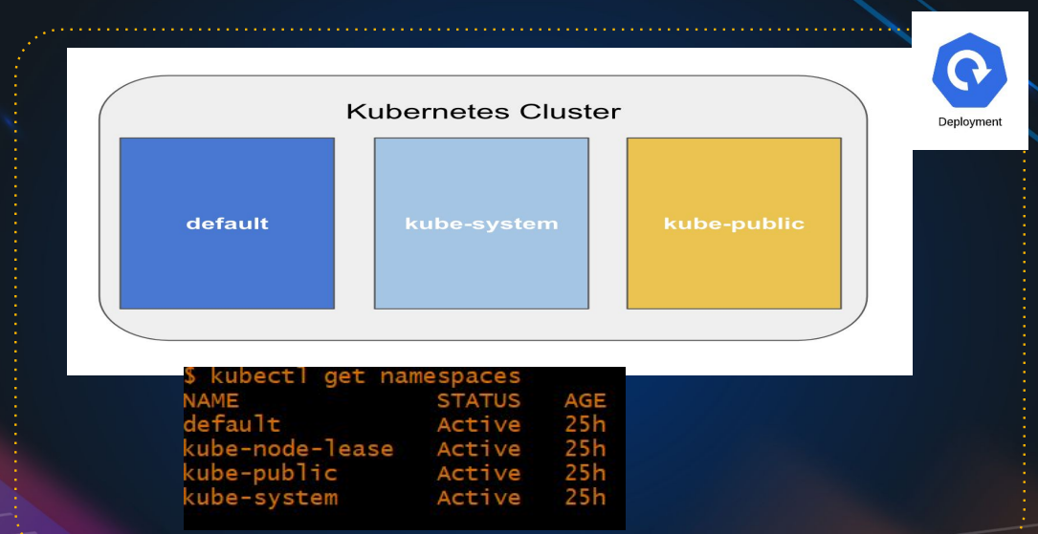

Kubernetes cluster as multiple namespaces, these namespaces will be used to set various kinds of Securities, quotas and few other things with your resources.

Note:

When you create a cluster there name namespaces gets create automatically(default, kube-system, kube-public) , but if you want we can add more namespaces and can select our resource gets our resource gets created in which namespace.

Kubectl get namespace 🡪 to see exiting namespace

Also you create more namespace: like DEV , PROD etc

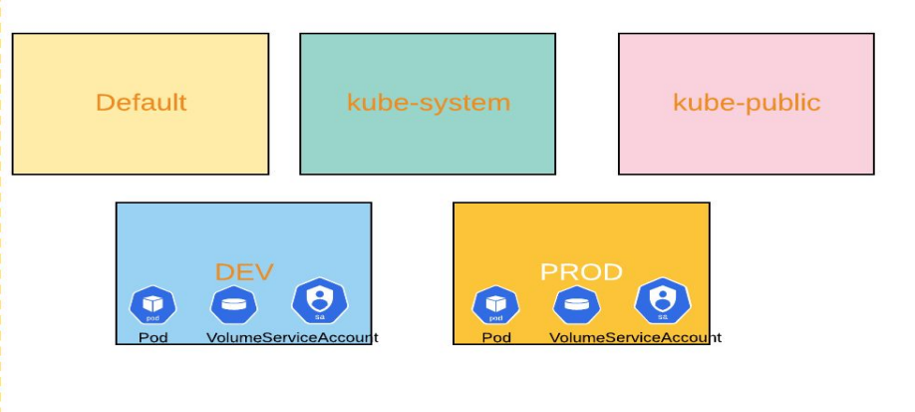

## Resources:

kubectl get ns

kubectl get all

kubectl get all --all-namespaces 🡪 All the resources from all the spaces

clear

kubectl get svc -n kube-system 🡪( svc 🡪 services)

kubectl create ns kubekart

kubectl run nginx1 --image=nginx -n kubekart

kubectl run nginx1 --image=nginx -n kubekart

vim pod1.yaml

cat pod1.yaml

apiVersion: v1

kind: Pod

metadata:

name: nginx12

namespace: kubekart

spec:

containers:

- name: nginx

image: nginx:1.14.2

ports:

- containerPort: 80

kubectl apply -f pod1.yaml

kubectl get pod -n kubekart

kubectl delete ns kubekart

## document:

[Namespaces | Kubernetes](https://kubernetes.io/docs/concepts/overview/working-with-objects/namespaces/)

## Lecture on Kubernetes Namespaces

### Introduction to Namespaces

Namespaces in Kubernetes are a fundamental concept for organizing and isolating resources within a single cluster. They allow for setting various types of securities, quotas, and more, making resource management easier and more efficient.

### Default Namespaces

When you create a Kubernetes cluster, several namespaces are automatically created:

* **default**: The default namespace for objects with no other namespace.
* **kube-system**: Namespace for objects created by the Kubernetes system.
* **kube-public**: Namespace readable by all users, including unauthenticated ones. It is mostly reserved for cluster information.

### Viewing and Creating Namespaces

You can view existing namespaces using the command:

bash

Copy code

kubectl get namespaces

To create a new namespace, you use:

bash

Copy code

kubectl create namespace <namespace-name>

For example, creating a namespace for a development environment can be done as follows:

bash

Copy code

kubectl create namespace dev

### Using Namespaces

When you create resources, you can specify the namespace they should belong to. By default, resources are created in the default namespace unless otherwise specified.

For example:

bash

Copy code

kubectl run nginx --image=nginx --namespace=dev

### Namespaces for Isolation

Namespaces provide isolation within a cluster. For instance, resource names need to be unique within a namespace but not across namespaces. This means you can have two pods with the same name in different namespaces.

### Viewing Resources in Namespaces

To view all resources within a specific namespace:

bash

Copy code

kubectl get all --namespace=<namespace-name>

To view all resources across all namespaces:

bash

Copy code

kubectl get all --all-namespaces

### Specifying Namespace in Configuration Files

When defining resources in YAML configuration files, you can specify the namespace within the metadata section:

yaml

Copy code

apiVersion: v1

kind: Pod

metadata:

name: nginx12

namespace: dev

spec:

containers:

- name: nginx

image: nginx

### Deleting a Namespace

One powerful and potentially dangerous feature is the ability to delete an entire namespace, which removes all resources within it:

bash

Copy code

kubectl delete namespace <namespace-name>

### Best Practices

* **Use namespaces for different environments**: Create separate namespaces for development, staging, and production environments.
* **Isolate projects**: Use namespaces to isolate different projects within the same cluster.
* **Manage resources**: Namespaces help in applying resource quotas and limit ranges to manage resources efficiently.

### Practical Commands

* **Check existing namespaces**:

bash

Copy code

kubectl get namespaces

* **Create a new namespace**:

bash

Copy code

kubectl create namespace mynamespace

* **Run a pod in a specific namespace**:

bash

Copy code

kubectl run nginx --image=nginx --namespace=mynamespace

* **View resources in a specific namespace**:

bash

Copy code

kubectl get all --namespace=mynamespace

* **Delete a namespace**:

bash

Copy code

kubectl delete namespace mynamespace

### Conclusion

Namespaces are a powerful feature in Kubernetes that helps in managing and isolating resources effectively within a cluster. They are essential for organizing large projects and multiple environments and can greatly simplify cluster management.

### Action Items

* Experiment with creating and managing namespaces.
* Review the official Kubernetes documentation on namespaces.
* Practice commands to get comfortable with namespace operations.

Join me in the next lecture, where we'll dive deeper into advanced topics related to Kubernetes resource management.

trol-plane-volume-size=8

52 aws s3 ls

53 kubectl validate

54 kubectl validate cluster --state=s3://puran678

55 kops validate cluster --state=s3://puran678

56 kubectl get nodes

57 kops validate cluster --state=s3://puran678

58 kubectl get nodes

59 cat ~/.kube/config

60 ls

61 vi pod.yaml

62 kubectl apply -f pod.yaml

63 kubectl get pod -n devlopment

64 kubectl delete -n devlopment

65 kubectl delete ns devlopment

Top of Form

# Pods

Run your apps isolated

A container runs inside the pod

PODS

A Pod is the basic execution unit of a Kubernetes application–the smallest and simplest unit in the Kubernetes object model that you create or deploy. A Pod represents processes running on your Cluster.

● Pods that run a single container.

○ The “one-container-per-Pod” model is the most common Kubernetes use case.

○ Pod as a wrapper around a single container,

○ Kubernetes manages the Pods rather than the containers directly.

● Multi Container POD

○ Tightly coupled and need to share resources

○ One Main container and other as a sidecar or init container

○ Each Pod is meant to run a single instance of a given application

○ Should use multiple Pods to scale horizantally.

<https://kubernetes.io/docs/concepts/workloads/pods/pod-overview/>

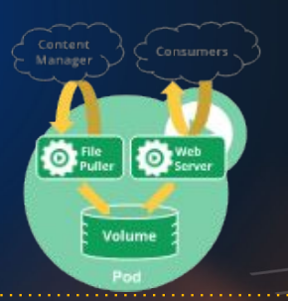

## Definitions file in YAML

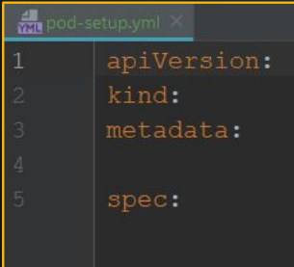

Similar to the docker-compose in docker(which is much more better way to manage the container),

Like that, we can run direct pod workload on the Kubernetes cluster or you can do it in definition file

* + Definition file is most suitable way because then you will have infrastructure as a code – IAC
  + We don’t need to run long commands on you shell, you put every thing in definition file and you run the definition file
  + Definition file as these entries



But we have the other option like

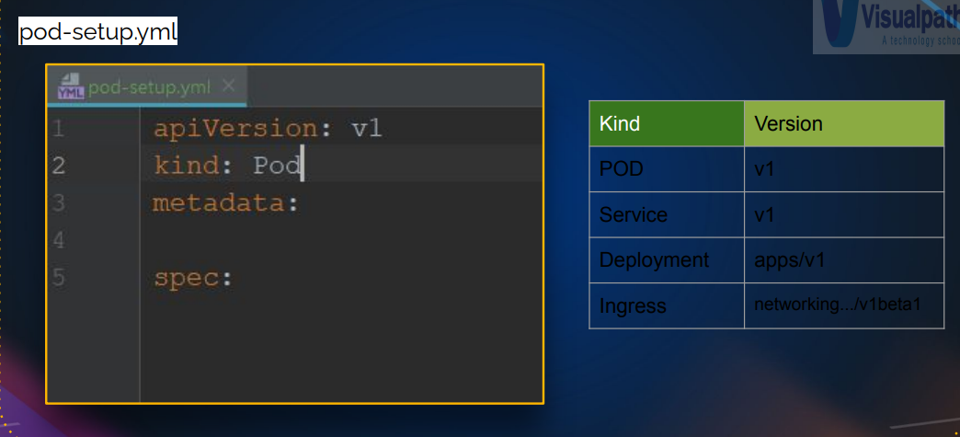

Ex: v1 🡪 stable release (Api, kind)

Metadata 🡪 it has information about the pod, like data about the data 🡪like name of the pod, you can give label, key-value pairs (like tags on AWS)

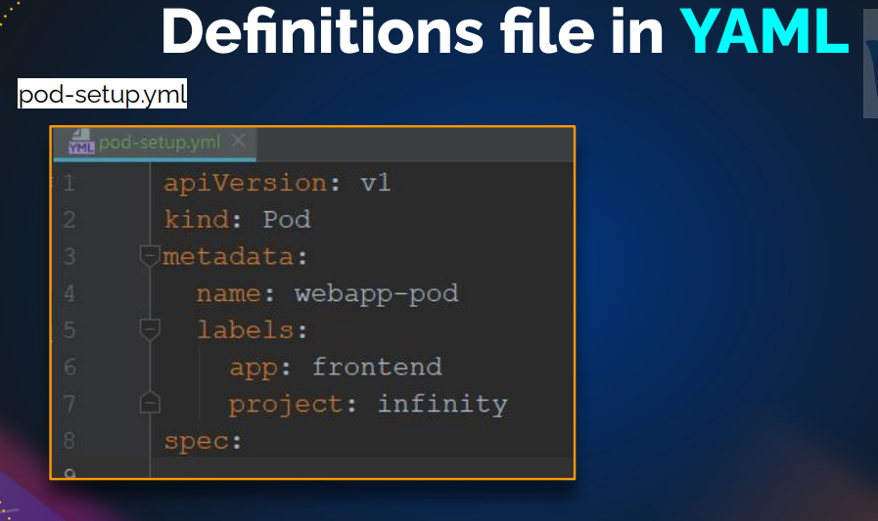

LIKE in python 🡪 YAML

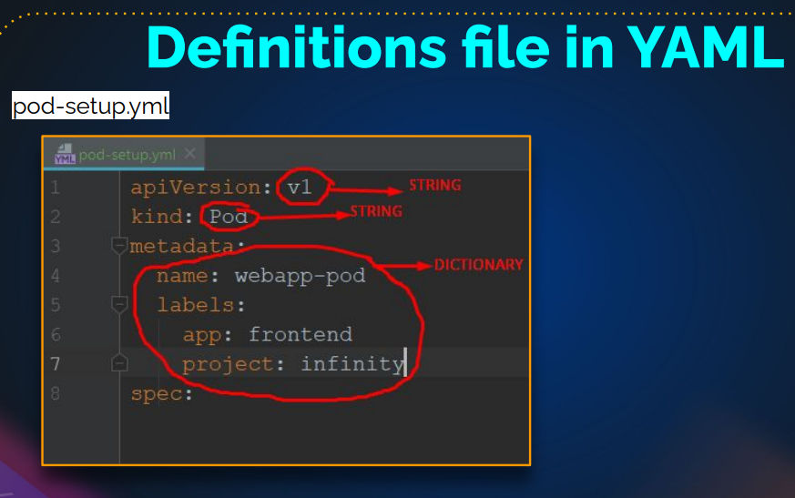

In spec:

We have technical details, container (it is pod definition file)

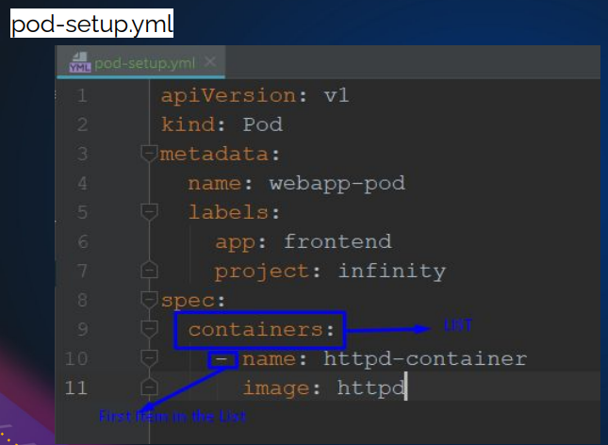

First item in the list

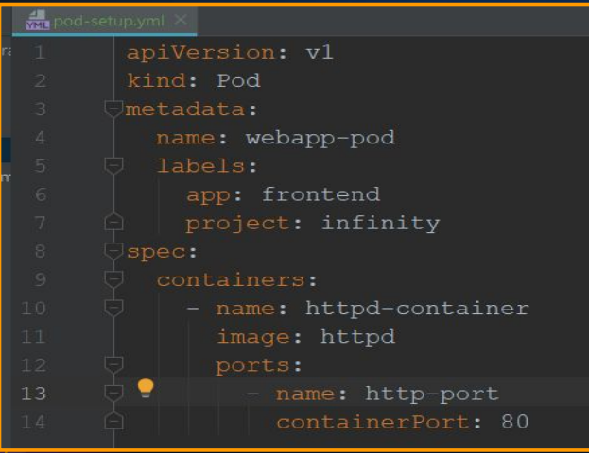

## Create and get POD Info

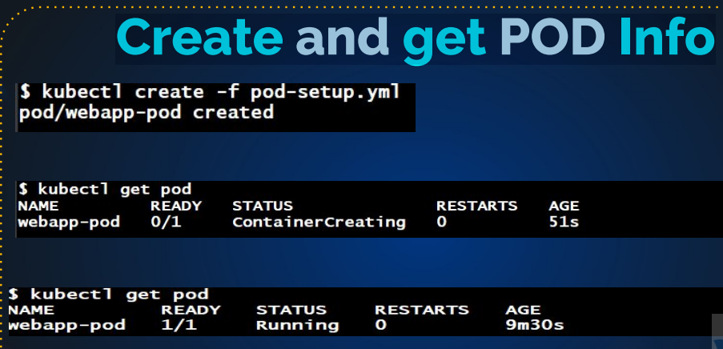

## Detailed POD Info

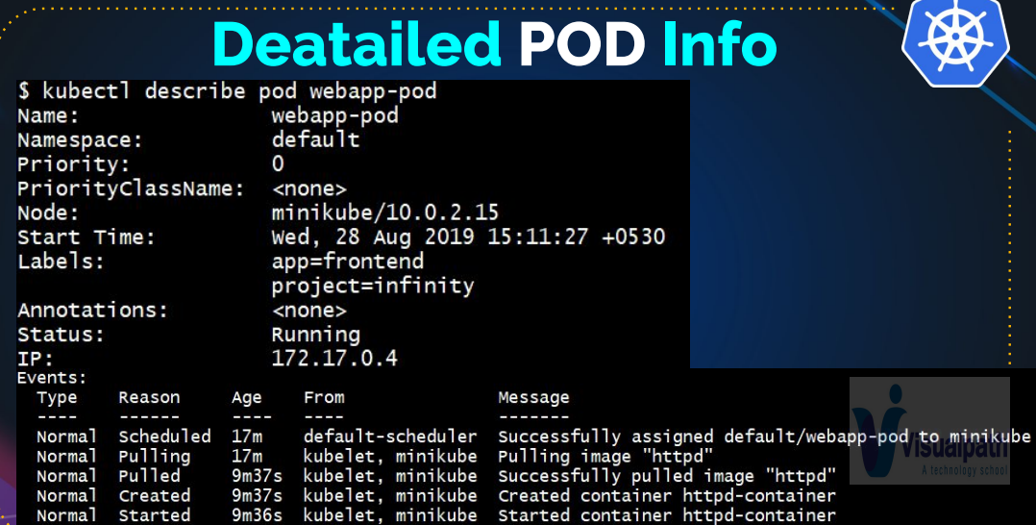

## Get & EDIT POD

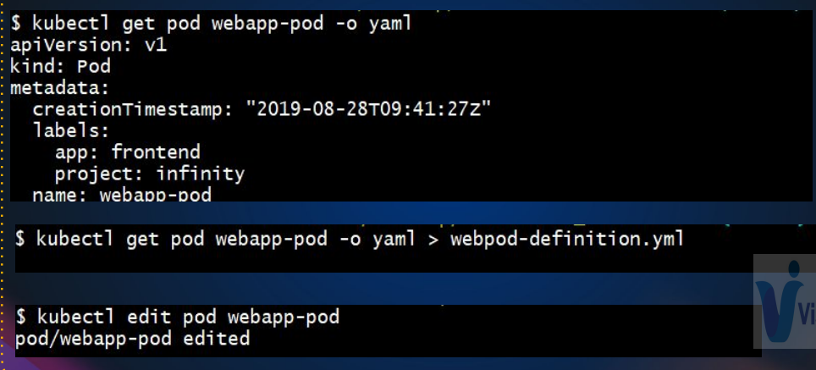

kops create cluster --name=kubevpro.groophy.in \

--state=s3://vprofile-kop-states --zones=us-east-2a,us-east-2b \

--node-count=2 --node-size=t3.small --master-size=t3.medium --dns-zone=kubevpro.groophy.in \

--node-volume-size=8 --master-volume-size=8

kops update cluster --name kubevpro.groophy.in --state=s3://vprofile-kop-states --yes –admin (not included)

kops validate cluster --name kubevpro.groophy.in --state=s3://vprofile-kop-states

kubectl get nodes

ls -a

cat ~./bukeconfig 🡪(information cluster info,context , user info)

kubectl describe node node-name

(node-name= ip-172-20-57-212. Us-east-2.compute.internal)

### You can get above command information in yaml format

Kubectl get node

Kubectl get node node-name= ip-172-20-57-212. Us-east-2.compute.internal -o yaml

* + Good for troubleshooting

### Definition file

mkdir definitions

cd definitions/

mkdir pod

cd pod/

cd prod/

vim vproapppod.yaml

apiVersion: v1

kind: v1

matadata:

name: vproapp

labels:

app: vproapp

spec:

* + Name: appcontainer

Image: imranvisualpath/freshtomapp: v7

Ports:

-name : vproapp-port

containerPort: 8080

kubectl create -f vproapppod.yaml

kubectl get pod

kubectl describe pod vproapp

kubectl get pod

kubectl delete pod vproapp

Sure, let's break down and elaborate on the concepts of pods in Kubernetes, focusing on their creation, management, and usage:

### Understanding Pods

* **Pods**: In Kubernetes, a pod is the smallest and most basic deployable object. It represents a single instance of a running process in your cluster. Each pod contains one or more containers, such as Docker containers.
* **Single-container Pod**: The most common scenario, where a single container runs within a pod.
* **Multi-container Pod**: Contains multiple containers that work closely together, sharing resources like storage and network. Typically, this includes a main application container and one or more helper containers (e.g., sidecars, init containers).

### Key Concepts

1. **Abstraction Layer**:
   * Kubernetes manages pods instead of individual containers. This abstraction helps in managing the lifecycle and resources of the containers collectively.
2. **Horizontal Scaling**:
   * For high availability, multiple instances of pods (each running one or more containers) are deployed and managed horizontally. This means you scale out by adding more pods rather than adding more containers to a single pod.
3. **Definition File (YAML)**:
   * Infrastructure as Code (IaC) is achieved by defining the desired state of your application in a YAML file. This file includes the apiVersion, kind, metadata, and spec.

### YAML File Structure

* **apiVersion**: Specifies the version of the Kubernetes API to use.
* **kind**: Specifies the type of Kubernetes object (e.g., Pod, Service, Deployment).
* **metadata**: Contains data about the object, such as name and labels.
* **spec**: Specifies the desired state, including details about the containers (name, image, ports, etc.).

### Example Pod Definition File

yaml

Copy code

apiVersion: v1

kind: Pod

metadata:

name: vproapp

labels:

app: vproapp

spec:

containers:

- name: appcontainer

image: imranvisualpath/freshtomato:v7

ports:

- name: vproapp-port

containerPort: 8080

### Commands for Pod Management

* **Create a Pod**:

sh

Copy code

kubectl create -f vproapppod.yaml

* **Get Pod Status**:

sh

Copy code

kubectl get pods

* **Describe a Pod**:

sh

Copy code

kubectl describe pod <pod-name>

* **Delete a Pod**:

sh

Copy code

kubectl delete pod <pod-name>

### Real-time Example

1. **Create Directory for Definitions**:

sh

Copy code

mkdir definitions

cd definitions

1. **Create Pod Definition File**:

sh

Copy code

nano vproapppod.yaml

(Paste the YAML content and save the file.)

1. **Create the Pod**:

sh

Copy code

kubectl create -f vproapppod.yaml

1. **Check Pod Status**:

sh

Copy code

kubectl get pods

1. **Describe Pod to See Details**:

sh

Copy code

kubectl describe pod vproapp

1. **Delete the Pod**:

sh

Copy code

kubectl delete pod vproapp

### Additional Information

* **Events for Troubleshooting**:
  + The kubectl describe pod command provides event logs at the end of the output, which are useful for troubleshooting issues related to pod scheduling, image pulling, and container startup.
* **Editing Pods**:
  + Pods are generally immutable, meaning their specifications cannot be changed directly. To make changes, you typically update the YAML file and recreate the pod, or use higher-level objects like Deployments for more flexible management.

Understanding these basics will help you effectively manage your Kubernetes clusters, ensuring that your applications are deployed and run efficiently. The next step involves learning about Kubernetes Services, which handle the networking and exposure of pods to the outside world, including load balancing and service discovery.

# Different levels of logging

In this lecture, we will discuss how to identify and resolve issues with your pods. Despite our best efforts to create and manage everything perfectly, mistakes can still occur. When they do, the first step is to identify the mistake, and the second step is to correct it.

To minimize errors, I recommend running initial tests in your local environment before moving on to testing in a development or production environment. Ensure that setting up a local testing environment is allowed in your project. You can use VMs or other platforms for your local setup.

Even with careful preparation, errors can still happen. To troubleshoot, you can use the 'kubectl get pod' command to check the status of your pods. If you encounter issues like 'ImagePullBackOff' or 'CrashLoopBackOff,' it often indicates a wrong image name. You can use 'kubectl get pod -o wide' to find more information about the image.

If you're still having trouble identifying the problem, you can use 'kubectl describe pod' to access event logs and potentially find the issue. Common errors include failed image pulls, repository access issues, or missing credentials for private registries.

To demonstrate, I intentionally created a mistake by using the wrong image name 'nginox' instead of 'nginx.' We'll fix this by deleting the pod, providing the correct image name, and reapplying it.

When troubleshooting issues like 'BackOff' or multiple restarts, examining the logs can be crucial. You can check the logs using 'kubectl logs [pod name]' to see the output of the container's processes.

In my example, I mistakenly ran a non-existent command, 'test 47,' which caused the container to fail. After deleting the pod, I corrected the command and ran it again, resolving the issue.

This process demonstrates how to identify and fix problems with your pods effectively. It's essential to check the status, use 'kubectl describe pod' for more details, and examine logs when necessary. Editing pods directly is not a common practice and is typically handled through deployments, DaemonSets, or replica sets, which we'll cover in later lessons. I hope you've gained valuable experience in troubleshooting pod issues and learned to test and fix problems effectively.

Certainly, let's break down the content and explain it in more detail.

**1. Introduction to the Lecture:** The lecture begins by introducing the topic: identifying and resolving issues with Kubernetes pods. It acknowledges that despite our best efforts, mistakes can happen when managing Kubernetes resources, and the focus is on learning how to detect and rectify these issues.

**2. Local Environment Testing:** The lecturer suggests a proactive approach to minimize errors. They recommend starting by testing in a local environment before moving to a development or production environment. This ensures that you catch and fix issues early. The mention of checking whether setting up a local environment is allowed in your project emphasizes the importance of following project guidelines.

**3. Identifying Issues in Pods:** The lecturer explains how to identify issues with pods by introducing the 'kubectl get pod' command. They mention that issues like 'ImagePullBackOff' or 'CrashLoopBackOff' often indicate problems with image names. The command 'kubectl get pod -o wide' is suggested to provide more information about the pods' status.

**4. Troubleshooting with 'kubectl describe pod':** If the initial commands don't reveal the issue, the lecturer introduces the 'kubectl describe pod' command. This command can provide details about events related to the pod, which can be invaluable in troubleshooting. The lecture highlights that you can often find the source of the problem in the events.

**5. Common Errors with Images:** The lecture explains that common errors include failed image pulls, issues with repository access, or missing credentials for private registries. These issues may lead to problems with image retrieval.

**6. Demonstrating an Error:** The lecturer demonstrates a mistake by intentionally using the wrong image name 'nginox' instead of 'nginx.' This serves as an example to show how errors can be created and identified.

**7. Fixing the Error:** The lecturer outlines the process of fixing the error. It involves deleting the problematic pod using 'kubectl delete pod,' correcting the command, and then reapplying the pod configuration. The error is resolved by providing the correct image name.

**8. Importance of Logs:** The lecture underscores the importance of examining logs when troubleshooting issues. Logs can provide insights into the execution of commands or processes within containers. In this case, a mistaken command 'test 47' is shown to have caused the error, which is detected through the logs.

**9. Pod Editing and Best Practices:** The lecture concludes by explaining that editing pods directly is not common practice. Instead, resources like deployments, DaemonSets, or replica sets are used for managing pods, and this will be covered in future lessons. This underscores the best practices for managing Kubernetes resources.

**10. Encouragement to Learn through Practice:** The lecturer encourages the audience to gain experience by testing and intentionally causing issues, followed by fixing them. Learning through practice and hands-on experience is highlighted as a valuable way to become proficient in troubleshooting Kubernetes pods.

In summary, this lecture aims to teach how to identify and resolve issues with Kubernetes pods, emphasizing the importance of testing in a controlled environment, checking pod status, using 'kubectl describe pod' for in-depth information, examining logs, and following best practices for managing Kubernetes resources.

# Create a faulty pod

vim pod2.yaml

apiVersion: v1

kind: Pod

metadata:

name: nginx12

spec:

containers:

- name: nginx

image: nginox:1.14.2

ports:

- containerPort: 80

kubectl apply -f pod2.yaml

# Find the problem

kubectl get pod

kubectl get pod -o wide

kubectl get pod nginx12 -o yaml

kubectl describe pod nginx12

clear

ls

# Fix it

vim pod2.yaml

apiVersion: v1

kind: Pod

metadata:

name: nginx12

spec:

containers:

- name: nginx

image: nginix:1.14.2

ports:

- containerPort: 80

kubectl apply -f pod2.yaml

# Create one more faulty pod

kubectl run web2 --image=nginx test47

# Find the problem

kubectl get pod

kubectl get pod web2 -o wide

kubectl get pod web2 -o yaml

kubectl get pod

kubectl describe pod web2

clear

kubectl logs web2

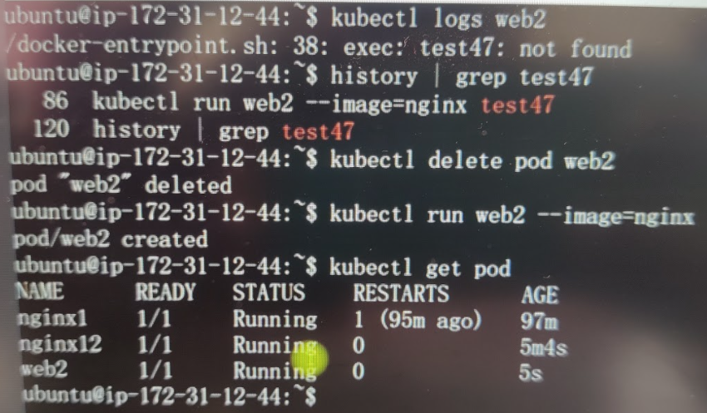

# Fix the problem

kubectl delete pod web2

kubectl run web2 --image=nginx

kubectl get pod

## Lecture: Finding Issues with Your Pods in Kubernetes

### Introduction

Welcome to today's lecture on finding issues with your pods in Kubernetes. While we strive to manage everything perfectly, mistakes happen. The key to resolving these issues involves two steps: identifying the mistake and fixing it.

### Minimize Mistakes: Use Local Environment

To minimize mistakes, I recommend running your setup in a local environment before deploying it to production. Here's how I approach it:

1. **Local Environment Setup:** Test everything locally.
2. **Testing Environments:** Deploy to test or dev environments.
3. **Production Deployment:** Finally, deploy to the production environment.

Ensure your project allows for a local setup, which you can do on VMs, instances, or wherever feasible.

### Common Pod Issues and Troubleshooting Steps

Let's explore how to identify and fix common issues with your pods.

#### Checking Pod Status

Start by checking the status of your pods using kubectl get pod. For example, you might see:

arduino

Copy code

kubectl get pod

Output:

sql

Copy code

NAME STATUS

nginx-1 Running

nginx-12 ImagePullBackOff

web-2 CrashLoopBackOff

Here, nginx-12 is in ImagePullBackOff status, and web-2 is in CrashLoopBackOff status.

#### Investigating ImagePullBackOff Error

This error often indicates an issue with the image name. Use the following commands to investigate further:

1. **Check Pod Details:**

arduino

Copy code

kubectl get pod nginx-12 -o wide

1. **Get Pod YAML:**

arduino

Copy code

kubectl get pod nginx-12 -o yaml

Look for the image name in the YAML output:

arduino

Copy code

image: ngnox

The wrong image name (ngnox instead of nginx) is the issue.

1. **Describe the Pod:**

sql

Copy code

kubectl describe pod nginx-12

In the events section, you'll see:

arduino

Copy code

Failed to pull image "ngnox": repository does not exist or may require authorization.

#### Fixing the Image Name

To fix the issue:

1. **Delete the Pod:**

arduino

Copy code

kubectl delete pod nginx-12

1. **Correct the YAML and Reapply:**

Update the image name to nginx and apply it:

Copy code

kubectl apply -f pod-2.yaml

Verify the fix:

arduino

Copy code

kubectl get pod

### Investigating CrashLoopBackOff Error

When a pod is in CrashLoopBackOff, it means the container is crashing and restarting repeatedly. Here's how to diagnose it:

1. **Check Pod Details:**

arduino

Copy code

kubectl get pod web-2 -o wide

1. **Get Pod YAML:**

arduino

Copy code

kubectl get pod web-2 -o yaml

1. **Describe the Pod:**

sql

Copy code

kubectl describe pod web-2

If the above steps don’t provide enough information, check the logs:

1. **Check Pod Logs:**

Copy code

kubectl logs web-2

The logs might show an error like:

bash

Copy code

exec: "test-47": executable file not found in $PATH

#### Fixing the Command Error

To resolve this:

1. **Delete the Pod:**

arduino

Copy code

kubectl delete pod web-2

1. **Correct the Command and Reapply:**

Remove the incorrect command (test-47) and run the pod again:

arduino

Copy code

kubectl run web-2 --image=nginx

Verify the fix:

arduino

Copy code

kubectl get pod

### Conclusion

By following these steps, you can efficiently identify and resolve issues with your pods:

1. Check the status with kubectl get pod.
2. Use -o wide, -o yaml, and describe commands to gather more information.
3. Check logs with kubectl logs.
4. Delete and reapply the corrected configuration.

Practice these steps to gain confidence in troubleshooting pod issues. In the next lecture, we will discuss how to manage credentials for private registries and other advanced topics.

# Service

Connect with or To your POD

Way to expose an application running on a set of Pods as a . network service. Similar to Load Balancers

If you want to expose you pod , the application running in the pod as a network service like you want to host NIGINX or TOMCAT to frontend or backends , you need to use service with your pod then ,

Service is Similar to Load Balancers like ELB in AWS

## Note:

It just like a loadbalancer and you want to expose you pod to communicating with each other, you need service in front of your pod.

## Why was service created? Why not just a port mapping?

We known pod are disposable, you want to make a change🡪we give different container image name, then we need to create a different pod (when we are making change, upgrade the image🡪 we need to replace the pod)

So pod are mortal/(so they ip is not static) 🡪 we need something static like endpoint

So service gives that endpoint like what ELB does in EC2(ELB gives the static endpoint so that we can access eleactic load balancer behind the change we can keep deleting/creatind EC2 instances).

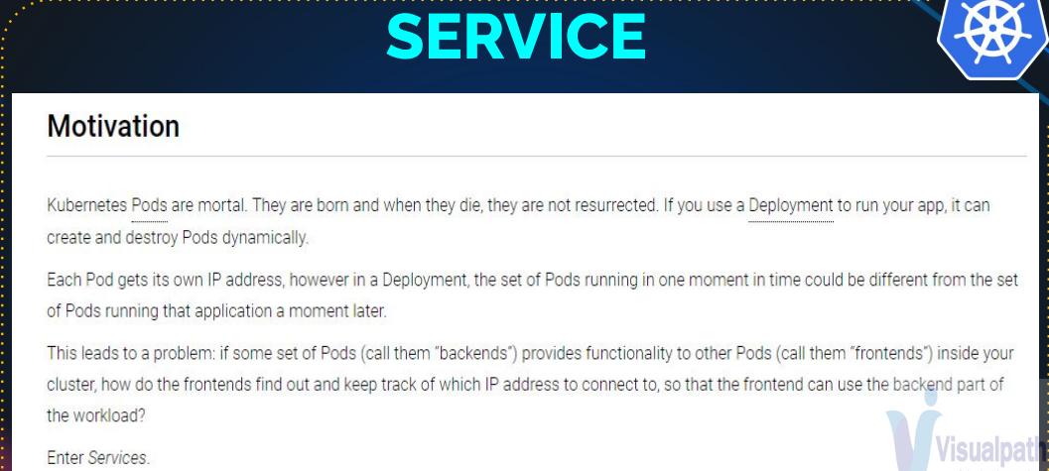

## Types of service:

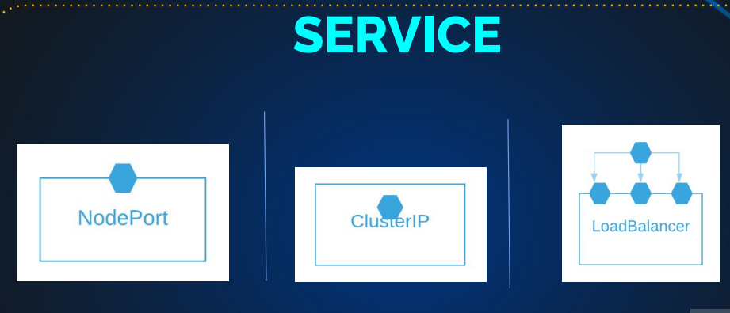

### Nodeport

It is similar to port mapping , we have seen in docker 🡪 host port you pickup and map it your container port 🡪 mostly it used for non-prod(it is not exposing the frontend to the production)

Only to expose pod to outside network, that’s we use node port

### Cluster ip

Cluster IP for internal communication 🡪 so they is no port mapped to your node 🡪internal communication

### Load balancers

It is again to expose outside network for production use cases, we are running tomcat pod, I want users from the internet to access that, I will create a service of type load balancer( on aws it create a actually an ELB and mapp my pod to it)

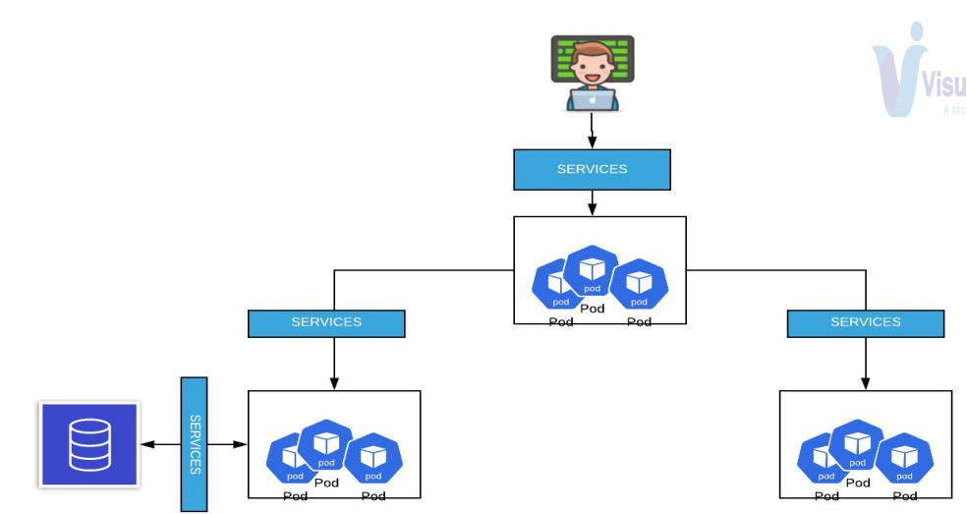

Every pod or cluster of pod that they are running, you need service in front of that , if it is providing a network,

Like frontend🡪 we have a service

Backend🡪 we have a service

Db 🡪 we have service

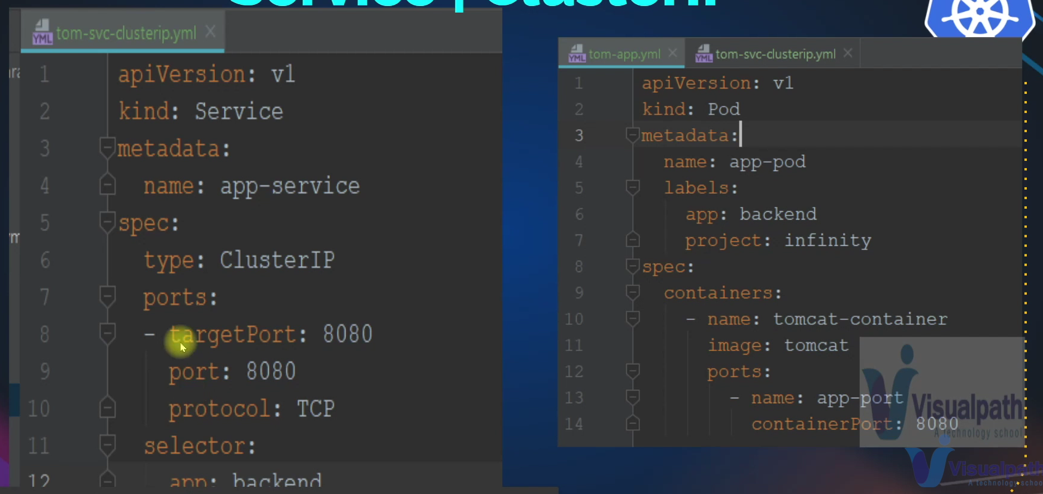

In Kubernetes, a "Service" is a crucial component that allows you to expose the applications running in your pods as network services, making them accessible to other parts of your cluster and potentially the external world. Services play a significant role in ensuring that your applications are available, discoverable, and reliable.

There are three primary types of services in Kubernetes: NodePort, ClusterIP, and LoadBalancer. Each type serves different purposes and offers various capabilities.

1. **NodePort**:
   * NodePort is a type of service that allows you to expose your application on a specific port on each of your worker nodes. This means that your application becomes accessible from outside the cluster on all nodes.
   * For instance, if you have an application running in a pod, you can create a NodePort service to make this application accessible to external clients.
   * The service will have both an internal port (the port at which the service is accessible inside the cluster) and an external port (the port at which it's accessible from external clients).
2. **ClusterIP**:
   * ClusterIP services are primarily used for internal communication within your Kubernetes cluster. These services are not exposed outside the cluster and are meant for communication between different parts of your application or between different applications in the same cluster.
   * For example, if you have a frontend application that needs to communicate with a backend service like a database, you can create a ClusterIP service for the database to facilitate this internal communication.
3. **LoadBalancer**:
   * The LoadBalancer service type is designed for production use cases where you want to expose your application to the external world, typically via a cloud provider's load balancer service.
   * When you create a LoadBalancer service, Kubernetes interacts with your cloud provider to provision a load balancer. This load balancer distributes traffic to your application across multiple pods to ensure high availability and scalability.
   * For example, if you're running a web application in your cluster and you want users from the internet to access it, you can create a LoadBalancer service. In this case, the load balancer provides a stable endpoint for external access.

When you define a service in Kubernetes, you specify its type in the service's YAML definition file. This file includes details about the ports, labels, and other settings for the service.

* **Port Mapping**: You specify the ports on which your service will listen. For NodePort and LoadBalancer services, you define an external port (for external access) and an internal port (for communication within the cluster).
* **Label Selectors**: You use label selectors to specify which pods the service should route traffic to. This ensures that requests are directed to the appropriate pods.
* **NodePort Range**: NodePort services use a specified range of port numbers on the worker nodes to accept traffic from outside the cluster. By default, NodePort numbers range from 30000 to 32767.
* **Load Balancer**: The LoadBalancer service type provisions an external load balancer (such as an AWS Elastic Load Balancer) to distribute traffic to your pods.

It's important to note that when you delete a service, Kubernetes also removes associated resources. For example, if you delete a LoadBalancer service, it will also remove the external load balancer provisioned for it.

In summary, services in Kubernetes provide an essential abstraction for routing and managing network traffic to your pods. They enable your applications to communicate both within the cluster and with external users, ensuring high availability and scalability. The choice of service type depends on your specific use case and requirements.

# Understanding Kubernetes Services

## Overview

In Kubernetes, a Service is an abstraction that defines a logical set of Pods and a policy by which to access them. Services provide a way to expose your application running in a Pod, making it accessible to other Pods within the cluster or to external clients. Services are crucial for enabling communication between different components of an application and for exposing the application to the outside world.

### Why Use Services?

1. **Pods Are Ephemeral**: Pods can be created and destroyed frequently, leading to changing IP addresses. A Service provides a stable IP address and DNS name for accessing the Pods, regardless of changes in Pod IPs.
2. **Load Balancing**: Services can distribute traffic across multiple Pods, similar to how load balancers like AWS ELB distribute traffic across EC2 instances.
3. **Internal and External Access**: Services enable internal communication within the cluster and can also expose applications to external users.

## Types of Services

### 1. NodePort

* **Use Case**: Primarily for development and testing, not recommended for production.
* **Functionality**: Exposes the Service on a static port on each Node's IP address.
* **How It Works**:
  + A node port is selected (30000-32767 by default).
  + Traffic coming to the node on this port is forwarded to the Service.
  + Example Definition:

yaml

Copy code

apiVersion: v1

kind: Service

metadata:

name: my-service

spec:

type: NodePort

selector:

app: MyApp

ports:

- protocol: TCP

port: 80 # Internal Cluster IP port

targetPort: 80 # Container port

nodePort: 30001 # External node port

### 2. ClusterIP

* **Use Case**: Internal communication within the cluster.
* **Functionality**: Exposes the Service on a cluster-internal IP. This makes the Service only reachable from within the cluster.
* **How It Works**:
  + No external access.
  + Used for inter-Pod communication.
  + Example Definition:

yaml

Copy code

apiVersion: v1

kind: Service

metadata:

name: my-service

spec:

type: ClusterIP

selector:

app: MyApp

ports:

- protocol: TCP

port: 80 # Internal Cluster IP port

targetPort: 80 # Container port

### 3. LoadBalancer

* **Use Case**: Exposing the Service to the external world, suitable for production.
* **Functionality**: Provisions an external load balancer (e.g., AWS ELB) and exposes the Service via this load balancer.
* **How It Works**:
  + A load balancer is created and assigned a public IP.
  + The load balancer forwards traffic to the Service.
  + Example Definition:

yaml

Copy code

apiVersion: v1

kind: Service

metadata:

name: my-service

spec:

type: LoadBalancer

selector:

app: MyApp

ports:

- protocol: TCP

port: 80 # External load balancer port

targetPort: 80 # Container port

## Service Example: NodePort

### Service Definition

yaml

Copy code

apiVersion: v1

kind: Service

metadata:

name: vproapp-nodeport

spec:

type: NodePort

selector:

app: vproapp

ports:

- port: 80

nodePort: 30001

targetPort: 8080

protocol: TCP

### Create the Service

sh

Copy code

kubectl create -f vproapp-nodeport.yaml

### Verify the Service

sh

Copy code

kubectl get svc

### Access the Service

* **External Access**: http://<NodeIP>:30001

## Service Example: LoadBalancer

### Service Definition

yaml

Copy code

apiVersion: v1

kind: Service

metadata:

name: vproapp-loadbalancer

spec:

type: LoadBalancer

selector:

app: vproapp

ports:

- port: 80

targetPort: 8080

protocol: TCP

### Create the Service

sh

Copy code

kubectl create -f vproapp-loadbalancer.yaml

### Verify the Service

sh

Copy code

kubectl get svc

### Access the Service

* **External Access**: http://<LoadBalancerIP>:80

## Conclusion

Services in Kubernetes are essential for enabling stable networking, load balancing, and ensuring that your application is accessible as required. Whether you are exposing your application internally within the cluster or to external users, Services provide a robust mechanism to achieve these goals.

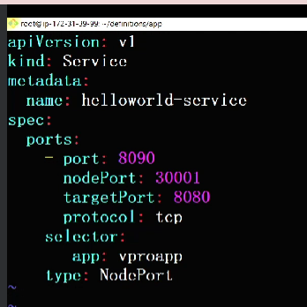 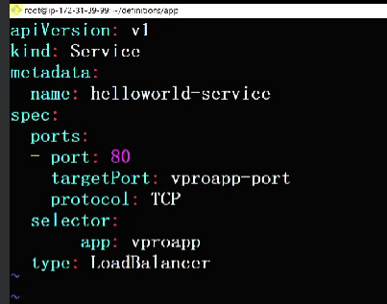

nodePort

clusterIP🡪port (if you using type as . loadblancer then this port indicates LB)

Container🡪targetPort

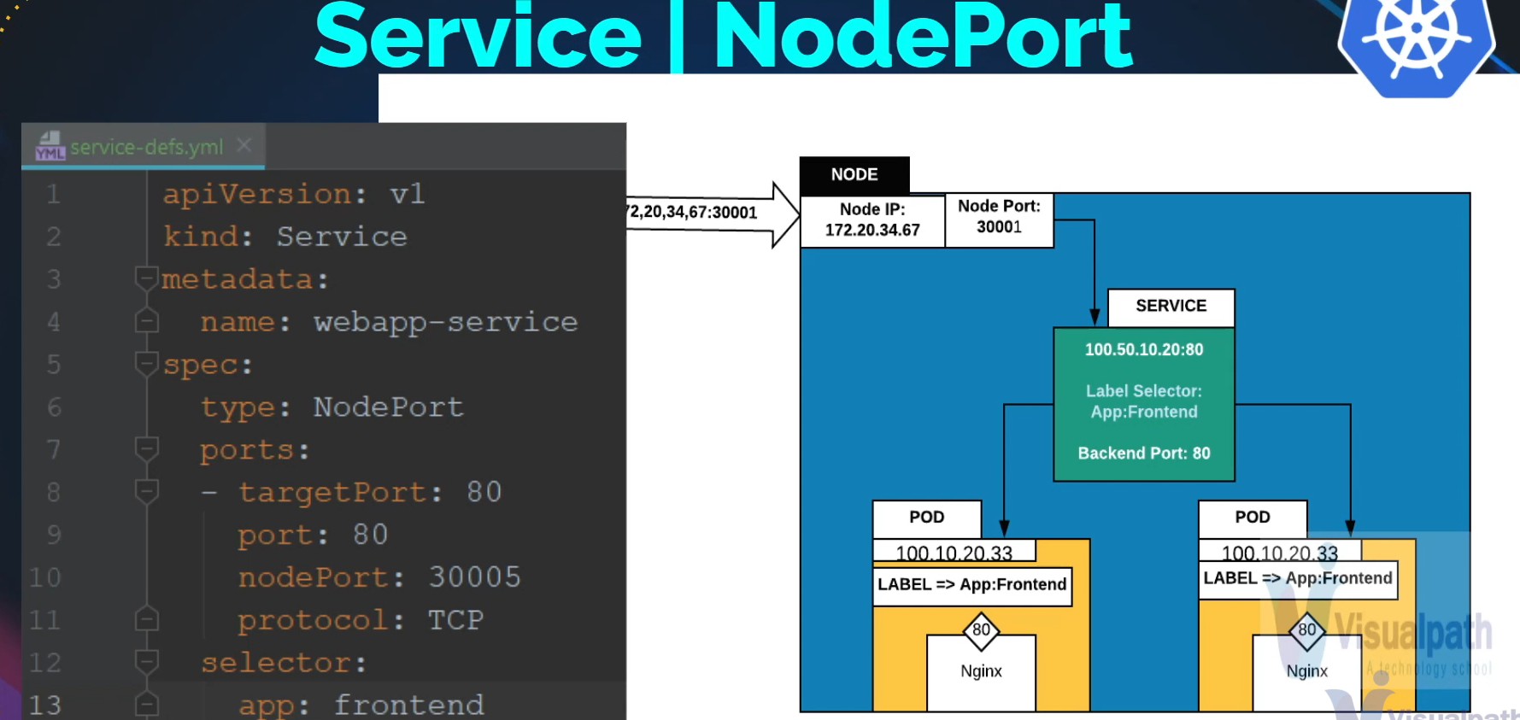 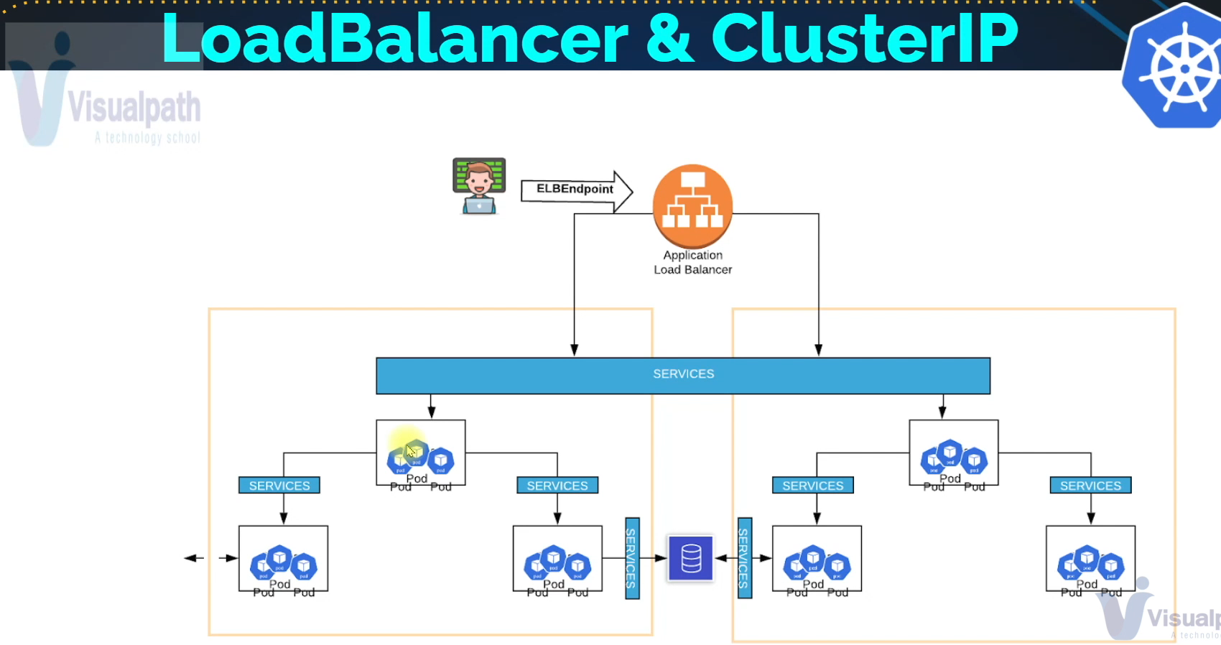

# ReplicaSet

Maintain Pod Replica

## Why do we really need ReplicaSet?

We have prod running from the node and user are accessing it, some reasons prod goes down, user won’t be able to access the service🡪 then someone needs to login delete the prod, recreate it/fix it. It can overcome with ReplicaSet.

If your pod is running with replicaSet , Replicaset objects you mention, this are the prod I want to run(this many replica’s I want to run to pod). replicaSet will do for you, if any pod crashes, it will create a new pod for you.

Replica’s for 🡪 scaling, you can add more pod into it, remove pod’s

"When I mention Replica, it doesn't have to be many. Just one will do—Replica One, to be specific. Why use ReplicaSet? For health checks.

If your pad goes down, ReplicaSet automatically recreates it, sparing you from manual work. The best part? Replicas scheduler spreads your pods across worker nodes. So, if a node crashes, pods on it can be recreated on healthy nodes. Without ReplicaSet, a pod on a crashed node is the end of the story. But with ReplicaSet, it recreates the pod for you. Now, let's dive into the documentation. It aims to maintain a stable set of Replica pods for guaranteed availability of a specified number of identical parts."

## Document

<https://kubernetes.io/docs/concepts/workloads/controllers/replicaset/>

login to kops instances or kubectl is they

vim replica.yaml

**apiVersion**: apps/v1

**kind**: ReplicaSet

**metadata**:

**name**: frontend

**labels**: # labels for filtering

**app**: guestbook

**tier**: frontend

**spec**:

*# modify replicas according to your case*

**replicas**: 3

**selector**:

**matchLabels**:

**tier**: frontend

**template**:

**metadata**:

**labels**:

**tier**: frontend

**spec**:

**containers**:

- **name**: php-redis

**image**: gcr.io/google_samples/gb-frontend:v3

kubectl create -f replica.yaml

kubectl get rs

kubectl get pod

kubectl delete frontend-1 frontend-2

kubectl get pod

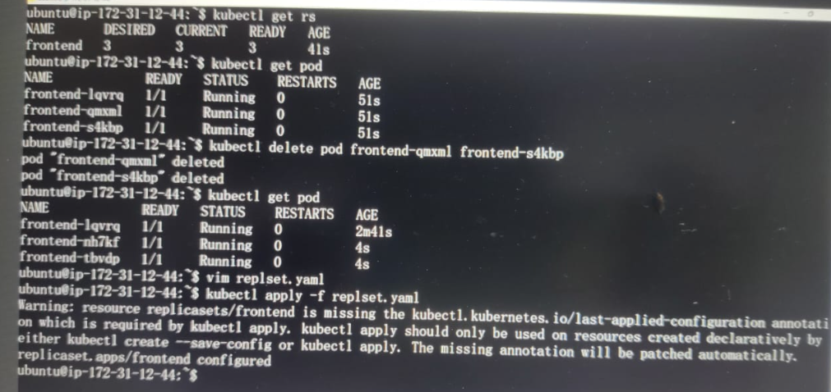

## Though command line (imperative way)

Kubectl scale –-replicas=1 rs/frontend

## Other way

Kubectl edit rs frontend

## Document for cheat sheet

<https://kubernetes.io/docs/reference/kubectl/cheatsheet/>

to remove pods, first you need to remove replica set

kubectl delete rs frontend

A **ReplicaSet** in Kubernetes is a fundamental component that ensures a specified number of pod replicas are running at any given time. Here’s a detailed breakdown of what a ReplicaSet is, its importance, and how it operates:

### What is a ReplicaSet?

A **ReplicaSet** is a Kubernetes resource defined by a YAML configuration file. It is responsible for maintaining a stable set of replica pods, ensuring that the desired number of pod instances are always running.

### Key Concepts:

* **Pod:** The smallest and simplest Kubernetes object. A pod represents a single instance of a running process in your cluster.
* **Replica:** An exact copy of a pod.

### Why Do We Need a ReplicaSet?

1. **Automatic Recovery:** If a pod crashes or a node fails, the ReplicaSet ensures that new pods are created to replace the ones that were lost. This automation provides resilience and ensures continuous availability of the application.
2. **Scaling:** ReplicaSets allow for easy scaling of applications by simply specifying the desired number of replicas. You can scale up (increase the number of replicas) or scale down (decrease the number of replicas) based on demand.
3. **Load Distribution:** When multiple replicas are running, Kubernetes can distribute the load across different nodes, enhancing the application’s performance and reliability.

### How Does a ReplicaSet Work?

1. **Definition File:**
   * The ReplicaSet is defined in a YAML file. This file includes metadata, the desired number of replicas, and a template for the pods that the ReplicaSet should manage.

yaml

Copy code

apiVersion: apps/v1

kind: ReplicaSet

metadata:

name: frontend

spec:

replicas: 3

selector:

matchLabels:

tier: frontend

template:

metadata:

labels:

tier: frontend

spec:

containers:

- name: frontend

image: nginx

1. **Selector:**
   * The selector field matches pods with specified labels. This is how the ReplicaSet identifies which pods it should manage.
2. **Template:**
   * The pod template section specifies the configuration of the pods that the ReplicaSet will create, including the container image, resources, and other necessary specifications.

### Practical Use:

1. **Creating a ReplicaSet:**
   * Save the YAML configuration to a file, for example, replica.yaml.
   * Apply the configuration using kubectl:

sh

Copy code

kubectl apply -f replica.yaml

1. **Checking ReplicaSet Status:**
   * Verify the status of the ReplicaSet and its pods:

sh

Copy code

kubectl get rs

kubectl get pods

1. **Scaling a ReplicaSet:**
   * Update the replica count in the YAML file and reapply it:

sh

Copy code

kubectl apply -f replica.yaml

* + Alternatively, scale using the kubectl scale command:

sh

Copy code

kubectl scale --replicas=5 rs/frontend

1. **Editing a ReplicaSet:**
   * Directly edit the ReplicaSet configuration:

sh

Copy code

kubectl edit rs frontend

1. **Deleting a ReplicaSet:**
   * To delete the ReplicaSet and its managed pods:

sh

Copy code

kubectl delete rs frontend

### Summary

A **ReplicaSet** is a crucial Kubernetes resource that ensures your application remains available and can handle increased load by maintaining the specified number of pod replicas. It automates the recovery of pods and simplifies scaling, making it easier to manage containerized applications in a Kubernetes cluster.

# Deployment

🡪Upgrade, Rollback and changes Gracefully

● A Deployment controller provides declarative updates for Pods and ReplicaSets.

● Define desired state in a Deployment, and the Deployment controller changes the actual state to the desired state at a controlled rate.

● Deployment creates ReplicaSet to manage number of PODS

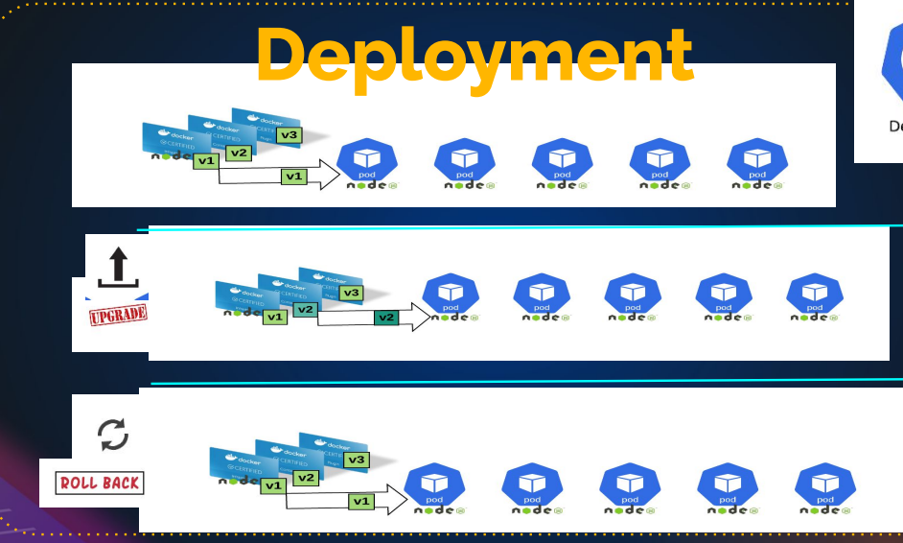

If you say your image tag is V1 and you want to upgrade in V2 (you can mention in deployment that I want to upgrade V2 in deployment) and something goes wrong we can easily rollback.

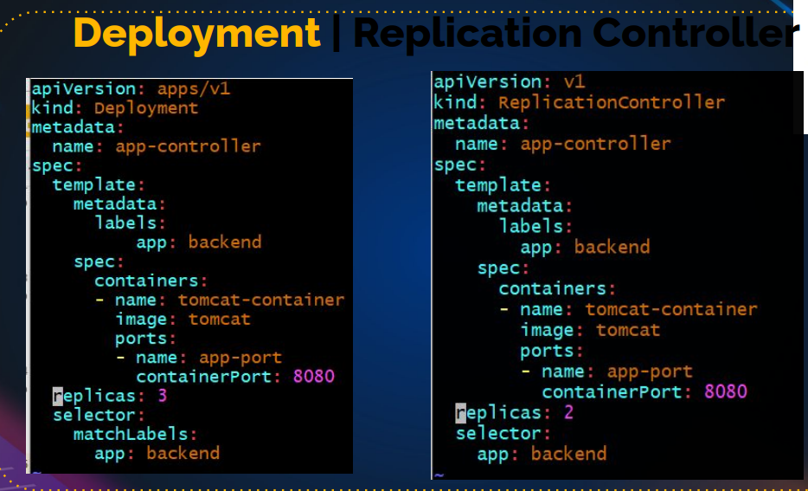

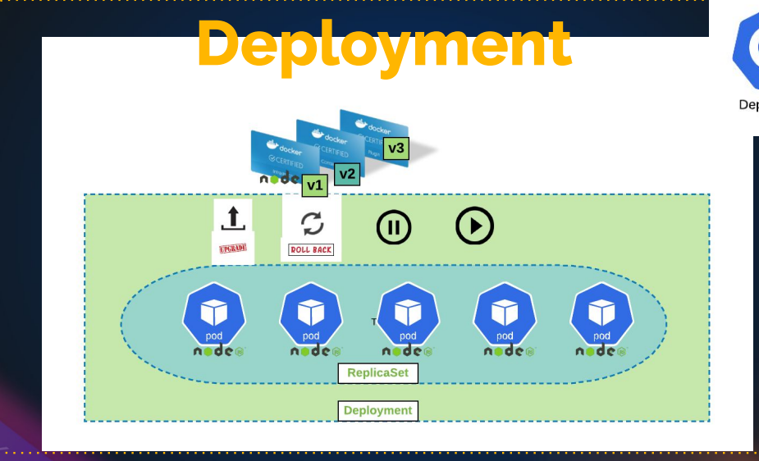

## Document

<https://kubernetes.io/docs/concepts/workloads/controllers/deployment/>

vim deployment.yaml

**apiVersion**: apps/v1

**kind**: Deployment

**metadata**:

**name**: nginx-deployment

**labels**:

**app**: nginx

**spec**:

**replicas**: 3

**selector**:

**matchLabels**:

**app**: nginx

**template**:

**metadata**:

**labels**:

**app**: nginx

**spec**:

**containers**:

- **name**: nginx

**image**: nginx:1.14.2

**ports**:

- **containerPort**: 80

Kubectl apply -f deployment.yaml

Kubectl get deploy

Kubectl get rs

Kubectl get pod

Kubectl describe pod

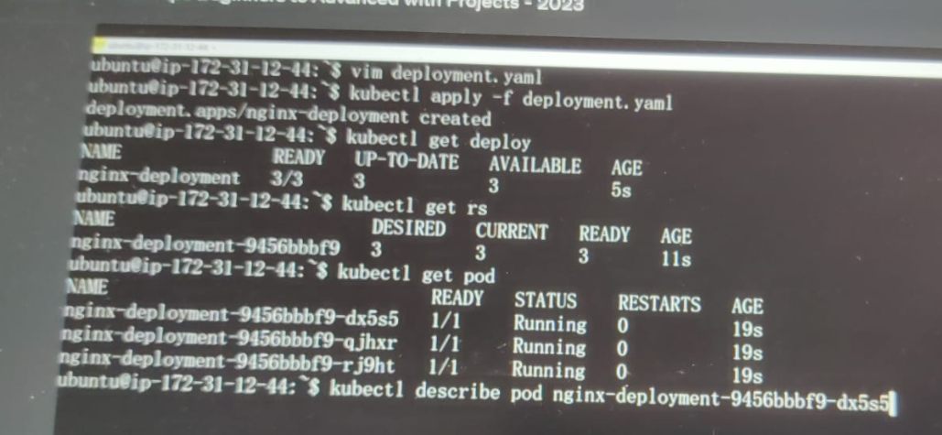

## Update container

Let's update the nginx Pods to use the nginx:1.16.1 image instead of the nginx:1.14.2 image.

kubectl set image deployment.v1.apps/nginx-deployment nginx=nginx:1.16.1

kubectl get deploy

kubectl get pod

kubectl describle pod nginx-deployment-ff6655787-2bn9t (this is the new pod old pod is deleted)

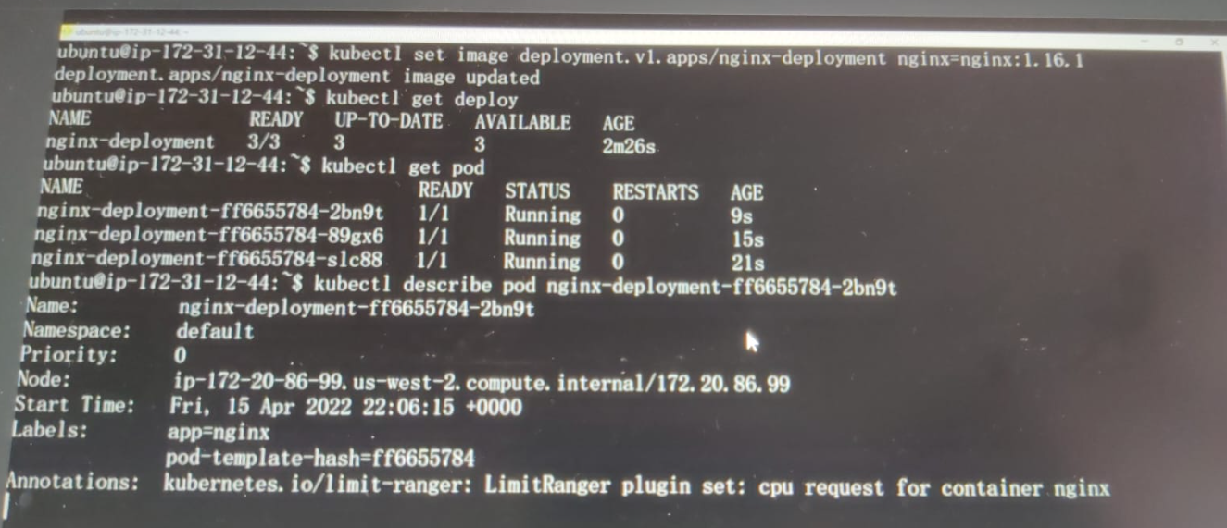

Kubectl get rs

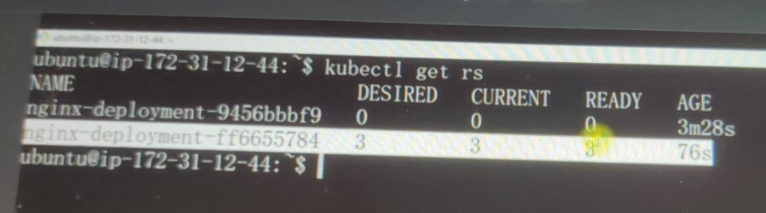

## Roll-back

To see the rollout status, run:

kubectl rollout status deployment/nginx-deployment

### **Rolling Back to a Previous Revision**

Follow the steps given below to rollback the Deployment from the current version to the previous version, which is version 2.

1. Now you've decided to undo the current rollout and rollback to the previous revision:
2. kubectl rollout undo deployment/nginx-deployment

The output is similar to this:

deployment.apps/nginx-deployment rolled back

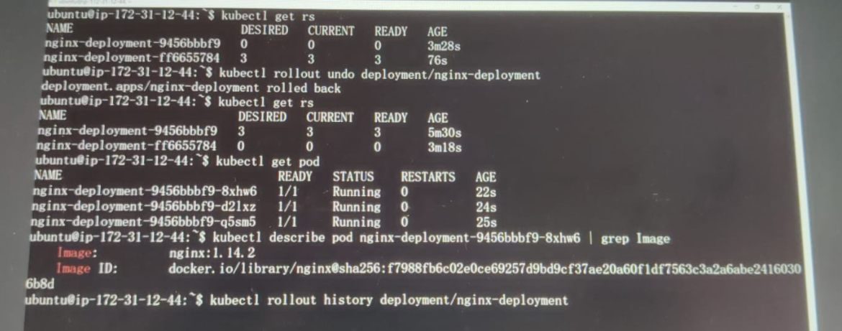

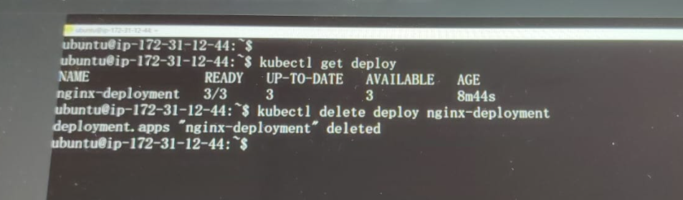

Hello and welcome.

In this lecture, we'll talk about **Kubernetes Deployments**, one of the most frequently used objects in the Kubernetes ecosystem, especially for DevOps tasks. Deployments are crucial for managing and automating the release of new versions of applications.

### What is a Deployment?

A **Deployment** in Kubernetes manages the creation and updates of ReplicaSets, which in turn manage Pods. The Deployment controller provides declarative updates to applications, meaning you can specify the desired state in a deployment definition file, and Kubernetes will ensure that the actual state matches the desired state.

### Key Features of Deployments:

1. **Declarative Updates:** You declare the desired state in a YAML file.
2. **Rolling Updates:** Updates to applications occur in a controlled fashion, one pod at a time, to ensure minimal disruption.
3. **Rollback:** Easily revert to previous versions if something goes wrong.
4. **Scaling:** Scale the number of pod replicas up or down.
5. **Self-healing:** Automatically replaces failed pods.

### How Does a Deployment Work?

1. **Definition File:**
   * The Deployment is defined in a YAML file, similar to a ReplicaSet.

yaml

Copy code

apiVersion: apps/v1

kind: Deployment

metadata:

name: nginx-deployment

spec:

replicas: 3

selector:

matchLabels:

app: nginx

template:

metadata:

labels:

app: nginx

spec:

containers:

- name: nginx

image: nginx:1.14.2

ports:

- containerPort: 80

1. **Creating a Deployment:**
   * Save the YAML configuration to a file, for example, deployment.yaml.
   * Apply the configuration using kubectl:

sh

Copy code

kubectl apply -f deployment.yaml

1. **Checking Deployment Status:**
   * Verify the status of the Deployment and its pods:

sh

Copy code

kubectl get deployments

kubectl get pods

1. **Rolling Updates:**
   * Update the Deployment with a new image version:

sh

Copy code

kubectl set image deployment/nginx-deployment nginx=nginx:1.16.1

1. **Rolling Back:**
   * Roll back to the previous revision:

sh

Copy code

kubectl rollout undo deployment/nginx-deployment

1. **Scaling a Deployment:**
   * Scale the Deployment to a different number of replicas:

sh

Copy code

kubectl scale deployment/nginx-deployment --replicas=5

### Detailed Steps and Commands

1. **Creating and Applying a Deployment:**

Save your Deployment YAML configuration as deployment.yaml and apply it:

sh

Copy code

kubectl apply -f deployment.yaml

Check the status:

sh

Copy code

kubectl get deployments

kubectl get pods

1. **Updating a Deployment:**

Update the image version in the Deployment definition and apply the changes:

yaml

Copy code

spec:

containers:

- name: nginx

image: nginx:1.16.1

Or use kubectl set image command for an imperative update:

sh

Copy code

kubectl set image deployment/nginx-deployment nginx=nginx:1.16.1

1. **Rolling Back a Deployment:**

Roll back to the previous revision:

sh

Copy code

kubectl rollout undo deployment/nginx-deployment

Check the rollout status:

sh

Copy code

kubectl rollout status deployment/nginx-deployment

1. **Scaling a Deployment:**

Scale the Deployment to a specific number of replicas:

sh

Copy code

kubectl scale deployment/nginx-deployment --replicas=5

Alternatively, you can edit the replicas in the YAML file and reapply:

yaml

Copy code

spec:

replicas: 5

1. **Deleting a Deployment:**

Delete the Deployment:

sh

Copy code

kubectl delete deployment nginx-deployment

### Summary

Deployments in Kubernetes provide a powerful and flexible way to manage applications. They enable automated, declarative updates, rollbacks, and scaling, ensuring that applications remain available and can be updated with minimal downtime. Using Deployments, you can maintain application stability and reliability even during updates and scaling operations.

Practice creating, updating, rolling back, and scaling Deployments to get a good grasp of their functionality. Deployments are essential for efficient and effective application management in a Kubernetes environment.

# Commands and Arguments

Pass Command & Args to your POD

## How can you pass the commands and Arguments to a container in a pod?

Document for docker file references documentation: <https://docs.docker.com/engine/reference/builder/>

THIS IS DOCUMENTION :

## [**CMD**](https://docs.docker.com/engine/reference/builder/#cmd)

The CMD instruction has three forms:

* CMD ["executable","param1","param2"] (exec form, this is the preferred form)
* CMD ["param1","param2"] (as default parameters to ENTRYPOINT)
* CMD command param1 param2 (shell form)

There can only be one CMD instruction in a Dockerfile. If you list more than one CMD then only the last CMD will take effect.

**The main purpose of a**CMD**is to provide defaults for an executing container.** These defaults can include an executable, or they can omit the executable, in which case you must specify an ENTRYPOINT instruction as well.

If CMD is used to provide default arguments for the ENTRYPOINT instruction, both the CMD and ENTRYPOINT instructions should be specified with the JSON array format.

* + When you go into run Container, and container will run the CMD command

Ex:1

[**FROM**](https://docs.docker.com/engine/reference/builder/#from) ubuntu

[**CMD**](https://docs.docker.com/engine/reference/builder/#cmd) echo "This is a test." **|** wc -

EX:2

[**FROM**](https://docs.docker.com/engine/reference/builder/#from) ubuntu

[**CMD**](https://docs.docker.com/engine/reference/builder/#cmd) **[**"/usr/bin/wc"**,**"--help"**]**

## EntryPoint :

Entrypoint also do same as CMD. But entry point has high priority.

If you have CMD and ENTRYPOINT both in same dockerfile, when you run the container it going to run first the command mention in the ENTRYPOINT and then it will run the command mention in CMD.

If the use together, usually entrypoint is the command and CMD is argument

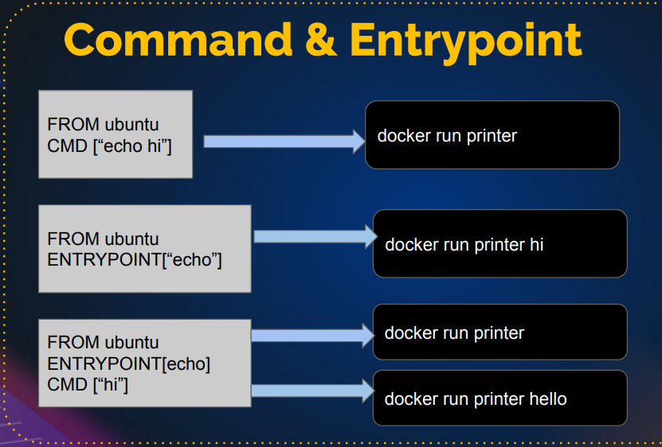

## kubernetes doumentation for commands and arguments

<https://kubernetes.io/docs/tasks/inject-data-application/define-command-argument-container/>

example:

**apiVersion**: v1

**kind**: Pod

**metadata**:

**name**: command-demo

**labels**:

**purpose**: demonstrate-command

**spec**:

**containers**:

- **name**: command-demo-container

**image**: debian

**command**: ["printenv"]

**args**: ["HOSTNAME", "KUBERNETES_PORT"]

**restartPolicy**: OnFailure

vim com.yaml

**apiVersion**: v1

**kind**: Pod

**metadata**:

**name**: command-demo

**labels**:

**purpose**: demonstrate-command

**spec**:

**containers**:

- **name**: command-demo-container

**image**: debian

**command**: ["printenv"]

**args**: ["HOSTNAME", "KUBERNETES_PORT"]

**restartPolicy**: OnFailure

kubectl apply -f com.yaml

kubectl get pod

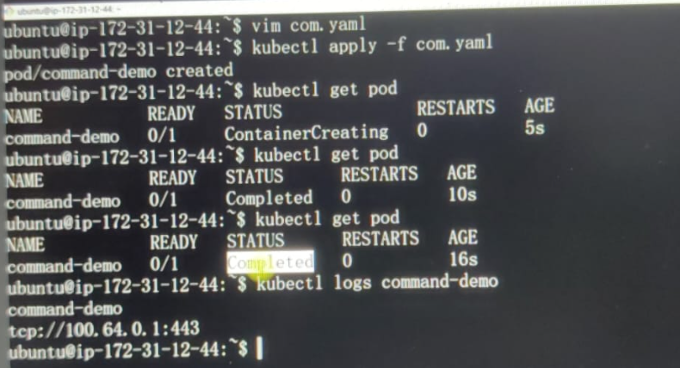

Example:

**env**:

- **name**: MESSAGE

**value**: "hello world"

**command**: ["/bin/echo"]

**args**: ["$(MESSAGE)"]

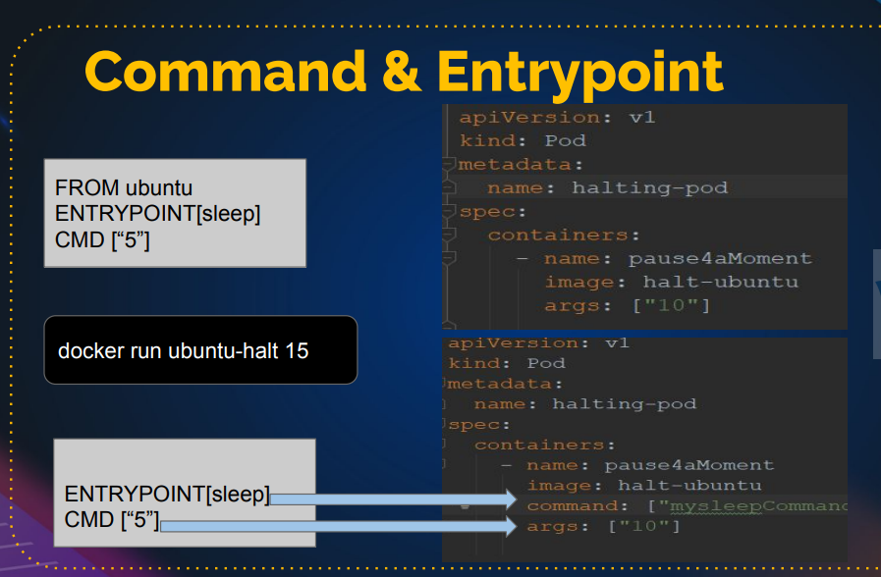

Hello and welcome.

In this lecture, we will talk about **commands and arguments** in Kubernetes. Specifically, how you can pass commands and arguments to a container within a pod. It's important to remember that the container, not the pod, executes the commands. The container inside the pod runs the specified commands.

### Docker Commands and Arguments

When building an image using Docker, you specify commands that the container will run. For example, the CMD instruction in a Dockerfile specifies the command that will be run when the container starts. Here's an example:

dockerfile

Copy code

FROM ubuntu

CMD ["echo", "Hello, World!"]

This Dockerfile creates an image from Ubuntu and specifies that when a container is run from this image, it will execute echo "Hello, World!".

There's also the ENTRYPOINT instruction in Docker, which defines a command that will always run when the container starts. If both CMD and ENTRYPOINT are defined, ENTRYPOINT takes precedence, and CMD provides default arguments to the ENTRYPOINT command. Here's an example to illustrate:

dockerfile

Copy code

FROM ubuntu

ENTRYPOINT ["echo"]

CMD ["Hello, World!"]

When you run this container, it will execute echo "Hello, World!". If you override the CMD at runtime, for example by running docker run <image> "Hi, there!", the container will execute echo "Hi, there!".

### Commands and Arguments in Kubernetes

In Kubernetes, we use pods to manage containers. To pass commands and arguments to a container, we define them in the pod's YAML definition file. Here’s an example from the Kubernetes documentation:

yaml

Copy code

apiVersion: v1

kind: Pod

metadata:

name: command-demo

spec:

containers:

- name: command-demo-container

image: debian

command: ["printenv"]

args: ["HOSTNAME", "KUBERNETES_PORT"]

In this example, the container will run the printenv command with the arguments HOSTNAME and KUBERNETES_PORT, printing their values.

### Steps to Define and Run Commands and Arguments in Kubernetes

1. **Create a Pod Definition File:**

Create a YAML file, for example, command-demo.yaml, with the following content:

yaml

Copy code

apiVersion: v1

kind: Pod

metadata:

name: command-demo

spec:

containers:

- name: command-demo-container

image: debian

command: ["printenv"]

args: ["HOSTNAME", "KUBERNETES_PORT"]

1. **Apply the Pod Definition:**

Apply the configuration using kubectl:

sh

Copy code

kubectl apply -f command-demo.yaml

1. **Check the Pod Status:**

Verify the status of the pod:

sh

Copy code

kubectl get pods

The status may show as Completed because the printenv command runs and then the container exits.

1. **View the Pod Logs:**

To see the output of the command, check the pod logs:

sh

Copy code

kubectl logs command-demo

You will see the output of the printenv command showing the values of HOSTNAME and KUBERNETES_PORT.

### Example: Using Environment Variables

You can also pass environment variables to the container and use them in commands. Here’s an example:

yaml

Copy code

apiVersion: v1

kind: Pod

metadata:

name: env-demo

spec:

containers:

- name: env-demo-container

image: debian

env:

- name: MESSAGE

value: "Hello, World!"

command: ["sh", "-c"]

args: ["echo $MESSAGE"]

In this example, the environment variable MESSAGE is set to "Hello, World!". The container runs the command sh -c "echo $MESSAGE", which prints "Hello, World!".

### Summary

Commands and arguments are powerful tools for customizing container behavior in Kubernetes. By specifying them in the pod definition file, you can control the exact commands and arguments that containers will run. This is particularly useful for running scripts, initializing services, or performing one-time setup tasks.

Experiment with different commands, arguments, and environment variables to see how they affect container behavior. Understanding these concepts is essential for effectively managing containerized applications in Kubernetes.

That's all for this lecture. See you in the next one!

# VOLUMES

DOUCUMENT: <https://kubernetes.io/docs/concepts/storage/volumes/>

Hello and welcome.

In this lecture, we will talk about **Kubernetes volumes**.

Volumes in Kubernetes are essential for managing storage in your pods, and understanding how to map a volume to your pod is crucial. While backend storage management is beyond the scope of this course, we will cover the basics needed for DevOps and developers to work with volumes in Kubernetes.

### Types of Volumes

Kubernetes supports many types of volumes, including:

* AWS Elastic Block Store (EBS)
* Azure Disk
* Ceph
* Cinder
* Fibre Channel (FC)
* Flocker
* Google Cloud Engine (GCE) Persistent Disk
* GlusterFS
* Local volumes
* Network File System (NFS)
* Portworx
* vSphere VMDK

For this lecture, we'll focus on the **HostPath** volume type, which maps a directory on the worker node to a directory in the container.

### Example: HostPath Volume

Let's look at an example of a pod definition file using a HostPath volume.

yaml

Copy code

apiVersion: v1

kind: Pod

metadata:

name: test-pod

spec:

containers:

- name: test-container

image: nginx

volumeMounts:

- mountPath: /test-pd

name: test-volume

volumes:

- name: test-volume

hostPath:

path: /data

type: Directory

In this example:

* The volumeMounts section specifies where the volume will be mounted inside the container (/test-pd).
* The volumes section specifies the volume source, which is a directory on the worker node (/data).

### Using HostPath Volume with MySQL

We'll modify this example to create a MySQL pod and map its data directory to a host path.

1. **Create the Pod Definition File:**

Create a YAML file named mysqlpod.yaml with the following content:

yaml

Copy code

apiVersion: v1

kind: Pod

metadata:

name: dbpod

spec:

containers:

- name: mysql

image: mysql:5.7

volumeMounts:

- mountPath: /var/lib/mysql

name: dbvol

env:

- name: MYSQL_ROOT_PASSWORD

value: "rootpassword"

volumes:

- name: dbvol

hostPath:

path: /data

type: DirectoryOrCreate

In this example:

* + The MySQL container image is mysql:5.7.
  + The MySQL data directory (/var/lib/mysql) is mounted to the host path /data.
  + The DirectoryOrCreate type ensures that the /data directory is created if it does not already exist.

1. **Apply the Pod Definition:**

Apply the configuration using kubectl:

sh

Copy code

kubectl apply -f mysqlpod.yaml

1. **Check the Pod Status:**

Verify the status of the pod:

sh

Copy code

kubectl get pods

1. **Describe the Pod:**

Check the pod description for volume details:

sh

Copy code

kubectl describe pod dbpod

You should see something like this:

yaml

Copy code

...

Volumes:

dbvol:

Type: HostPath (bare host directory volume)

Path: /data

HostPathType: DirectoryOrCreate

...

This confirms that the volume is correctly mounted.

1. **View Logs:**

If needed, view the pod logs to confirm that MySQL is running correctly:

sh

Copy code

kubectl logs dbpod

### Summary

Volumes in Kubernetes provide a way to manage persistent data storage for your pods. By using a HostPath volume, you can map directories on the worker node to directories in your containers. This is useful for development and testing, but for production, you would typically use more robust storage solutions like EBS, NFS, or other network storage systems.

Experiment with different types of volumes and understand how they work in your Kubernetes environment. This knowledge is crucial for effectively managing stateful applications.

That’s all for this lecture. Let's delete the pod to clean up:

sh

Copy code

kubectl delete pod dbpod

Join me in the next lecture.

## Host path:

**apiVersion**: v1

**kind**: Pod

**metadata**:

**name**: test-pd

**spec**:

**containers**:

- **image**: registry.k8s.io/test-webserver

**name**: test-container

**volumeMounts**:

- **mountPath**: /test-pd

**name**: test-volume

**volumes**:

- **name**: test-volume

**hostPath**:

*# directory location on host*

**path**: /data

*# this field is optional*

**type**: Directory

vim mysqlpod.yaml

**apiVersion**: v1

**kind**: Pod

**metadata**:

**name**: dbpod

**spec**:

**containers**:

- **image**: mysql:5.7

**name**: mysql

**volumeMounts**:

- **mountPath**: /var/lib/mysql

**name**: dbvol

**volumes**:

- **name**: dbvol

**hostPath**:

*# directory location on host*

**path**: /data

*# this field is optional*

**type**: DirectoryOrCreate

kubectl apply -f mysqlpod.yaml

kubectl get pod

kubectl describe pod dbpod

* + Here we got a issue

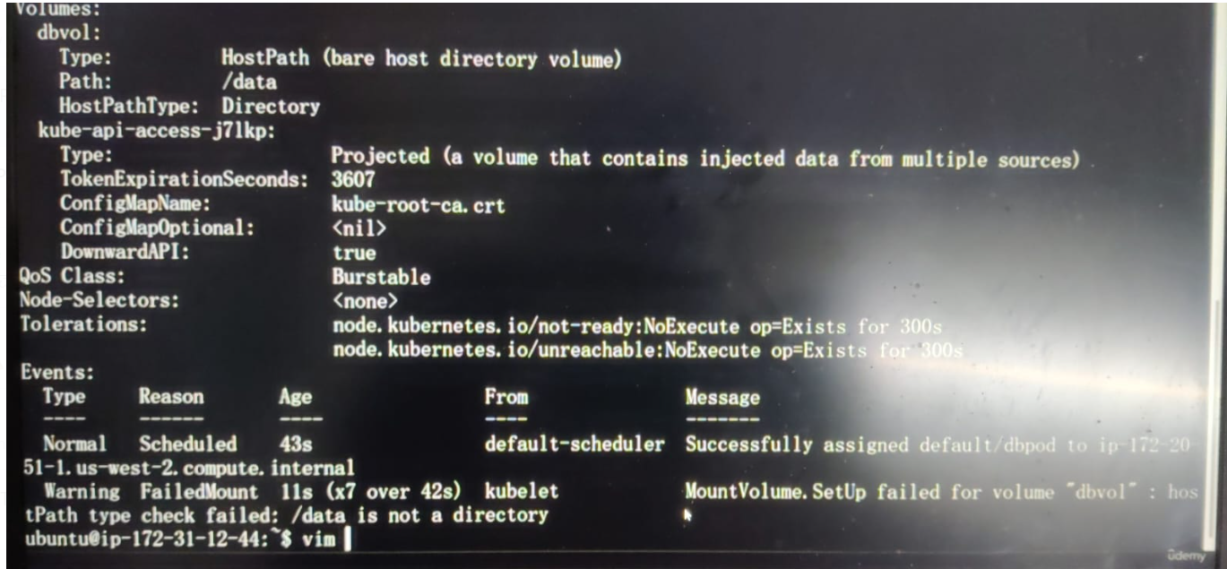



So to avoid it my changing

**type**: DirectoryOrCreate

kubectl delete pod dbpod

kubectl apply -f mysqlpod.yaml

kubectl describe pod dbpod

# Config Map

## Environment Variables

Assign Variable Values

### Who we can inject data in the pod?

We know pods are disposable, if we want to make change, we want to delete them and create a new POD with new container image so we have the persistence’s changes

While we running the pod we also inject variable and configuration in the pod

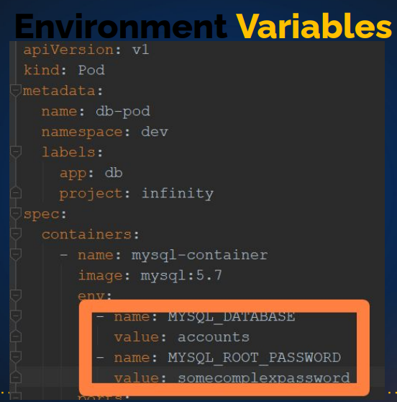

### Variable:

In above screenshot two variable is there:

* + Name : MYSQL_DATABASE

Value: account

* + Name : MYSQL_ROOT_PASSWORD

Value: somecomplexpassword

When you run this POD definition file which as this container mysql-container, this container has two variable that we created (MYSQL_DATABASE ,MYSQL_ROOT_PASSWORD)

We can use echo $ MYSQL_DATABASE 🡪 we can see the value (basically export this value in the container) 🡪 but really it goes beyond this, when you going running application or application stack will have many variable and also configuration that changes over the time. So we can use something called as Config Maps ( to store all your variable & configuration at one place and then whenever you want in any pod you can inject these variable or file which will be configuration files mostly.

### Config Maps

* + Collection of variable, and you can inject those variable in the pod

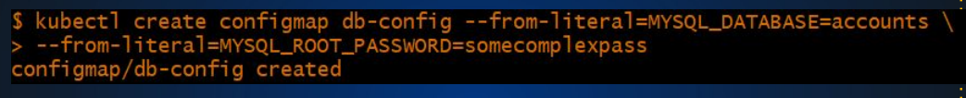

Imperative command line which you should avoid but you should anyways know how to do it. Kubectl create a config map

Kubectl get cm 🡪 you will get all the config maps

Kubectl get cm db-config -o yaml 🡪 you can see information inside that, yaml file mysql_database mysql_root_password are called as keys which as values associated with it

Kubectl describe cm db-config 🡪 you can see the content , so this is creating configMap imperative we can also

Config Maps

Set & Inject Variables/files in POD

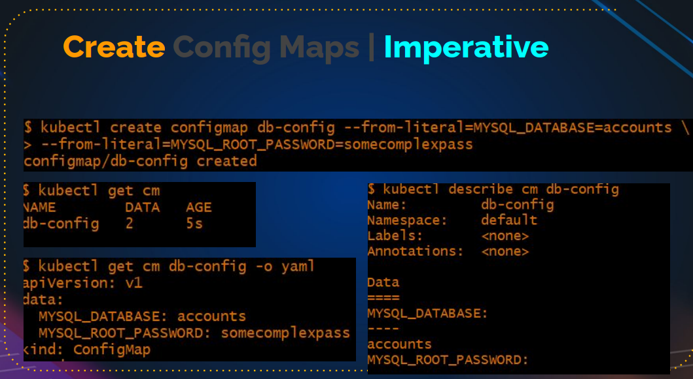

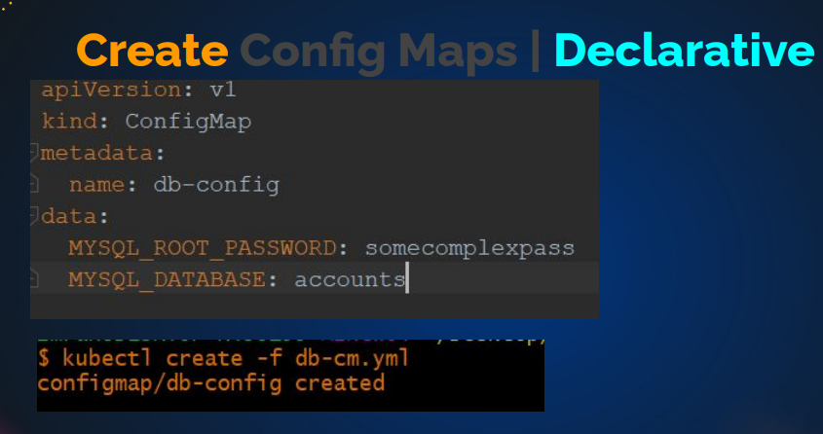

Now you have variable stored in the config map. Then how do you inject it?

* + One way is

envFrom:

-configMapRef:

Name: db-config

And this should be inside the container now should be in the pod level(now this configMap has 10, 20 etc variable🡪 all those variable is exported in this container)

🡪But what if you want to be selective? (select a key a configMap,)

Then you have to go with config map key references

Env:

-name: DB_HOST

valueFrom:

-configMapRef:

Name: db-config

Key: DB_HOST

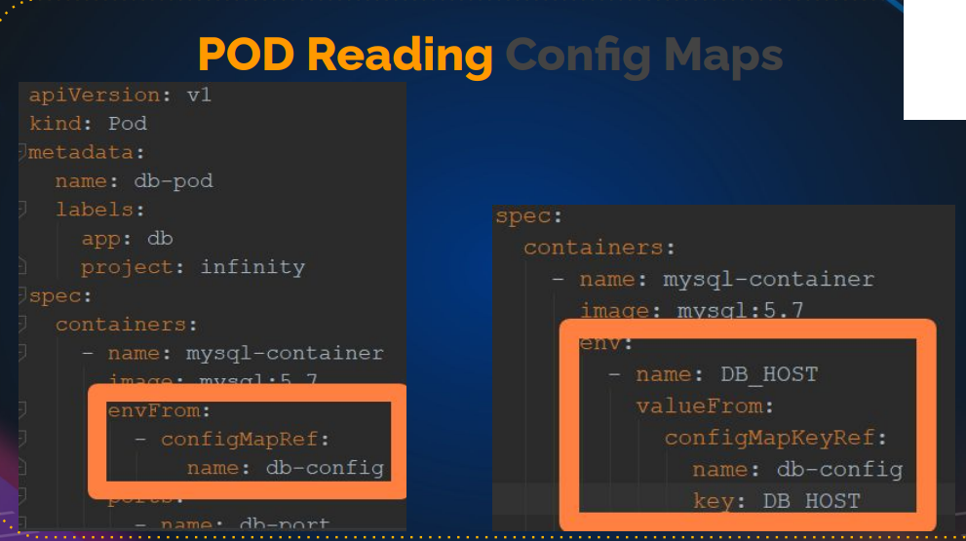

## Documentation:

<https://kubernetes.io/docs/concepts/configuration/configmap/>

# ConfigMaps

A ConfigMap is an API object used to store non-confidential data in key-value pairs. [Pods](https://kubernetes.io/docs/concepts/workloads/pods/) can consume ConfigMaps as environment variables, command-line arguments, or as configuration files in a [volume](https://kubernetes.io/docs/concepts/storage/volumes/).

A ConfigMap allows you to decouple environment-specific configuration from your [container images](https://kubernetes.io/docs/reference/glossary/?all=true#term-image), so that your applications are easily portable.

Example:

**apiVersion**: v1

**kind**: ConfigMap

**metadata**:

**name**: game-demo

**data**:

*# property-like keys; each key maps to a simple value*

**player_initial_lives**: "3"

**ui_properties_file_name**: "user-interface.properties"

*# file-like keys*

**game.properties**: |

*enemy.types=aliens,monsters*

*player.maximum-lives=5*

**user-interface.properties**: |

*color.good=purple*

*color.bad=yellow*

*allow.textmode=true*

vim samplecm.yaml

**apiVersion**: v1

**kind**: ConfigMap

**metadata**:

**name**: game-demo

**data**:

*# property-like keys; each key maps to a simple value*

**player_initial_lives**: "3"

**ui_properties_file_name**: "user-interface.properties"

*# file-like keys*

**game.properties**: |

*enemy.types=aliens,monsters*

*player.maximum-lives=5*

**user-interface.properties**: |

*color.good=purple*

*color.bad=yellow*

*allow.textmode=true*

kubectl apply -f samplecm.yaml

kubectl get cm

kubectl get cm game-demo -o yaml

There are four different ways that you can use a ConfigMap to configure a container inside a Pod:

1. Inside a container command and args
2. Environment variables for a container
3. Add a file in read-only volume, for the application to read
4. Write code to run inside the Pod that uses the Kubernetes API to read a ConfigMap

Example:

**apiVersion**: v1

**kind**: Pod

**metadata**:

**name**: configmap-demo-pod

**spec**:

**containers**:

- **name**: demo

**image**: alpine

**command**: ["sleep", "3600"]

**env**:

*# Define the environment variable*

- **name**: PLAYER_INITIAL_LIVES *# Notice that the case is different here*

*# from the key name in the ConfigMap.*

**valueFrom**:

**configMapKeyRef**:

**name**: game-demo *# The ConfigMap this value comes from.*

**key**: player_initial_lives *# The key to fetch.*

- **name**: UI_PROPERTIES_FILE_NAME

**valueFrom**:

**configMapKeyRef**:

**name**: game-demo

**key**: ui_properties_file_name

**volumeMounts**:

- **name**: config

**mountPath**: "/config"

**readOnly**: **true**

**volumes**:

*# You set volumes at the Pod level, then mount them into containers inside that Pod*

- **name**: config

**configMap**:

*# Provide the name of the ConfigMap you want to mount.*

**name**: game-demo

*# An array of keys from the ConfigMap to create as files*

**items**:

- **key**: "game.properties"

**path**: "game.properties"

- **key**: "user-interface.properties"

**path**: "user-interface.properties"

vim readcmpod.yaml

**apiVersion**: v1

**kind**: Pod

**metadata**:

**name**: configmap-demo-pod

**spec**:

**containers**:

- **name**: demo

**image**: alpine

**command**: ["sleep", "3600"]

**env**:

*# Define the environment variable*

- **name**: PLAYER_INITIAL_LIVES *# Notice that the case is different here*

*# from the key name in the ConfigMap.*

**valueFrom**:

**configMapKeyRef**:

**name**: game-demo *# The ConfigMap this value comes from.*

**key**: player_initial_lives *# The key to fetch.*

- **name**: UI_PROPERTIES_FILE_NAME

**valueFrom**:

**configMapKeyRef**:

**name**: game-demo

**key**: ui_properties_file_name

**volumeMounts**:

- **name**: config

**mountPath**: "/config"

**readOnly**: **true**

**volumes**:

*# You set volumes at the Pod level, then mount them into containers inside that Pod*

- **name**: config

**configMap**:

*# Provide the name of the ConfigMap you want to mount.*

**name**: game-demo

*# An array of keys from the ConfigMap to create as files*

**items**:

- **key**: "game.properties"

**path**: "game.properties"

- **key**: "user-interface.properties"

**path**: "user-interface.properties"

kubectl get pod

kubectl exec –stdin –tty configmap-demo-pod -- /bin/sh

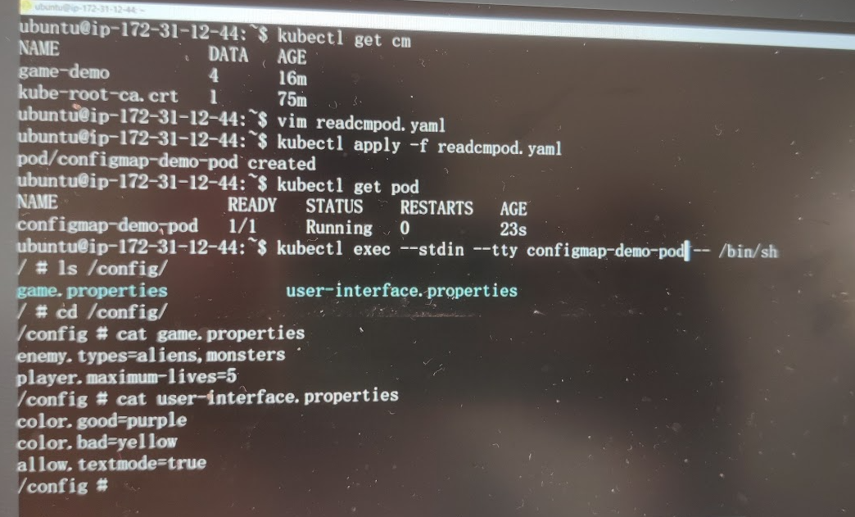

In this lecture, we will discuss variables and configuration injection in Kubernetes pods. Pods are ephemeral, meaning any changes require recreating them with new images. To manage persistent configurations and variables dynamically, Kubernetes offers mechanisms like environment variables and ConfigMaps.

### Environment Variables

Assigning environment variables to a pod is straightforward, similar to Bash or Python. Here’s how you can define them in a pod definition file:

yaml

Copy code

env:

- name: MYSQL_DATABASE

value: my_database

- name: MYSQL_ROOT_PASSWORD

value: my_password

When this pod runs, the MySQL container will have two environment variables, MYSQL_DATABASE and MYSQL_ROOT_PASSWORD. You can access their values within the container using commands like echo $MYSQL_DATABASE.

### ConfigMaps

ConfigMaps store configuration data in key-value pairs. This data can be injected into pods, making it easier to manage configurations centrally.

#### Creating a ConfigMap Imperatively

To create a ConfigMap using the command line (imperative method):

bash

Copy code

kubectl create configmap db-config --from-literal=MYSQL_DATABASE=my_database --from-literal=MYSQL_ROOT_PASSWORD=my_password

You can then view all ConfigMaps:

bash

Copy code

kubectl get configmaps

And describe a specific ConfigMap to see its content:

bash

Copy code

kubectl describe configmap db-config

#### Creating a ConfigMap Declaratively

A ConfigMap can also be created using a YAML file (declarative method):

yaml

Copy code

apiVersion: v1

kind: ConfigMap

metadata:

name: db-config

data:

MYSQL_DATABASE: my_database

MYSQL_ROOT_PASSWORD: my_password

Apply this ConfigMap with:

bash

Copy code

kubectl apply -f db-config.yaml

### Injecting ConfigMap Data into Pods

#### Injecting All Variables

To inject all variables from a ConfigMap into a pod:

yaml

Copy code

envFrom:

- configMapRef:

name: db-config

This method will export all keys from the ConfigMap as environment variables in the container.

#### Injecting Selective Variables

For selective injection:

yaml

Copy code

env:

- name: MYSQL_DATABASE

valueFrom:

configMapKeyRef:

name: db-config

key: MYSQL_DATABASE

- name: MYSQL_ROOT_PASSWORD

valueFrom:

configMapKeyRef:

name: db-config

key: MYSQL_ROOT_PASSWORD

This will only export the specified keys as environment variables.

### Using ConfigMap as Volume

ConfigMaps can also be mounted as volumes to provide configuration files to applications.

#### Example ConfigMap with Multi-line Data

yaml

Copy code

apiVersion: v1

kind: ConfigMap

metadata:

name: game-config

data:

game.properties: |

enemies=aliens

lives=3

ui.properties: |

color=green

font=Arial

#### Mounting ConfigMap as Volume

To mount this ConfigMap as a volume in a pod:

yaml

Copy code

apiVersion: v1

kind: Pod

metadata:

name: game-pod

spec:

containers:

- name: game-container

image: alpine

env:

- name: GAME_LIVES

valueFrom:

configMapKeyRef:

name: game-config

key: lives

volumeMounts:

- name: config-volume

mountPath: /config

volumes:

- name: config-volume

configMap:

name: game-config

In the container, /config will contain files game.properties and ui.properties with the corresponding data.

### Summary

* **Environment Variables:** Directly set key-value pairs in the pod definition.
* **ConfigMaps:** Store and manage multiple configurations centrally.
  + **Imperative Creation:** Using kubectl create configmap.
  + **Declarative Creation:** Using YAML files.
* **Injection into Pods:** Using envFrom, env, and volume mounts.

ConfigMaps provide a robust way to manage configurations that can be dynamically injected into pods, ensuring flexibility and ease of management.

### Next Steps

Practice creating ConfigMaps and injecting them into pods using both environment variables and volume mounts. Refer to Kubernetes documentation for more advanced usage and examples.

By mastering these techniques, you will have a solid foundation for managing configurations in Kubernetes, a critical skill for deploying and maintaining scalable applications.

# Secrets

🡪 Share encoded/encrypted variables to POD . 🡪Store and manage sensitive information, such as passwords

Hello and welcome.

In this lecture, we will talk about Kubernetes Secrets. In the previous lecture, we covered ConfigMaps, which store variables or files in clear text. While ConfigMaps are useful, they are not suitable for sensitive information like passwords or Docker registry credentials. Using Secrets, we can store such data in an encoded format, making it safer to inject into pod definition files.

### Introduction to Secrets

Secrets in Kubernetes provide a way to store and manage sensitive information. Unlike ConfigMaps, Secrets encode their data using Base64, reducing the risk of accidental exposure in repositories. Here’s how to create and use Secrets:

### Creating Secrets Imperatively

#### Basic Secret Creation

To create a Secret imperatively:

bash

Copy code

kubectl create secret generic my-secret --from-literal=username=admin --from-literal=password=my-secret-pass

When you check the Secret, you’ll see the values are encoded:

bash

Copy code

kubectl get secret my-secret -o yaml

You’ll notice that the values are Base64 encoded.

#### Encoding Data with Base64

Here’s how you can manually encode data using Base64:

bash

Copy code

echo -n "my-secret-pass" | base64

To decode it:

bash

Copy code

echo "bXktc2VjcmV0LXBhc3M=" | base64 --decode

### Creating Secrets Declaratively

For declarative creation, you must first encode your data:

yaml

Copy code

apiVersion: v1

kind: Secret

metadata:

name: my-secret

type: Opaque

data:

username: YWRtaW4=

password: bXktc2VjcmV0LXBhc3M=

Apply this Secret with:

bash

Copy code

kubectl apply -f my-secret.yaml

### Using Secrets in Pods

#### Injecting All Keys

To inject all keys from a Secret into a pod:

yaml

Copy code

envFrom:

- secretRef:

name: my-secret

This will export all keys from the Secret as environment variables.

#### Injecting Selective Keys

For selective injection:

yaml

Copy code

env:

- name: SECRET_USERNAME

valueFrom:

secretKeyRef:

name: my-secret

key: username

- name: SECRET_PASSWORD

valueFrom:

secretKeyRef:

name: my-secret

key: password

This will only export the specified keys as environment variables.

### Types of Secrets

Kubernetes supports several types of Secrets, including:

* **Opaque:** Default type, used for arbitrary user-defined data.
* **kubernetes.io/service-account-token:** Used to store a service account token.
* **kubernetes.io/dockercfg:** Used to store Docker registry credentials.
* **kubernetes.io/dockerconfigjson:** Similar to dockercfg, but stores the credentials in JSON format.
* **kubernetes.io/ssh-auth:** Used to store SSH authentication data.
* **kubernetes.io/tls:** Used to store TLS certificates.

### Using Docker Registry Secrets

To store Docker registry credentials:

bash

Copy code

kubectl create secret docker-registry my-registry-secret --docker-username=<username> --docker-password=<password> --docker-email=<email> --docker-server=<server>

Use this secret in a pod definition:

yaml

Copy code

spec:

containers:

- name: my-container

image: my-private-image

imagePullSecrets:

- name: my-registry-secret

### Example: Creating and Using Secrets

#### Step 1: Encode Data

bash

Copy code

echo -n "admin" | base64

echo -n "my-secret-pass" | base64

#### Step 2: Create Secret Definition File

yaml

Copy code

apiVersion: v1

kind: Secret

metadata:

name: my-secret

type: Opaque

data:

username: YWRtaW4=

password: bXktc2VjcmV0LXBhc3M=

#### Step 3: Apply the Secret

bash

Copy code

kubectl apply -f my-secret.yaml

#### Step 4: Create Pod Definition File

yaml

Copy code

apiVersion: v1

kind: Pod

metadata:

name: secret-pod

spec:

containers:

- name: redis

image: redis

env:

- name: SECRET_USERNAME

valueFrom:

secretKeyRef:

name: my-secret

key: username

- name: SECRET_PASSWORD

valueFrom:

secretKeyRef:

name: my-secret

key: password

#### Step 5: Apply the Pod

bash

Copy code

kubectl apply -f secret-pod.yaml

#### Step 6: Verify the Secret in the Pod

bash

Copy code

kubectl exec --stdin --tty secret-pod -- /bin/bash

Inside the pod:

bash

Copy code

echo $SECRET_USERNAME

echo $SECRET_PASSWORD

### Summary

* **Secrets:** Store sensitive information in encoded form.
* **Imperative Creation:** Using kubectl create secret.
* **Declarative Creation:** Using YAML files with encoded data.
* **Usage in Pods:** Inject as environment variables or volume mounts.

Secrets are essential for securely managing sensitive data in Kubernetes. They provide a way to handle passwords, tokens, and other confidential information without exposing it in clear text.

### Next Steps

Practice creating and using Secrets, both imperatively and declaratively. Explore different types of Secrets and how they can be used in various scenarios. Understanding Secrets is crucial for secure and efficient Kubernetes operations.

By mastering Kubernetes Secrets, you can ensure the security and integrity of sensitive data in your Kubernetes deployments, which is vital for maintaining a secure and compliant environment.

### Imperative type

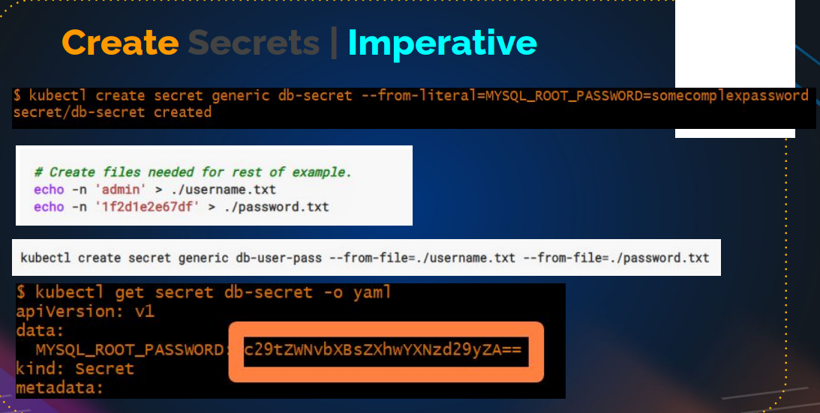

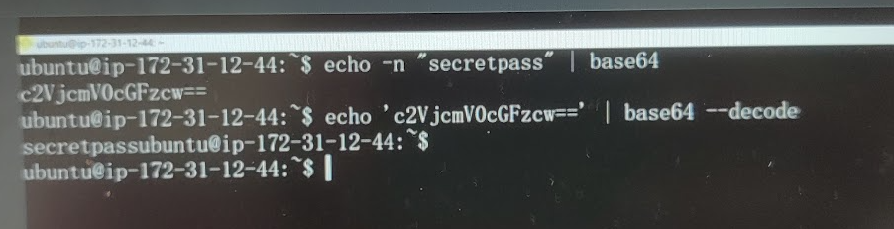

We can encode and decode it

How it is safe?

It store in Kubernetes control plane so if you have access to that , then you We can decode it. It like we can avoid accidental exposure

### Declarative type

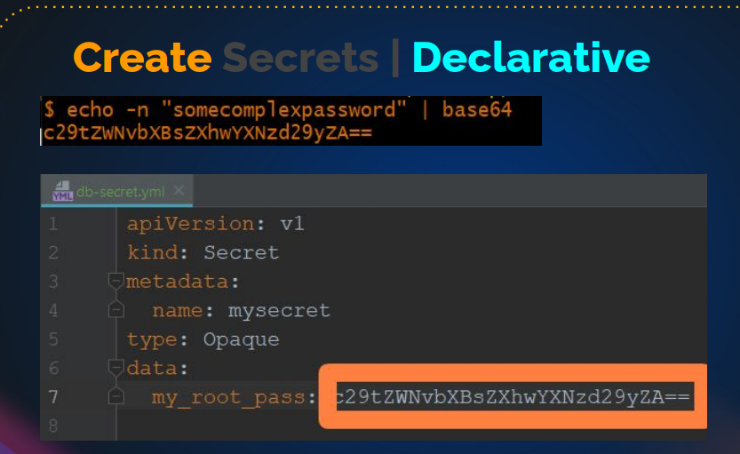

First we have to encode the data and then when you create a secret declarative

### POD definition file

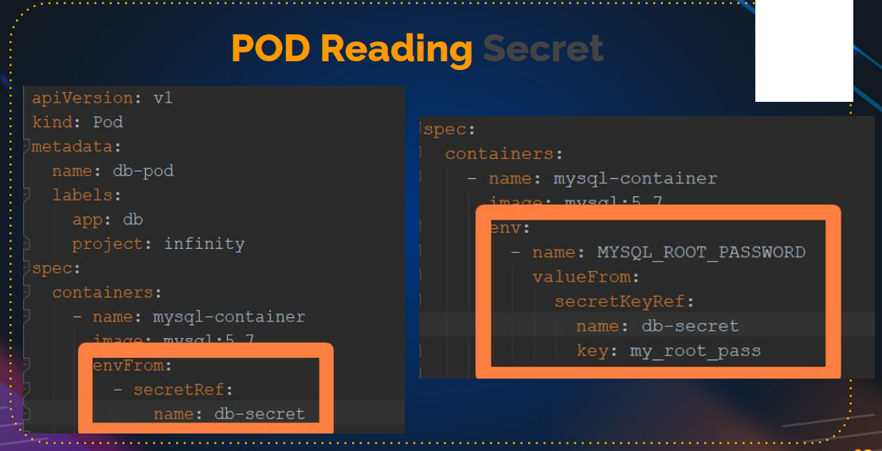

## Documentation:

<https://kubernetes.io/docs/concepts/configuration/secret/>

| **Built-in Type** | **Usage** |
| --- | --- |
| Opaque | arbitrary user-defined data |
| kubernetes.io/service-account-token | ServiceAccount token |
| kubernetes.io/dockercfg | serialized ~/.dockercfg file |
| kubernetes.io/dockerconfigjson | serialized ~/.docker/config.json file |
| kubernetes.io/basic-auth | credentials for basic authentication |
| kubernetes.io/ssh-auth | credentials for SSH authentication |
| kubernetes.io/tls | data for a TLS client or server |
| bootstrap.kubernetes.io/token | bootstrap token data |

When you create Docker config Secrets using a manifest, the API server checks whether the expected key exists in the data field, and it verifies if the value provided can be parsed as a valid JSON. The API server doesn't validate if the JSON actually is a Docker config file.

You can also use kubectl to create a Secret for accessing a container registry, such as when you don't have a Docker configuration file:

kubectl create secret docker-registry secret-tiger-docker **\**

--docker-email=tiger@acme.example **\**

--docker-username=tiger **\**

--docker-password=pass1234 **\**

--docker-server=my-registry.example:5000

## Documentation of pull-image-private-registry

<https://kubernetes.io/docs/tasks/configure-pod-container/pull-image-private-registry/>

example:

# Encode text

echo -n "admin" | base64

echo -n "mysecretpass" | base64

# Create Secret

vim mysecret.yaml

apiVersion: v1

kind: Secret

metadata:

name: mysecret

data:

username: YWRtaW4=

password: bXlzZWNyZXRwYXNz

type: Opaque

kubectl create -f mysecret.yaml

# Create Pod to read secret keys

vim readsecret.yaml

apiVersion: v1

kind: Pod

metadata:

name: secret-env-pod

spec:

containers:

- name: mycontainer

image: redis

env:

- name: SECRET_USERNAME

valueFrom:

secretKeyRef:

name: mysecret

key: username

optional: false # same as default; "mysecret" must exist

# and include a key named "username"

- name: SECRET_PASSWORD

valueFrom:

secretKeyRef:

name: mysecret

key: password

optional: false # same as default; "mysecret" must exist

# and include a key named "password"

restartPolicy: Never

kubectl create -f readsecret.yaml

kubectl get pod

# Login to Pod echo print variables

kubectl exec --stdin --tty secret-env-pod -- /bin/bash

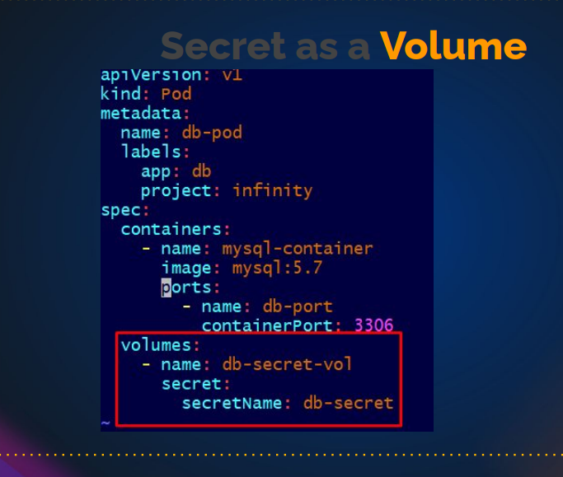

# INGRESS

Hello and welcome.

In this lecture, we will learn about **Ingress** in Kubernetes.

**What is Ingress?**

Ingress is an API object that manages external access to the services in a cluster, typically HTTP or HTTPS. Unlike a Service of type NodePort or LoadBalancer, which expose a service to external traffic, Ingress can provide load balancing, SSL termination, and name-based virtual hosting.

### Why Use Ingress?

* **External Access:** It exposes HTTP and HTTPS routes from outside the cluster to services within the cluster.
* **Routing:** It allows routing rules to control traffic based on hostnames, paths, and more.
* **SSL Termination:** It can manage SSL certificates and terminate SSL, making it easier to secure your services.
* **Consolidation:** It can manage multiple services with a single external IP.

### How Ingress Works

1. **User Request:** A user sends a request to a Kubernetes cluster.
2. **Ingress Controller:** The request first hits the Ingress Controller, which acts as a reverse proxy.
3. **Ingress Resource:** The Ingress Controller uses the rules defined in the Ingress resource to route the request to the appropriate Service.
4. **Service:** The Service then forwards the request to the correct Pod.

### Prerequisites

* **Ingress Controller:** An Ingress Controller is required to implement the Ingress resource. Popular Ingress Controllers include NGINX, Traefik, and HAProxy.

### Types of Ingress Controllers

* **NGINX Ingress Controller**
* **Traefik**
* **HAProxy**
* **AWS ALB Ingress Controller**

For this example, we'll use the NGINX Ingress Controller.

### Installation of NGINX Ingress Controller

1. **Install the Ingress Controller:**

sh

Copy code

kubectl apply -f https://raw.githubusercontent.com/kubernetes/ingress-nginx/main/deploy/static/provider/aws/deploy.yaml

1. **Verify the Installation:**

sh

Copy code

kubectl get pods -n ingress-nginx

### Creating Ingress Resources

#### Deployment and Service

1. **Create a Deployment:**

yaml

Copy code

apiVersion: apps/v1

kind: Deployment

metadata:

name: myapp

spec:

replicas: 1

selector:

matchLabels:

app: myapp

template:

metadata:

labels:

app: myapp

spec:

containers:

- name: myapp

image: vprofile/tomcat

ports:

- containerPort: 8080

1. **Create a Service:**

yaml

Copy code

apiVersion: v1

kind: Service

metadata:

name: myapp-service

spec:

selector:

app: myapp

ports:

- protocol: TCP

port: 80

targetPort: 8080

#### Ingress Resource

1. **Create an Ingress Resource:**

yaml

Copy code

apiVersion: networking.k8s.io/v1

kind: Ingress

metadata:

name: myapp-ingress

annotations:

nginx.ingress.kubernetes.io/rewrite-target: /

spec:

rules:

- host: myapp.example.com

http:

paths:

- path: /

pathType: Prefix

backend:

service:

name: myapp-service

port:

number: 80

### Configuring DNS

To access your application via myapp.example.com, you need to configure a DNS CNAME record pointing to the external IP address of your Ingress Controller.

### Verification

1. **Apply the Deployment and Service:**

sh

Copy code

kubectl apply -f myapp-deployment.yaml

kubectl apply -f myapp-service.yaml

1. **Apply the Ingress Resource:**

sh

Copy code

kubectl apply -f myapp-ingress.yaml

1. **Check the Ingress:**

sh

Copy code

kubectl get ingress

1. **Test the Access:** Open your browser and go to http://myapp.example.com.

### Cleanup

To delete the resources created:

1. **Delete the Ingress:**

sh

Copy code

kubectl delete -f myapp-ingress.yaml

1. **Delete the Deployment and Service:**

sh

Copy code

kubectl delete -f myapp-deployment.yaml

kubectl delete -f myapp-service.yaml

1. **Delete the Ingress Controller:**

sh

Copy code

kubectl delete -f https://raw.githubusercontent.com/kubernetes/ingress-nginx/main/deploy/static/provider/aws/deploy.yaml

In this lecture, we covered the basics of Ingress in Kubernetes, how to set up an NGINX Ingress Controller, create Ingress resources, and configure DNS for external access. Ingress provides a powerful way to manage external access to services running in your Kubernetes cluster, offering routing, SSL termination, and more.

Feel free to experiment with different rules and Ingress Controllers to see how they can fit your needs.

Document: Kubernetes ingress document

<https://kubernetes.io/docs/concepts/services-networking/ingress/>

# Ingress

**FEATURE STATE:** Kubernetes v1.19 [stable]

An API object that manages external access to the services in a cluster, typically HTTP.

Ingress may provide load balancing, SSL termination and name-based virtual hosting.

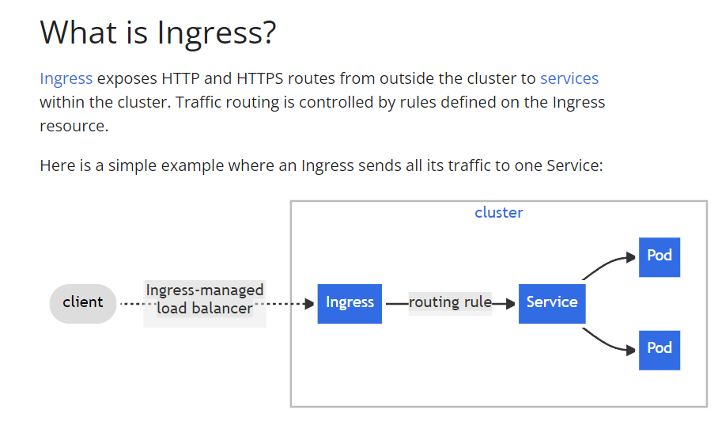

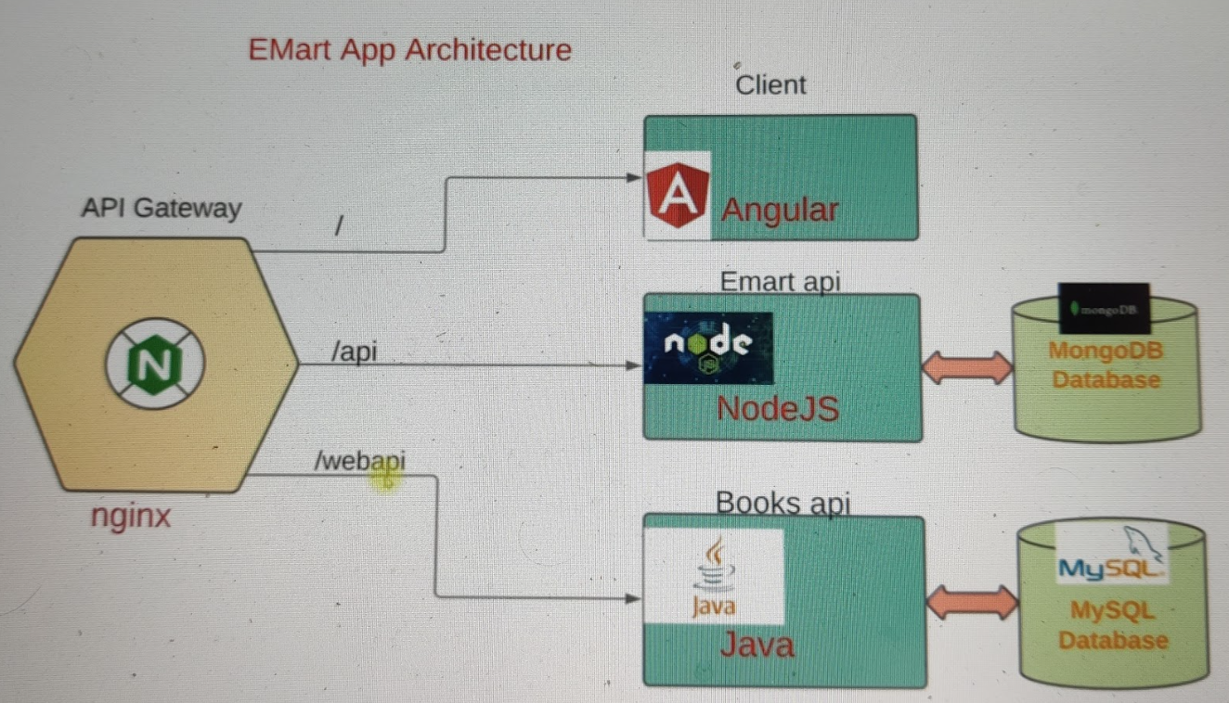

It sounds like you're describing the architecture of a microservices application using an API gateway like NGINX to manage routing. In this setup, the API gateway serves as a single entry point for clients to access various microservices. Here's a more detailed breakdown of how this setup works, both with and without an Ingress controller in Kubernetes:

### Without an Ingress Controller

1. **API Gateway as a Pod**:
   * You create a Pod with an NGINX container.
   * Inside the NGINX configuration, you define routing rules.
   * These rules specify how incoming requests should be routed to different microservices or APIs.
2. **Routing Rules in NGINX**:
   * Based on the URL path (e.g., /api, /web), NGINX routes requests to the appropriate microservice.
   * For example, requests to /api might be directed to an API microservice, while requests to /web might go to a web front-end service.
3. **Scalability and Maintenance**:
   * Each microservice can be developed, deployed, and scaled independently.
   * This setup allows for better management of different parts of the application and makes it easier to maintain.

### With an Ingress Controller

Using an Ingress Controller in Kubernetes simplifies the setup and management of routing rules for your microservices. Here's how it works:

1. **Deploy the Ingress Controller**:
   * Install an Ingress Controller like NGINX Ingress Controller.
   * The Ingress Controller acts as a reverse proxy and manages the routing of requests based on the rules defined in Ingress resources.
2. **Define Ingress Resources**:
   * Ingress resources specify the routing rules.
   * For example, you can define rules that route requests to different services based on the URL path or hostname.
3. **Centralized Management**:
   * The Ingress Controller centralizes the management of routing rules.
   * Instead of configuring NGINX in each Pod, you define Ingress resources that apply across the cluster.
4. **Features Provided by Ingress**:
   * **Load Balancing**: Distribute traffic across multiple instances of a service.
   * **SSL Termination**: Handle SSL/TLS termination at the Ingress Controller.
   * **Name-based Virtual Hosting**: Route traffic based on hostnames.
   * **Path-based Routing**: Route traffic based on URL paths.

### Example: Microservice Application with Ingress

Let's consider an example of a microservices application named emart with different microservices like API, Web API, and root directory.

1. **Define Deployment and Services**:
   * Create deployments and services for each microservice.
   * For instance, you might have services like api-service, web-service, etc.
2. **Create Ingress Resource**:
   * Define an Ingress resource with rules to route traffic to these services.

yaml

Copy code

apiVersion: networking.k8s.io/v1

kind: Ingress

metadata:

name: emart-ingress

annotations:

nginx.ingress.kubernetes.io/rewrite-target: /

spec:

rules:

- host: emart.example.com

http:

paths:

- path: /api

pathType: Prefix

backend:

service:

name: api-service

port:

number: 80

- path: /web

pathType: Prefix

backend:

service:

name: web-service

port:

number: 80

- path: /

pathType: Prefix

backend:

service:

name: root-service

port:

number: 80

1. **DNS Configuration**:
   * Configure DNS to point to the Ingress Controller's external IP.
   * For example, set up a CNAME record for emart.example.com to point to the Ingress Controller.

### Steps to Implement

1. **Install the Ingress Controller**:

sh

Copy code

kubectl apply -f https://raw.githubusercontent.com/kubernetes/ingress-nginx/main/deploy/static/provider/cloud/deploy.yaml

1. **Create Deployment and Services**:

sh

Copy code

kubectl apply -f api-deployment.yaml

kubectl apply -f web-deployment.yaml

kubectl apply -f root-deployment.yaml

1. **Apply the Ingress Resource**:

sh

Copy code

kubectl apply -f emart-ingress.yaml

1. **Configure DNS**:
   * Set up DNS records to point to the Ingress Controller's external IP.

### Summary

Using an Ingress Controller in Kubernetes offers a more streamlined and flexible approach to managing external access to your microservices. It simplifies the configuration and management of routing rules, provides additional features like load balancing and SSL termination, and centralizes the management of ingress traffic. This makes it easier to scale and maintain your microservices application.

## install ingress Nginx :

document : <https://kubernetes.github.io/ingress-nginx/deploy/#aws>

###STEPS###

# Create Controller

# Create Deployment

# Create Service

# Create DNS Cname Record for LB

# Create Ingress

# Test

# Create controller

kubectl apply -f <https://raw.githubusercontent.com/kubernetes/ingress-nginx/controller-v1.1.3/deploy/static/provider/aws/deploy.yaml>

kubctl get ns

kubctl get all -n ingress-nginx

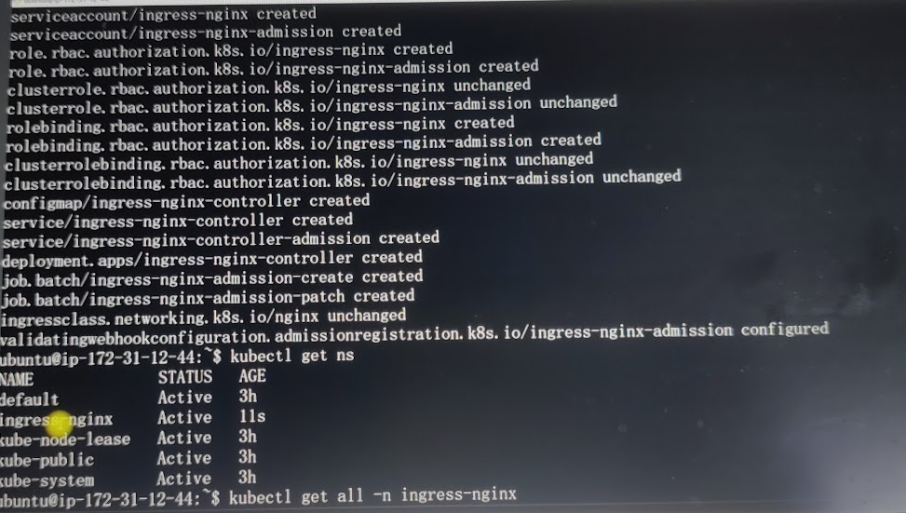

# Create Deployment

vim vprodep.yaml

apiVersion: apps/v1

kind: Deployment

metadata:

name: my-app

spec:

selector:

matchLabels:

run: my-app

replicas: 1

template:

metadata:

labels:

run: my-app

spec:

containers:

- name: my-app

image: imranvisualpath/vproappfix

ports:

- containerPort: 8080

kubectl apply -f vprodep.yaml

# Create service

vim vprosvc.yaml

apiVersion: v1

kind: Service

metadata:

name: my-app

spec:

ports:

- port: 8080

protocol: TCP

targetPort: 8080

selector:

run: my-app

type: ClusterIP

kubectl apply -f vprosvc.yaml

kubectl get svc

kubectl describe svc my-app

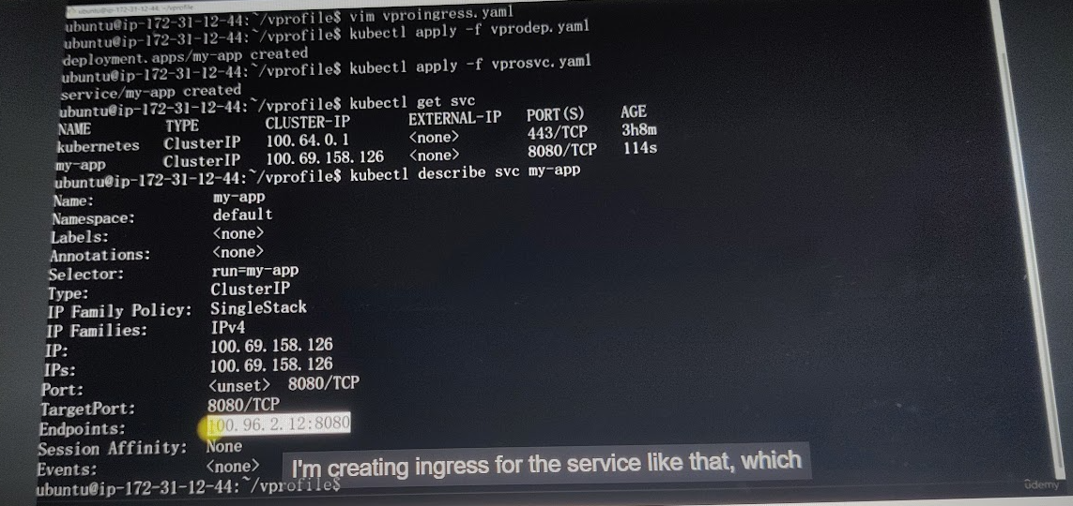

# Create DNS Cname Record for LB

Go to your domain hosted records

Add CNAME record

hostname => Load balancer Endpoint URL

# Create Ingress

vim vproingress.yaml

kind: Ingress

metadata:

name: vpro-ingress

annotations:

nginx.ingress.kubernetes.io/use-regex: "true"

spec:

ingressClassName: nginx

rules:

- host: vprofile.groophy.in

http:

paths:

- path: /login

pathType: Prefix

backend:

service:

name: my-app

port:

number: 8080

kubectl apply -f vproingress.yaml

# Update Path in ingress from /login to /

kubectl get ingress

kubectl delete ingress vpro-ingress

vim vproingress.yaml

paths:

- path: /

kubectl apply -f vproingress.yaml

kubectl get ingress

kubectl get ingress --watch

clear

kubectl get ns

kubectl delete -f <https://raw.githubusercontent.com/kubernetes/ingress-nginx/controller-v1.1.3/deploy/static/provider/aws/deploy.yaml>

So take your time. Go through this video.

I know this was a little longer video in Kubernetes.

So before I leave you on this

one, remember we create ingress for the

service in microservices you will have requirement.

also delete when I say apply, it created.

When I say delete, it's going to delete

everything that it reads from this manifest.

So it's going to take some time to delete.

It's going to wait for the load

balance and everything to delete and clear.

So take your time. Go through this video.

I know this was a little longer video in Kubernetes.

So before I leave you on this

one, remember we create ingress for the

service in microservices you will have requirement.

If I access it at API, it goes here.

This should ring the bell.

Oh, I need to create English rule.

Or if I access with this host name,

it should go to this particular part.

So when there is if I access

this then it should go like that.

Then these calls for ingress rules.

All right then I'll leave you here.

Go ahead, do your experiment.

.

# Kubectl CLI & Cheatsheet

## Documentation of cheat sheet

<https://kubernetes.io/docs/reference/kubectl/cheatsheet/>

Hello and welcome!

In this lecture, we will talk about kubectl tricks and tips. No matter how many tips and tricks we have, it's difficult to remember all of them. Fortunately, Kubernetes has created an amazing document for that—the kubectl cheat sheet. Just search for it, and you'll find regularly used commands that we need in our day-to-day Kubernetes operations.

For example, kubectl config view shows us the configuration:

sh

Copy code

kubectl config view

This command shows the kubeconfig file but hides certificates. There are many such commands listed in the cheat sheet, like viewing the output in JSON format and selectively getting the right keys. For instance, in the kubeconfig file, you have users, so you can use:

sh

Copy code

kubectl config view -o jsonpath='{.users[0].name}'

This displays the first user. There are also commands to get or change contexts:

sh

Copy code

kubectl config get-contexts

kubectl config current-context

kubectl config use-context <context-name>

You can have multiple contexts in the same kubeconfig file, which is useful when managing multiple Kubernetes clusters.

Next, let's talk about kubectl apply. You can apply a manifest by providing a path to a file or directory containing multiple definitions, or even a URL:

sh

Copy code

kubectl apply -f <path-or-url>

For example:

sh

Copy code

kubectl apply -f https://k8s.io/examples/application/deployment.yaml

This applies the manifest from the given URL.

For creating resources, you can use commands like kubectl create deployment:

sh

Copy code

kubectl create deployment nginx --image=nginx

This creates a deployment with a pod running the nginx container. You can also create a manifest file using a cool trick with a dry run:

sh

Copy code

kubectl run nginx --image=nginx --dry-run=client -o yaml > nginx-pod.yaml

This command generates a pod definition file without actually creating the pod. You can then edit the YAML file as needed and apply it:

sh

Copy code

kubectl apply -f nginx-pod.yaml

Similarly, for deployments:

sh

Copy code

kubectl create deployment nginx-dep --image=nginx --dry-run=client -o yaml > nginx-dep.yaml

This creates a deployment definition file, which you can edit and apply.

This approach is especially helpful in Kubernetes certification exams where time is critical. Instead of going to the documentation to fetch manifest settings, you can quickly generate them using the dry-run trick.

Let's go back to the cheat sheet for more examples:

To create a job:

sh

Copy code

kubectl create job hello --image=busybox -- echo "Hello, Kubernetes!"

To get detailed information about pods:

sh

Copy code

kubectl explain pods

For output in JSON format, you can filter keys:

sh

Copy code

kubectl get pods -o jsonpath='{.items[*].metadata.labels}'

For updating resources, such as setting an image in a deployment:

sh

Copy code

kubectl set image deployment/nginx nginx=nginx:1.16

To roll back changes:

sh

Copy code

kubectl rollout undo deployment/nginx

For scaling deployments:

sh

Copy code

kubectl scale deployment nginx --replicas=3

To delete resources:

sh

Copy code

kubectl delete -f <path-to-manifest>

kubectl delete pod -l app=nginx

For interacting with running pods, viewing logs, and executing commands inside pods:

sh

Copy code

kubectl logs <pod-name> -c <container-name>

kubectl exec -it <pod-name> -- /bin/bash

For copying files to and from containers:

sh

Copy code

kubectl cp <file> <pod-name>:<container-path>

kubectl cp <pod-name>:<container-path> <file>

For port forwarding:

sh

Copy code

kubectl port-forward <pod-name> <local-port>:<pod-port>

For node and cluster administration:

sh

Copy code

kubectl cordon <node-name>

kubectl drain <node-name> --ignore-daemonsets

kubectl uncordon <node-name>

The cheat sheet also includes commands for patching resources, but it's generally better to use manifest files for changes. For example, to patch a deployment:

sh

Copy code

kubectl patch deployment/nginx --type=json -p='[{"op": "replace", "path": "/spec/template/spec/containers/0/image", "value":"nginx:1.17"}]'

This command changes the container image in the deployment.

### Summary

The kubectl cheat sheet is a valuable resource for managing Kubernetes clusters. Regularly using these commands will help you become proficient with kubectl, making daily operations and exams much easier. Keep practicing with these commands to get comfortable with the kubectl CLI.

That is all for this video. Go ahead and try these commands: create pods, deployments, and services. Use these commands, test them, and get comfortable with the kubectl CLI. You will really need it every day.

See you in the next lecture. Bye!

# Extras

## Documentation :

<https://kubernetes.io/docs/home/>

Hello and welcome.

In this lecture, we will explore a few extra Kubernetes features which you may or may not use in your daily work, depending on your project. These features are quite simple, and I thought you should know about them.

### Taints and Tolerations

Let's start with Taints and Tolerations. Think of tainting as painting a node with certain information. Tolerations are like the key that allows a pod to tolerate and run on a tainted node.

For example, to taint a node:

sh

Copy code

kubectl taint nodes <node-name> key=value:NoSchedule

This command paints the node with a key-value pair and an effect of NoSchedule, meaning no pods can be scheduled on this node unless they have a matching toleration.

To allow a pod to tolerate the taint, you include the toleration in the pod's definition:

yaml

Copy code

tolerations:

- key: "key"

operator: "Equal"

value: "value"

effect: "NoSchedule"

If the pod doesn't have this toleration, it won't be scheduled on the tainted node.

### Resource Requests and Limits

Next, let's talk about setting resource requests and limits for your pods.

* **Requests**: Reserve a specific amount of CPU and memory for your pod.
* **Limits**: Set the maximum amount of CPU and memory the pod can use.

Here is an example of how to define these in a pod specification:

yaml

Copy code

resources:

requests:

memory: "64Mi"

cpu: "250m"

limits:

memory: "128Mi"

cpu: "500m"

### Jobs and CronJobs

Jobs are used for running containers that perform a specific task and then terminate. Here's an example of a job definition:

yaml

Copy code

apiVersion: batch/v1

kind: Job

metadata:

name: example-job

spec:

template:

spec:

containers:

- name: example

image: busybox

command: ["echo", "Hello Kubernetes!"]

restartPolicy: Never

CronJobs are similar to Linux cron jobs, scheduling tasks to run at specified times. Here is an example of a CronJob definition:

yaml

Copy code

apiVersion: batch/v1beta1

kind: CronJob

metadata:

name: example-cronjob

spec:

schedule: "*/1 * * * *"

jobTemplate:

spec:

template:

spec:

containers:

- name: example

image: busybox

command: ["echo", "Hello Kubernetes!"]

restartPolicy: Never

This CronJob runs every minute.

### DaemonSets

DaemonSets ensure that a copy of a pod runs on all or some nodes. If nodes are added to the cluster, new pods are added to those nodes. DaemonSets are typically used for log collection or monitoring.

Here is an example of a DaemonSet definition:

yaml

Copy code

apiVersion: apps/v1

kind: DaemonSet

metadata:

name: fluentd

spec:

selector:

matchLabels:

name: fluentd

template:

metadata:

labels:

name: fluentd

spec:

tolerations:

- key: "node-role.kubernetes.io/master"

operator: "Exists"

effect: "NoSchedule"

containers:

- name: fluentd

image: fluent/fluentd

resources:

requests:

memory: "100Mi"

cpu: "100m"

limits:

memory: "200Mi"

cpu: "200m"

To check existing DaemonSets in your cluster:

sh

Copy code

kubectl get ds --all-namespaces

This command lists all DaemonSets across all namespaces.

### Summary

These features—Taints and Tolerations, Resource Requests and Limits, Jobs, CronJobs, and DaemonSets—are useful for managing Kubernetes clusters more effectively. Regularly practicing these commands and concepts will help you become more proficient with Kubernetes.

That’s all for this video. Go ahead and try these features: tainting nodes, setting resource requests and limits, creating jobs, scheduling tasks with CronJobs, and managing DaemonSets. Test them out to get comfortable with these Kubernetes capabilities.

See you in the next lecture. Bye!



**You**

please explain in detail

ChatGPT

**ChatGPT**

Absolutely, let's delve deeper into the concepts presented in the text.

1. **Taints and Tolerations**:

<https://kubernetes.io/docs/concepts/scheduling-eviction/taint-and-toleration/>

* + **Taints**: Tainting a node in Kubernetes is analogous to marking it with specific attributes or information. This "taint" restricts what kind of pods can run on that node. For example, a node might be marked as unschedulable, meaning pods without the corresponding toleration won't be scheduled to run there.
  + **Tolerations**: Toleration is the permission granted to pods to run on nodes that have been tainted. It's essentially a way for pods to say, "I'm okay with this specific condition on a node; I can work here."

**Usage Example**:

* + In your Pod definition, you specify tolerations based on the taints present on nodes. This ensures that your Pod can run on nodes that match its toleration requirements.

1. **Resource Requests and Limits**:

<https://kubernetes.io/docs/concepts/configuration/manage-resources-containers/>

* + **Resource Requests**: When deploying a Pod, you can define resource requests, which reserve specific amounts of memory and CPU for that Pod. It's like saying, "I need at least this much memory and CPU to run."
  + **Resource Limits**: Limits, on the other hand, impose a cap on how much CPU and memory a Pod can consume. If you don't set these limits, a Pod might potentially use up all available resources or those allocated to the namespace.

**Usage Example**:

* + By defining resource requests and limits, you ensure that your Pod gets the necessary resources and doesn't consume too many resources, preventing potential issues for other critical workloads.

1. **Jobs and Cron Jobs**:

<https://kubernetes.io/docs/concepts/workloads/controllers/cron-jobs/>

* + **Jobs**: In Kubernetes, a Job is a way to run a container that executes a specific task and then completes. It's suitable for processes that perform a task and exit, rather than continuously running services.
  + **Cron Jobs**: Cron Jobs are similar to regular cron jobs in Linux. They schedule Jobs to run at specific times or intervals following a specified time pattern.

**Usage Example**:

* + If you have a task that needs to run periodically or at certain times, you can use Cron Jobs to schedule these tasks, ensuring they run at the desired intervals.

1. **DaemonSets**:

<https://kubernetes.io/docs/concepts/workloads/controllers/daemonset/>

Kubectl get ds -A

* + **DaemonSets**: These ensure that a particular Pod is running on all or specific nodes within a Kubernetes cluster. If a new node is added to the cluster, the DaemonSet automatically deploys the corresponding Pod to that node.

**Usage Example**:

* + DaemonSets are often used for tasks like log collection or node monitoring. They're beneficial for scenarios where you need a specific task to run on every node or a specific set of nodes.

apiVersion: apps/v1

kind: DaemonSet

metadata:

name: fluentd-elasticsearch

namespace: kube-system

labels:

k8s-app: fluentd-logging

spec:

selector:

matchLabels:

name: fluentd-elasticsearch

template:

metadata:

labels:

name: fluentd-elasticsearch

spec:

tolerations:

# these tolerations are to have the daemonset runnable on control plane nodes

# remove them if your control plane nodes should not run pods

- key: node-role.kubernetes.io/control-plane

operator: Exists

effect: NoSchedule

- key: node-role.kubernetes.io/master

operator: Exists

effect: NoSchedule

containers:

- name: fluentd-elasticsearch

image: quay.io/fluentd_elasticsearch/fluentd:v2.5.2

resources:

limits:

memory: 200Mi

requests:

cpu: 100m

memory: 200Mi

volumeMounts:

- name: varlog

mountPath: /var/log

# it may be desirable to set a high priority class to ensure that a DaemonSet Pod

# preempts running Pods

# priorityClassName: important

terminationGracePeriodSeconds: 30

volumes:

- name: varlog

hostPath:

path: /var/log

And since we have given Toleration, that's

why it's also running on master node.

Otherwise, it won't run on master node.

If you do not put the Toleration,

it won't run on master node.

CTL get Pod and Cube System.

Okay.

You see Pod, there are three pods, but

they are running on all the three nodes

that they are running on one worker node.

DaemonSet will always distribute among the nodes.

And it works the same way as deployment here.

After, if you try to delete a Pod,

the DaemonSet will recreate on that node.

If the node is gone, then only the

Pod of that DaemonSet will be gone.

Otherwise, it will keep running as long as the

worker node is running or even master node.

So these were some extras. Mostly.

This is the administration part of Kubernetes.

But I thought you should know them

since they are very easy to know. Right. Okay.

That is all in this video.

These concepts primarily revolve around managing and controlling the behavior of Pods within a Kubernetes cluster. Understanding these functionalities helps in resource management, task scheduling, and ensuring specific tasks run on designated nodes.

# Lens

lens kubernetes

<https://k8slens.dev/>

Hello and welcome.

By now, you should be quite proficient with kubectl commands and can manage your Kubernetes clusters effectively. However, using commands can sometimes be cumbersome. Wouldn't it be great to have a centralized dashboard to view and manage everything? Enter **Lens**, an IDE for Kubernetes that provides a beautiful and powerful way to manage your clusters from your local machine.

### Installing Lens

To get started with Lens, download it from its [official website](https://k8slens.dev/). It's available for Windows, macOS, and Linux. Just choose your operating system, download, and install the application.

Once installed, open Lens. Here’s how you can set it up and explore its features:

### Adding a Cluster to Lens

1. **Open Lens**: Once Lens is open, you will see the catalog. If you have existing clusters, they will be listed here.
2. **Add a New Cluster**: Click on the "+" button to add a new cluster. You can do this by providing the kubeconfig file.
3. **Copy kubeconfig**: Locate your kubeconfig file, typically found at ~/.kube/config, and copy its content. Make sure to copy everything.
4. **Paste kubeconfig**: Paste the kubeconfig content into Lens and click on "Add cluster".

### Setting Up Metrics

Upon adding your cluster, you might see an error about missing metrics. Lens uses Prometheus for metrics. If Prometheus is not installed, Lens can deploy it for you.

1. **Enable Prometheus Stack**: Go to the cluster settings, navigate to "Lens Metrics", and enable the bundled Prometheus stack.
2. **Apply Changes**: Click on "Apply" and wait for the metrics to be installed and configured.
3. **Verify Metrics**: Once set up, go back to the dashboard. If metrics don’t appear automatically, you can select "Lens" under the metrics source instead of "Auto Detect".

### Exploring Lens

Once everything is set up, you can explore the various features Lens offers:

1. **Overview**: Provides a summary of the cluster, including CPU and memory usage, capacity, and running workloads.
2. **Nodes**: View detailed information about each node in your cluster.
3. **Workloads**: See all the workloads running in your cluster, such as pods, deployments, and daemonsets. You can filter by namespace.
4. **Shell Access**: Get a shell into any running pod directly from Lens.
5. **Logs**: View logs for your pods to troubleshoot issues.
6. **Config Maps and Secrets**: Manage config maps and secrets across your namespaces.
7. **Network**: Monitor services, ingresses, and network policies.
8. **Storage**: View persistent volume claims and persistent volumes.
9. **Access Control**: Manage roles, role bindings, service accounts, and more.
10. **Events**: Track events happening within your cluster.

### Hands-On Example

Let's walk through a quick example of viewing a pod's details and logs:

1. **Select Namespace**: Choose a namespace from the dropdown menu or select "All Namespaces".
2. **View Pods**: Click on "Pods" under the "Workloads" section to see all pods in the selected namespace.
3. **Pod Details**: Click on a pod to view detailed information, including its status, metadata, and YAML configuration.
4. **Shell Access**: Click on the terminal icon to open a shell session within the pod.
5. **View Logs**: Click on the hamburger menu next to a pod and select "Logs" to see real-time logs.

### Conclusion

Lens provides a powerful, user-friendly interface to manage your Kubernetes clusters, offering a comprehensive view and easy access to logs, metrics, and configurations. It’s an excellent tool for both beginners and experienced Kubernetes users, complementing the command-line utilities you’re already familiar with.

Take your time to explore Lens, play around with its features, and see how it can simplify your Kubernetes management tasks.

That’s all for this video. I’ll see you in the next one.

# Prometheus

Prometheus is an open-source monitoring and alerting toolkit originally developed by SoundCloud. It's designed to collect, process, and display metrics and logs from various systems. The "end-to-end" concept in Prometheus refers to its comprehensive approach in monitoring an entire system or application stack, from data collection to visualization and alerting, without relying on third-party tools for each step.

Here's an end-to-end breakdown:

1. **Data Collection:** Prometheus uses a pull-based model for data collection. It scrapes metrics from instrumented target systems, such as applications, servers, or other services. These targets expose metrics in a specific format (usually in Prometheus exposition format) over HTTP.
2. **Prometheus Server:** The collected data is stored in a time-series database. The Prometheus server continuously polls configured targets based on predefined intervals, collecting metrics and storing them in its database.
3. **Data Querying and Processing:** Prometheus offers a powerful query language called PromQL (Prometheus Query Language). It allows users to retrieve and manipulate time-series data to create custom dashboards, graphs, and alerts.
4. **Visualization and Graphing:** Prometheus has a basic web-based interface, but it's often used in conjunction with other visualization tools like Grafana. Grafana provides a more advanced and customizable dashboarding and graphing experience. It connects to Prometheus as a data source and visualizes the collected metrics in various formats.
5. **Alerting:** Prometheus allows you to define alerting rules based on predefined conditions. These rules are written in Prometheus's alerting language and can trigger alerts when certain conditions are met. Alerts can be sent through various channels like email, Slack, PagerDuty, etc.
6. **Integration:** Prometheus can be integrated with other tools and systems. For instance, it can be used with Kubernetes for monitoring containerized environments or integrated with different service discovery mechanisms for dynamic target discovery.

Overall, the "end-to-end" aspect of Prometheus involves the entire lifecycle of monitoring: collecting data, storing it, querying and processing, visualizing, and alerting based on the collected metrics. It provides a comprehensive monitoring solution for applications and systems.